L-3 CONTEXTOS LA FAMILIA

LEER: ¿Cómo te llamas? (Text p. 86)

¿Cierto o Falso?

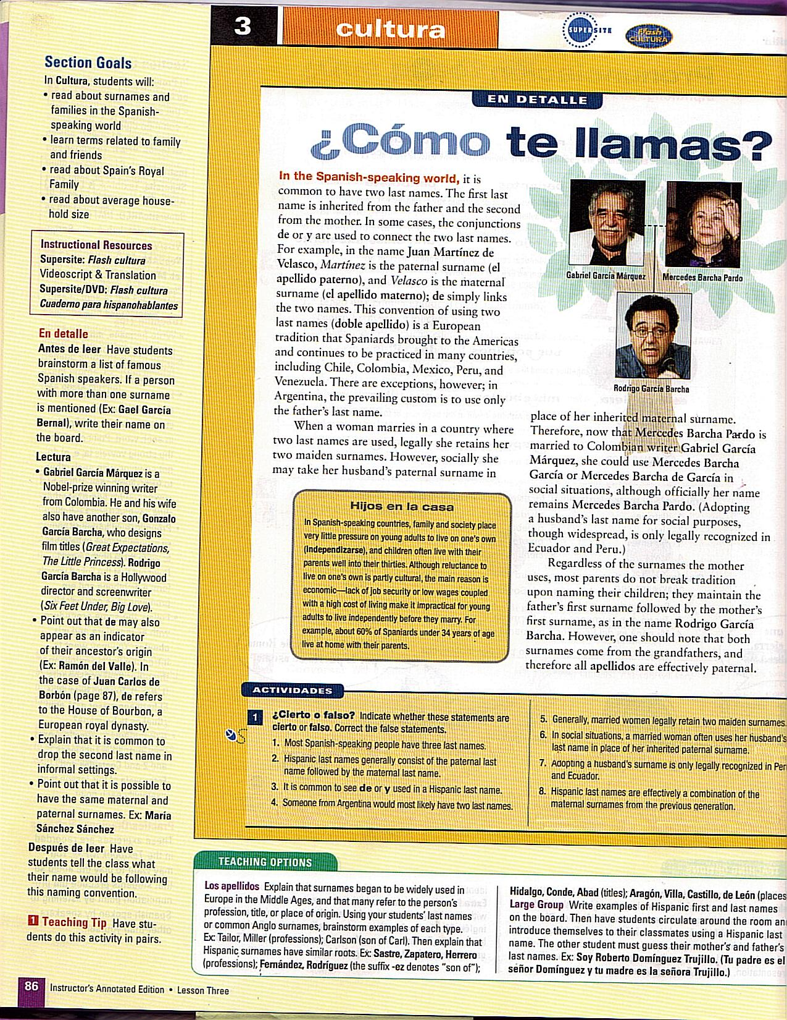
Before reading the information of cultura on p. 86, predict if the following statements are cierto or falso.

Now, read the information and review your answers. Incorrect answers should not be erased, only corrected.

Correct the false statements.

