L-3 CONTEXTOS LA FAMILIA

ESCUCHAR: Personas (text p. 79 Práctica 2)
Indicate each word that you hear mentioned in the narration.

- _____cuñado
- _____tía
- _____periodista
- _____niño
- _____esposo
- _____abuelos
- _____ingeniera
- _____primo

ESCUCHAR: Escoger (track 1)
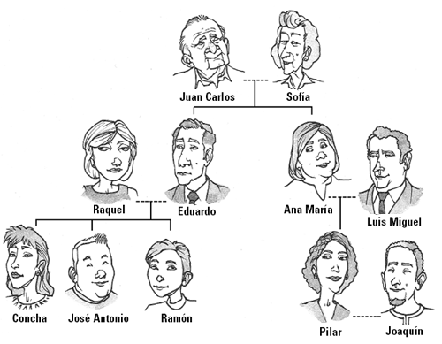
You will hear some questions. Look at the family tree and choose the correct answer to each question.

