1.2 NUMBERS 0-30

ESCUCHAR: Completar (track 14)

Nombre: ______________________________ fecha/date: ___________

You will hear a series of math problems. Write the missing numbers and solve the problems.
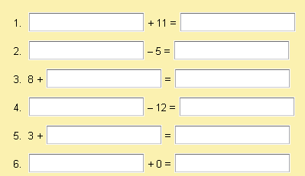

-------------------------------------------------------------------------------------------------------
1.2 NUMBERS 0-30

ESCUCHAR: Completar (track 14)

Nombre: ______________________________ fecha/date: ___________

You will hear a series of math problems. Write the missing numbers and solve the problems.

