1.1 NOUNS AND ARTICLES

Nombre: _____________________________________ fecha/date: _____________

ESCRIBIR: Nouns and Articles

Write the corresponding noun and its definite article (el/la/los/las) and indefinite article (un/una/unos/unas) for each of the pictures below.
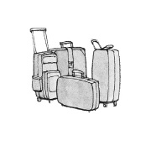
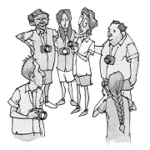
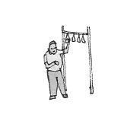
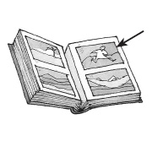

1. ____________________ 2. _________________ 3. __________________ 4. ___________________

**¹ tourists ² suitcases ³ picture ⁴ passenger

----------------------------------------------------------------------------------------------------------------------------------

1.1 NOUNS AND ARTICLES

Nombre: _____________________________________ fecha/date: _____________

ESCRIBIR: Nouns and Articles

Write the corresponding noun and its definite article (el/la/los/las) and indefinite article (un/una/unos/unas) for each of the pictures below.

1. ____________________ 2. _________________ 3. __________________ 4. ___________________

**¹ tourists ² suitcases ³ picture ⁴ passenger

