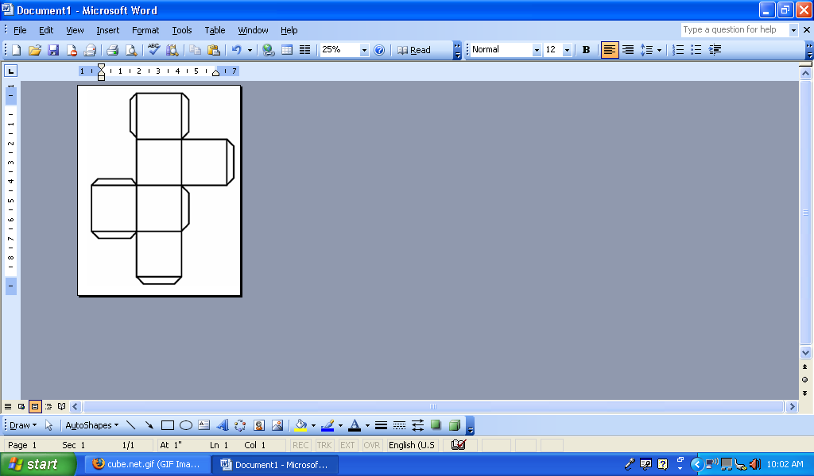
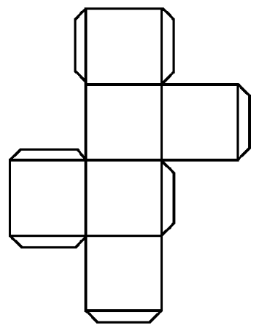
PLURAL
SINGULAR
ACCENTS
ACCENT VARIA-TIONS
FEMENINE
MASCULINE

