Troilus and Cressida

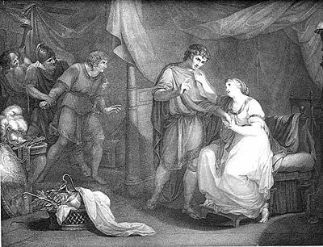

Tristan and

Iseuld

GROUP DISCUSSION
- Your group will have 20 minutes to discuss your story and 10 minutes Q&A.
- You are graded individually on this assignment as though it were an oral test.
- Every time you contribute to the conversation, you will receive a certain number of points, which will later translate into a grade worth 75 points.
- If I feel you are dominating the conversation, I deduct points.
- I give points to the same degree for the person who brings out conversation among others in the group unless there is not a clear demonstration somewhere that this person has read the story and is prepared.
- The moderator is given extra credit based on how well he/she promotes discussion, allows interaction, controls the focus, moves through the discussion points. Making sure everyone gets an opportunity to speak is critical for his/her grade, and for the moderator’s.
- At the end of the other group’s discussion, your group will ask questions. This will be added to your score not as extra credit, but as part of the 75 point expectation.
- As you read, jot down questions you want to talk about. Hand these in to the moderator during Part A Prep.

Part A Prep
- Choose a moderator
- Hand in your questions for discussion to the moderator.
- Brainstorm specific issues that should be discussed. Be as specific as you can in a way that will open up a difference of opinion.
- The issues should be in question format. Example: What is this story saying about loyalty? -or- Is there a conflict between loyalties, as in loyalty to a lover versus loyalty to a family member?
- Discuss what stand members of your group will take on the issues so that you are sure to have varying opinions and an interesting discussion.
- Talk about strategies and ways to be prepared for the discussion.

Part B Discussion
- Launch a fast-paced discussion
- If you are shy, check it at the door and open your mouth. It’s the only way to get a decent grade on this assignment.
- Jot down questions for the other group during their discussion. This is also critical for your grade. If there are too few questions for the other group, all your scores go down.

