Early Rome and the Rise of Christianity, Manuscripts, Monasticism
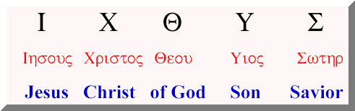
300 BC-500 AD

Septuagint
Platonism (428-348 BC)
Stoicism
Epicureanism/Epicurus (341-270 BC)
Pater familias
Pneuma
Galen (129-200)
Origen (185-254)
Constantine the Great (272-337)
Edict of Milan (3130
Athanasius (293-373)
Arius (256-336)
First Council of Nicaea (325)
Monasticism
Anthony of Egypt (251-356)
orans
diptych
ichthus
alpha omega
Chi Rho
rosette
Evangelist symbols
Matthew
Mark
Luke
John
Romanesque
Jerome (342-420)
Vulgate Bible
Ambrose (339-397)
Pope Gregory the Great (540-604)
Gregorian chant

