Component 7 /Unit 5
Assessment

Assessment 1
Students will be asked to identify a usability problem that they have encountered in their everyday life. This may be in the form of the devilishly confusing remote control, the on/off switch on the gas barbeque, the buttons on the car clock from which you are expected to “spring forward” or “fall back”, the location of the bathroom light switch at your in-laws house, etc. From this identified usability problem, students should fully describe the problem, try to understand how such a problem arose, and suggest several feasible re-designs.

Assessment 2
Using the principles learned in the lecture and obtained in ther readings, choose 1 design from section 1 and 2 designs from section 2 below. Specifically cite the usability problem and which of the 6 principles of usabillity that are violated. Produce robust suggestions for how each of the three that you have chosen can be improved using good usability principles. Illustrations with explanations are permissable.

SECTION 1:
#1
Do you like to eat fruit?
YES
NO
Next


#2

#3
#4

SECTION 2

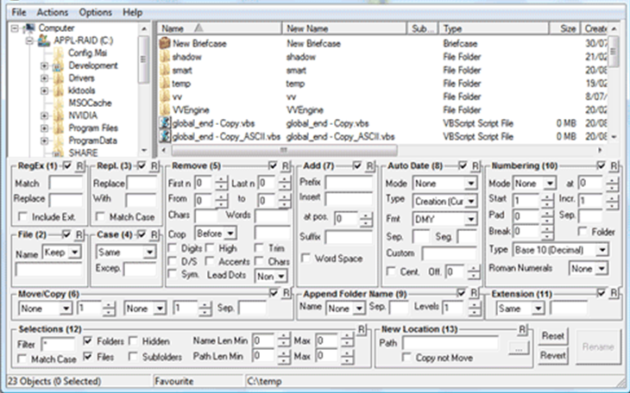
#5

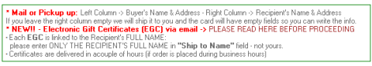
#6

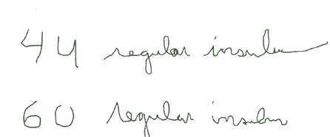
#7

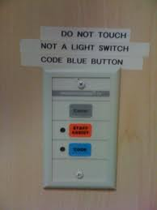
#8
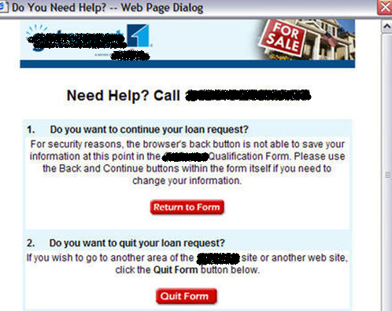
#9
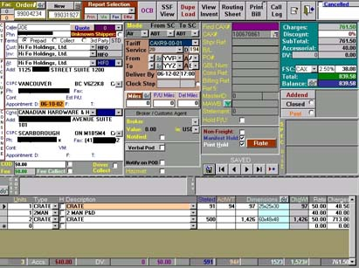
#10


#11

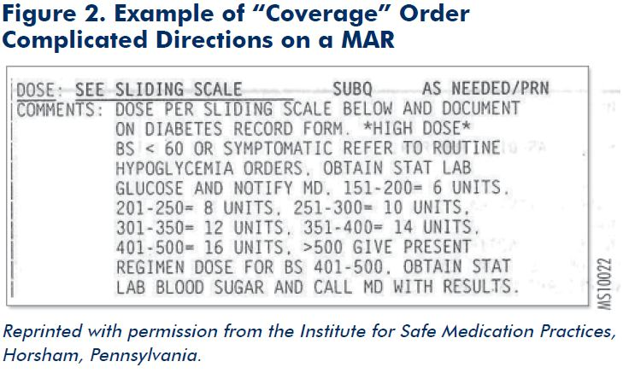
#12


#13

