Component 7/Unit 10
Application Activities

In this activity for unit 10 of component 7, students will complete a hands-on activity with an example of HIT in support of patient centered care from the VA. Instructors may choose other publicly available examples of this type of HIT-enablement for patient-centered approaches to health such as Microsoft HealthVault, Google Health, or MyPHR if desired. This activity however is crafted specifically for MyHealthe-Vet, and will illustrate the function of a new feature launched in the fall of 2010 called “The Blue Button”. Blue Button is a joint activity between the VA and the Center for Medicare and Medicaid Services (CMS) to allow participants to not only create an online personal health record (PHR), but to download it for transport to other care providers.
Video Orientation
- Students are to watch the entire “My Healthe-Vet” Orientation Video that is located at: www.myhealth.va.gov . This is a video in the public domain and should be available on any computer that has a connection to the internet. In addition, a link exists on the URL above to download the entire video, which may be replicated and distributed with attribution (for those who may not have reliable internet connectivity).
  - username: mhvuser
  - password: mhvdemo#1
Hands-on Assignment
In this assignment, students will interact with My Healthe-vet using the demo account provided by the VA to illustrate functionality. Students are asked to approach this activity from the perspective of a patient or a patient’s caregiver (i.e. a parent of a sick child, or the child of a sick parent). Building upon material covered to date in component 7 – students will learn to use the system, make a few minor entries/changes to the demo account, use the “Blue Button” feature to export their PHR (the demo PHR with modifications) and critique is usefulness and usability – from a patient perspective.

- Students should watch the assigned My Healthe-Vet orientation video located at: www.myhealth.va.gov. Following the observation of the video, students will explore each of the tabs on the toolbars and each of the “quick links” pictured in the image below.
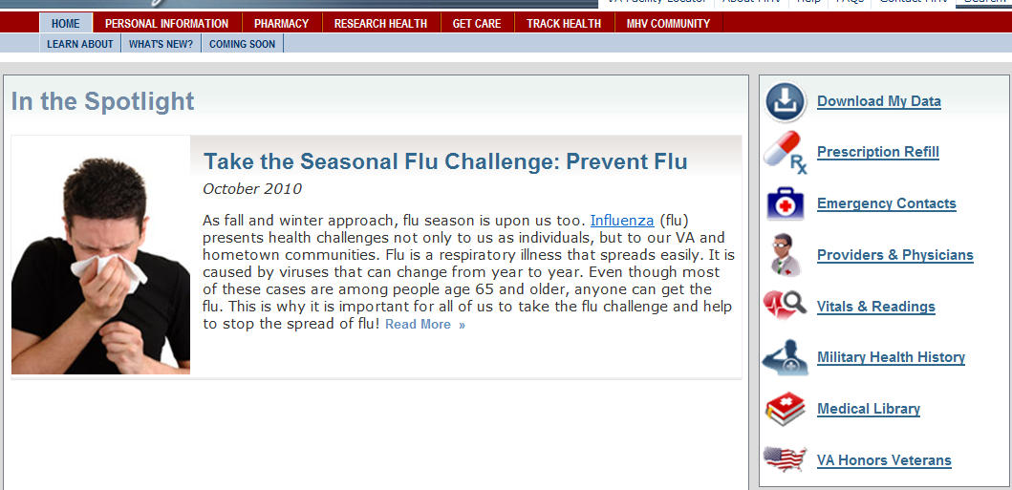
Quick Links
Toolbar Menu
Sub-Menus

- Putting themselves in the shoes of a patient, students will click into each of the menu items in the TOOLBAR (Personal Information; Pharmacy; Research Health; Get Care; & Track Health) and review the sub-menus.

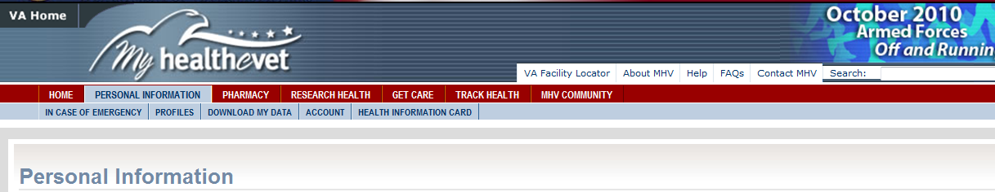
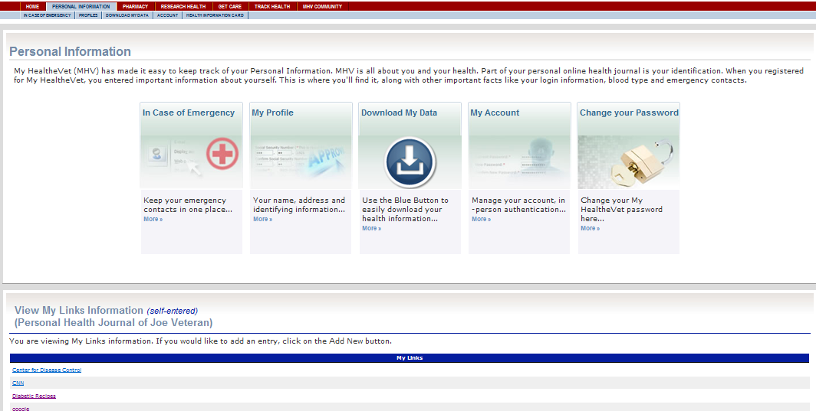
- For menu item “PERSONAL INFORMATION” students (still in the role of a patient) are to add a weblink to a health-related site (such as smoking cessation from the American Cancer Society or recipes for diabetics, etc.)

- In the menu items of Pharmacy; Research Health; Get Care; & Track Health – students are free to choose from any of the sub-menus that allow data input – and they are to enter at least 1 new piece of data in each menu item from the toolbar. All actions should be from the perspective of a patient.
  - In example, under the menu item of PHARMACY, only the icon for My Medications and Supplements allows for data entry. Add at least one new medication of any type.
  - Under the menu item of TRACK HEALTH – all 4 icons/sub-menus allow data entry. Choose only one of the icons and make at least one data entry.
  - Continue until all menu items (skipping “MHV COMMUNITY”) have at least one “new” data element added.

WHAT TO HAND IN:
The 2 deliverables for this assignment are: 1 :) a print out (or a digital file) that reflects the PHR output after making the modifications detailed above AND 2.) a print out (or digital file) of the patient’s “HEALTH INFORMATION CARD”
- Return to HOME in My Healthe-vet toolbar. Chose “DOWNLOAD MY DATA”.
- Choose “VIEW/PRINT” to review and verify that your entered data appears. If so, do NOT print (could be very long). Return to the “DOWNLOAD” option (instead of view/print). If the student entered data does not appear, students should return to the entry process and validate and/or re-enter prior to submission.
- Download your data file (the “BLUE BUTTON” formats to a .txt file – the HEALTH INFORMATION CARD simple prints/appears as a single sheet). From the BLUE BUTTON output - highlight the data that you entered.
- Check with your instructor for submission instructions.

