Component 7 /Unit 1
Application Activities

Activity 1

Students will observe 6 short videos (saved as PDFs) that will orient them to the demonstration electronic health record system (EHRS) environment. This will prepare students to participate in a learning activity that will enable them to apply the concepts provided in the lecture material in hands on lab experiences. Students will learn how to navigate within the example EHRS, to gain familiarity with a generic HIT user interface, the general structure of an electronic patient record, and basic functionality.

(Optional) Orientation Videos:
- Part 1 Orientation - Working with HIT Systems (comp7_unit1_video_part1)
- Part 2 Orientation – Exploring the Coversheet (comp7_unit1_video_part2)
- Part 3 Orientation – Diving Deeper into the Tabs (comp7_unit1_video_part3)
- Part 3 Orientation – Diving Deeper into the Tabs – Part 2 (comp7_unit1_video_part4)
- Part 5 Orientation – Labs, Reports, & Starting to Scavenge (comp7_unit1_video_part5)
- Part 6 Orientation – Scavenger Hunt (to be used with scavenger hunt activity) (comp7_unit1_video_part6)

Objectives:
Identify common components of a clinical HIT system
Demonstrate beginning level competency in maneuvering inside of the demonstration EHRS

Activity 2
A scavenger hunt for various data values within the HIT demonstration system is designed to further familiarize students with components of, and navigation within, a representative clinical HIT system. Instructions, the scavenger hunt “search list” and the scavenger hunt video (#5 & #6 as mentioned in Activity 1) are included with UNIT 1.
It is strongly recommended that you view the 4 short video files that will orient you to the VAVistA CPRS interface, organization of VAVista data, navigation of the VAVista CPRS system, and the example of how to complete the Scavenger Hunt prior to completing this assignment. Your instructor will point you to the location of these five-minute video overviews. Document all of your answers and submit to your instructor.
- Log in to VAVistA using the ACCESS Code and VERIFY CODE that has been provided to you by your instructor or institution. The login is case sensitive.
- Click on the “OK” button
- VAVistA CPRS will open. From the patient selection dialog box that appears – chose Seven, Inpatient.
- Examine Mr. Seven’s record using the “cover sheet” tab.
- For the Scavenger Hunt assignment, you must find and document the answers/data for each of the below questions

QUESTIONS for Scavenger Hunt

  - What are the allergic signs and symptoms that are documented in the record for Mr. Seven for Keflex?

  - What was Mr. Seven’s Serum Glucose value on August 20, 2010?

  - Over the past two years, what is the highest temperature that was ever recorded for Mr. Seven and what date was that recorded on?

  - Where would you find the lab test information that contains the description of the lab tests that are available to order?

  - In the lab test description - for a CBC profile panel, how many tests are included in the panel? How much does a CBC cost? Copy the answers and paste them into the assignment answer sheet.

  - Over the past year, has Mr. Seven lost weight or gained weight? Turn the weight measurements into a graph. Capture the graph and all of the dates and values for vital signs for Mr. Seven, copy and paste the display into your assignment answer sheet.

  - When was Mr. Seven in an automobile accident and what was the injury he received? When did that problem become inactive?

  - List all reasons that you believe Mr. Seven needs an Influenza Vaccine (per the reminder dialog box).

EXTRA CREDIT
- If I wanted to increase the font size of the CPRS display, how would I do that?

- Where could I find the legend that tells me what each of the icons means?
- What three tests were dictated for Mr. Seven on his discharge summary for his inpatient stay that ended on July 23, 2010?
Objectives:
  - Define a system and relate systems concepts to HIT
  - Discuss specific examples of settings where Health IT is used (acute, rural, public health, clinic, office, patient home, etc.)
  - Identify common components of a clinical HIT system
  - Demonstrate beginning level competency in maneuvering the demonstration EHRS

Expected Outcome:
- What are the allergic signs and symptoms that are documented in the record for Mr. Seven for Keflex?
ANSWER:
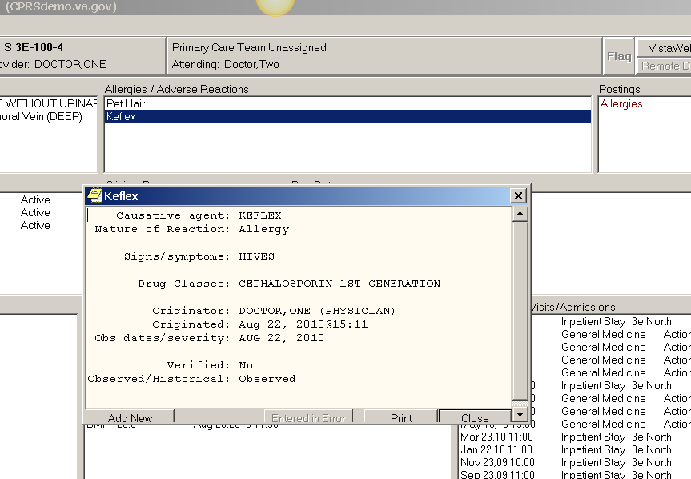

Causative agent: KEFLEX
Nature of Reaction: Allergy

Signs/symptoms: HIVES

Drug Classes: CEPHALOSPORIN 1ST GENERATION
Originator: DOCTOR,ONE (PHYSICIAN)
Originated: Aug 22, 2010@15:11
Obs dates/severity: AUG 22, 2010
Verified: No
Observed/Historical: Observed

- What was Mr. Seven’s Serum Glucose value on August 20, 2010?

ANSWER:
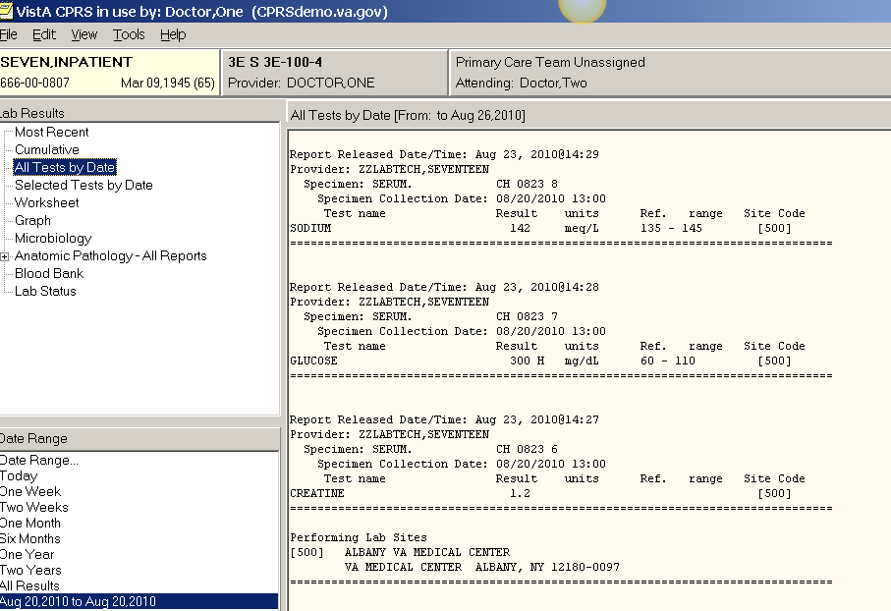

Report Released Date/Time: Aug 23, 2010@14:28
Provider: ZZLABTECH,SEVENTEEN
Specimen: SERUM. CH 0823 7
Specimen Collection Date: 08/20/2010 13:00
Test name Result units Ref. range Site Code
GLUCOSE 300 H mg/dL 60 - 110 [500]
===============================================================================

- Over the past two years, what is the highest temperature that was ever recorded for Mr. Seven and what date was that recorded on?

ANSWER: 101.6 and March 23, 2010

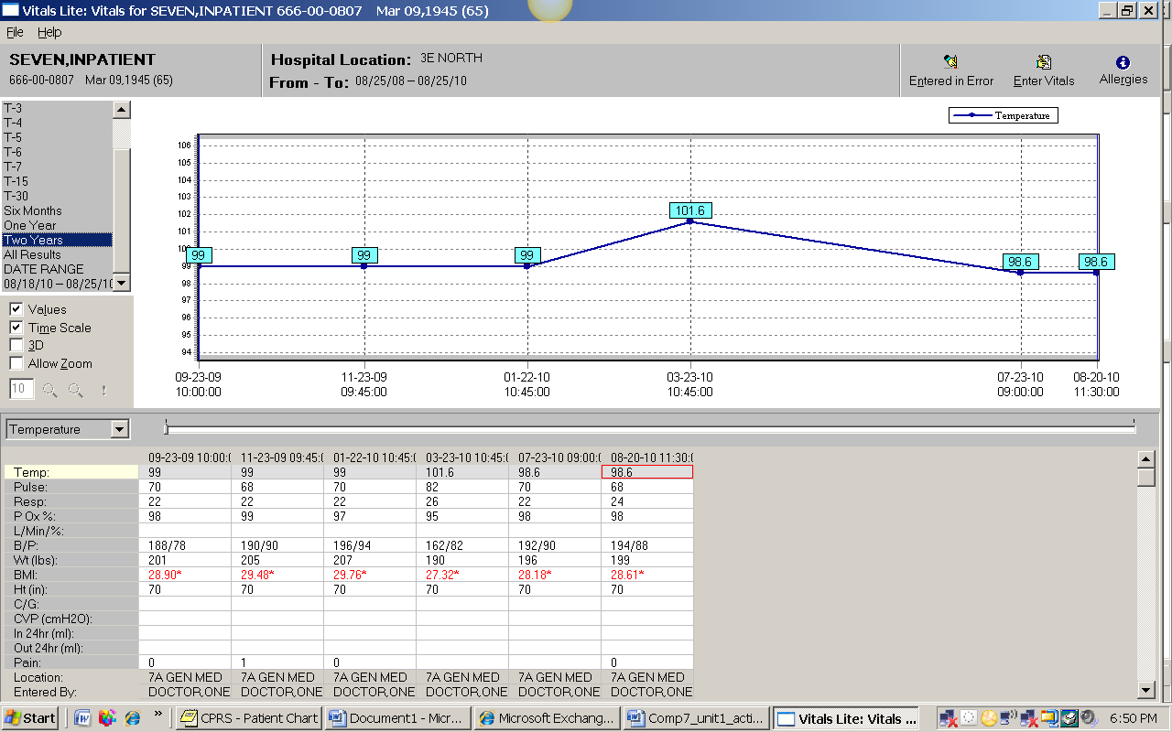

- Where would you find the lab test information that contains the description of the lab tests that are available to order?

ANSWER: Under the toolbar on the top left hand side, click “Lab Test Information”

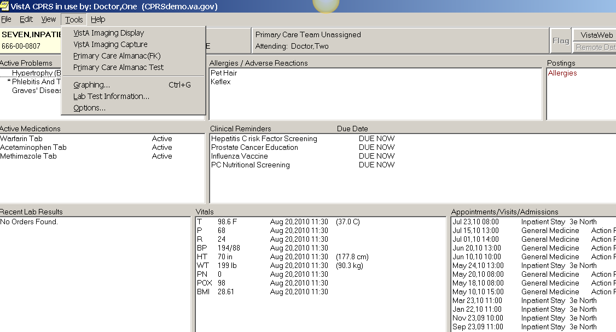

- In the lab test description - for a CBC profile panel, how many tests are included in the panel? How much does a CBC cost? Copy the answers and paste them into the assignment answer sheet. Ten Tests and $2.34

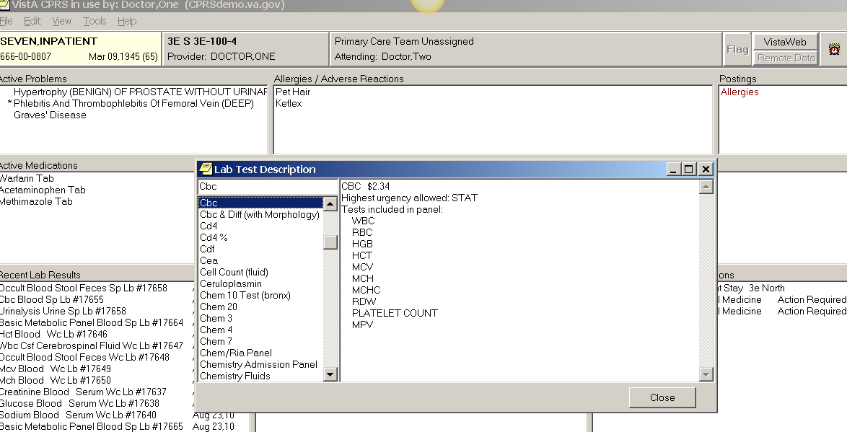
10

- Over the past year, has Mr. Seven lost weight or gained weight? Turn the weight measurements into a graph. Capture the graph and all of the dates and values for vital signs for Mr. Seven, copy and paste the display into your assignment answer sheet.
ANSWER: Overall, Mr. Seven has been yo-yo ing with his weight – but he weighs less now than he did at the start, so the answer is “lost weight”.
There are many different ways to do this assignment, so the displays received may be quite varied. Two examples are provided below. The first display (Example 1) was obtained by double-clicking on WEIGHT from the cover sheet view of the VITALS window and choosing the TWO YEARS from the date range box on the upper left of the screen that appears. Example 2 was obtained by choosing TOOLS from the upper left menu bar in the cover sheet view – and selecting graphing. From the box that appears, students will highlight the data they want to graph and the data will graph automatically in the window to the right. Choosing “individual graphs” will result in numerous graphs – un-clicking will result in the image provided here (where all graphs are on the same display). Right clicking on the “dots” on the graph will provide the option to display the values. Students can also choose the SELECT/DEFINE and SETTINGS buttons at the bottom of the graph also. In short, as long as the student turns in the answer (lost weight), an image of the graph, and the dates and values for Mr. Seven, they should get a high mark. Instructors may want to reserve points for those students who went above and beyond to produce exceptional displays.
Example 1:
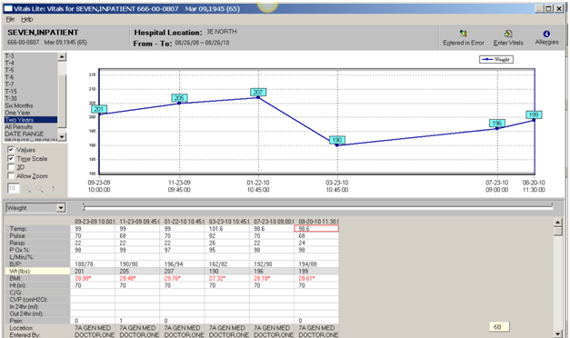

Example 2:
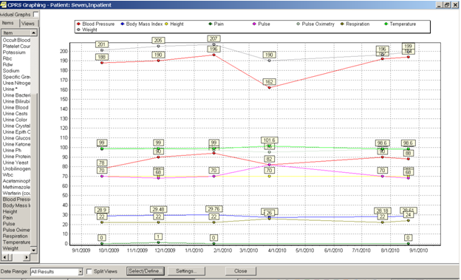

- When was Mr. Seven in an automobile accident and what was the injury he received? Is this an active or an inactive problem?
ANSWER: He was in an auto accident in June of 2005 and he received an fracture of the tibia and fibula on the right side. It is an inactive problem.
Students obtain this answer by clicking on the problem sheet, and then clicking on inactive problems.
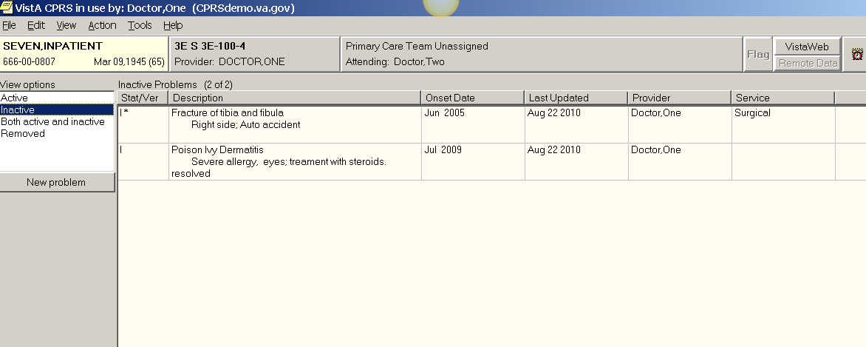

- List all reasons that you believe Mr. Seven need’s an Influenza Vaccine (per the reminder dialog box).

ANSWER: Students will click on “Influenza Vaccine” from the cover sheet in the Clinical Reminders section. The narrative that will open will tell students that patients over the age of 65 should get an influenza vaccine AND that there is no record of Mr. Seven receiving the vaccine in the EHR.

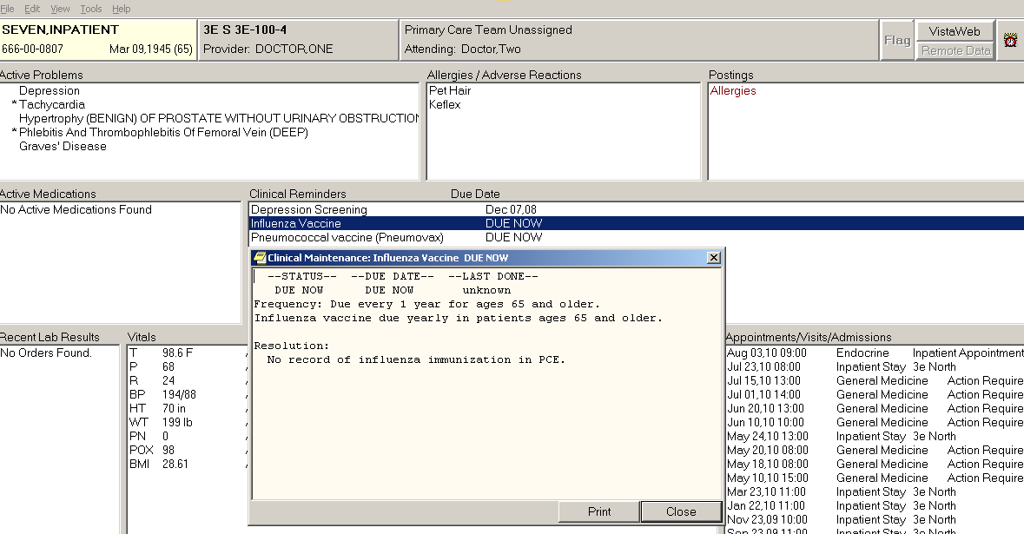

EXTRA CREDIT
- If I wanted to increase the font size of the CPRS display, how would I do that?
ANSWER: Choose toolbar, upper left, select PREFERENCES and then FONT. Image below just for illustration.
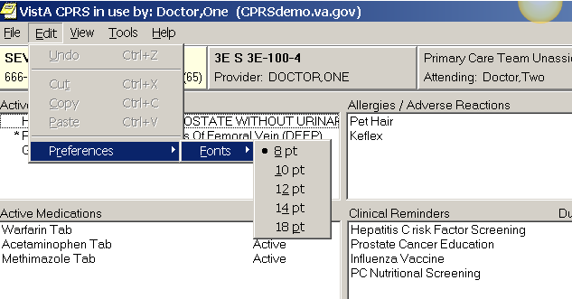

- Where could I find the legend that tells me what each of the icons means?
ANSWER: Students must choose either the NOTES or CONSULTS or D/C SUMMARY Tab. Then by clicking VIEW in the upper Toolbar, the Icon Legend dialog box will open. The image below is just for illustration. The principle here is to get students to realize that the tool bar changes based on the tab that is open.
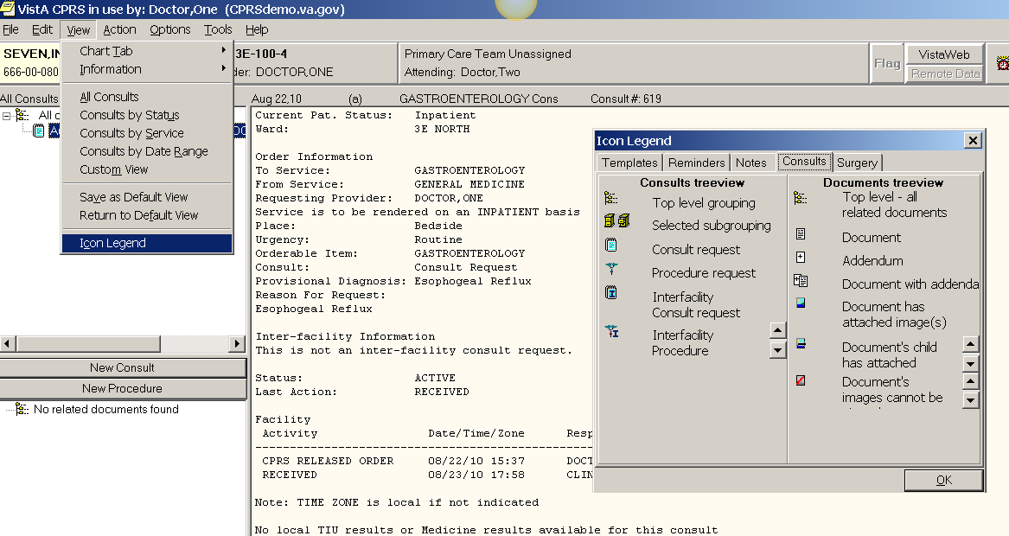

- What three tests were dictated for Mr. Seven on his discharge summary for his inpatient stay that began on July 23, 2010?
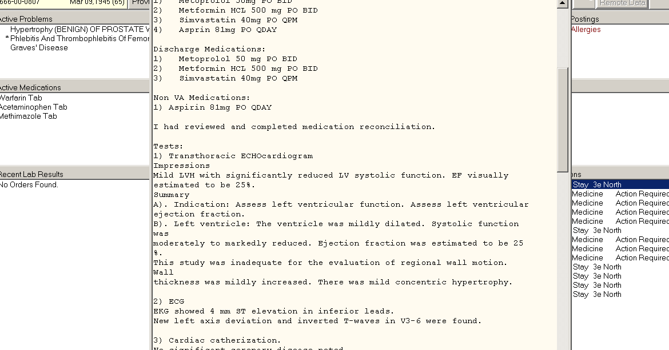
Tests:
1) Transthoracic ECHOcardiogram

2) ECG

3) Cardiac catherization.

