Component 7 /Unit 4
Application Activities

Activity 1
Students will observe 5 short videos (saved as PDFs) that will orient them to the the query function in VistA. This will prepare students to participate in a learning activity that will enable them to apply the concepts provided in the lecture material in hands on lab experiences. Students will learn how to extract data from VistA using three different approaches and how to produce a specific discharge report for a given patient.
Orientation Videos
- Part 1_The Reports Tab (comp7_unit4_video_part1)
- Part 2_Reporting: Clincial VS AdHoc (comp7_unit4_video_part2)
- Part 3_Fun With Graphs (comp7_unit4_video_part3)
- Part 4_Resolving Reminders (comp7_unit4_video_part4)
- Part 5_Facilitating Quality & Efficiency with Reminders (comp7_unit4_video_part5)

Activity 2
In this assignment, students will interact with the CPRS system as a user would, extracting patient specific data for a particular purpose. The focus of this unit is not upon knowledge of clinical nuances, since not all students will have clinical experience. The focus of this exercise is upon understanding how the reporting function works, and the strengths, weaknesses, and appropriateness of each.

Also embedded within this experience will be a hands-on experience with how HIT functions serve to both remind providers of needed tests and interventions while facilitating workflow. In this exercise, students will observe how the automated clinical reminder system supports best practices in assessment and documentation and enhances continuity of care (automated planning of next steps, ordering consults, etc.). Students are strongly encouraged to watch the orientation videos associated with unit 4 prior to completing the assignment.

The questions below are structured to encourage exploration of the reporting interface of VistA and create a deeper understanding of the differences between reporting functions within an individual patient record. In addition, an experience with displaying data in graphical format is provided as well as exposure to integrated workflow support in the example of automated clinical reminders.

This is NOT a data entry assignment. This assignment relates directly to the assessment paper where students are asked to compare and contrast the different reporting capabilities, and to better understand which type of report is best suited for specific needs. The following hands-on exercises bring those considerations and experiences to the fore.

Keeping in mind the deliverables, - as students walk through this exercise, they should:
- Capture their work for submission to their instructor. Options for doing this may include using the print screen function (with a cut and paste to a document file), CNTRL-C & CNTRL-V, or certain software applications such as Screen Print & Capture 32, SnagIT, CaptureWiz, etc. Many actions have a “PREVIEW” button which an optimal place to do a cut and paste of your work. Students should check with their instructor for submission requirements. Deliverables are highlighted.
- Students are to refrain from entering unprofessional data, remembering that all entries are linked to your login. Data approximating reality is close enough – as it is understood that not all students have a clinical background.

Student Instructions:
From within the VistA system, select Seven, Inpatient and open his record. Click on the “REPORTS TAB”.

Using the CLINICAL REPORT Function answer the following three questions, making sure to capture and save your work/answers for submission.

Question #1- On August 23, 2010 Mr. Seven had laboratory tests done (Chem & Hematology). What was the result of his Serum Potassium? Was it high or low or normal?
Question #2- On the discharge summary from April 1, 2010, what was the discharge diagnosis?
Question #3 - Mr. Seven experienced a marked weight loss in March, 2010. Retrieve his vital signs from the period of January 1, 2010 until March 31, 2010. What was Mr. Seven’s weight drop from January 22, 2010 to March 23, 2010? What other of Mr. Seven’s vital signs also showed a noticeable change?
Using HEALTH SUMMARY REPORTS – ADHOC Function construct a report to complete question #4.
Question #4 – Create a report containing only the following items: a.) Active Problems; b.) Lab Tests Selected: Urine Glucose and Blood Sugar ONLY; c.) Allergies; d.) Vital Signs – selected to reflect only his weight ; e.) Progress Note selected to show only the patient’s Ophthalmology Consult Note. Capture & save your work (Copy and Paste) for submission to instructor.

Using REPORT Tab generate a vital signs graph and answer question #5:
Question #5 – In Reports Tab using “Graphing (Local Only)” create a graphical display of Mr. Seven’s Blood Pressure, Pulse, Respirations, Weight & Temperature for the date range of March 1, 2010 through August 31, 2010. Capture & save your work for submission to instructor.
You note that Mr. Seven has a few outstanding reminders. To resolve some of these reminders - create a new note for Mr. Seven and follow the instructions below.
Question #6 –
  - Open Mr. Seven Inpatient’s chart and change the “Provider and Location for Current Activities” (click second box on top tool bar where current provider is listed) to the visit date of June 10, 2010 for General Medicine – note that date will change in the chart header to June 10.
  - Create a new note for Mr Seven Inpatient from notes tab. Choose “Admission Assessment” as the type of note you will create, making sure to change the “date and time of note” to June 10.
  - Click “Reminders” and click on the “Depression Screening”. Complete the Depression Screening documentation, PHQ2 and PHQ 9 (IGNORE any warning boxes about a missing DLL file – click through). Click “Next”.
  - You will note that the system supports clinical workflow by immediately popping up the next reminder that should be addressed today while the patient is in the clinic (the Retinal Exam). Choose “Refer Patient to Optometry…..” and click “finish”. Choose yourself as the primary provider for this visit in the box that appears.
  - Describe what happens next, and explain how this is evidence of HIT support for workflow.
  - Click into the “orders tab”, to see the new consult that has been ordered automatically. Take a screen shot of this for submission to instructor.
- Sign the note when prompted, or choose “ACTION” from the tool bar to sign the note. The electronic signature is your Access Code (such as DOCTOR1); exit the system.
- Ask instructor for directions on how to submit the assignment.

Objectives
Identify characteristics of an effective HIT system.
Define and provide examples of how evidence-based practice can be supported in HIT Systems.
Define and cite examples of usability, configurability, scalability and reliability in HIT systems.
List and contrast different types of reports/queries (predefined vs. ad hoc) required for internal and external reporting.

Expected Outcomes:
Activity 2 Answer Sheet
(NOTE to Instructors: Students should be given credit for following the instructions; therefore the screen shots submitted should be similar to those provided in this answer sheet. There are many ways to obtain the results, but this is not about simply getting the right answers – it is about illustrating to students the different ways and displays that can be utilized and will be built upon in subsequent units.)
Please inform students of how you (as the instructor) would like them to submit their work.
~~~~~~~~~~~~~~~~~~~~~~~~~~~~~~~~~~~~~~~~~~~~~~~~~~~~~~~~~~~~~~~~~~
Question #1- On August 23, 2010 Mr. Seven had laboratory tests done (Chem & Hematology). What was the result of his Serum Potassium? Was it high or low or normal?
ANSWER: 7.5 was the value and it was high. I can tell it is high because there is a “flag” next to it (H*).
(NOTE to Instructor: There are 3 potassium measurements in this display, but only 1 is from SERUM. If they choose a BLOOD Potassium measurement – the answer is wrong.)
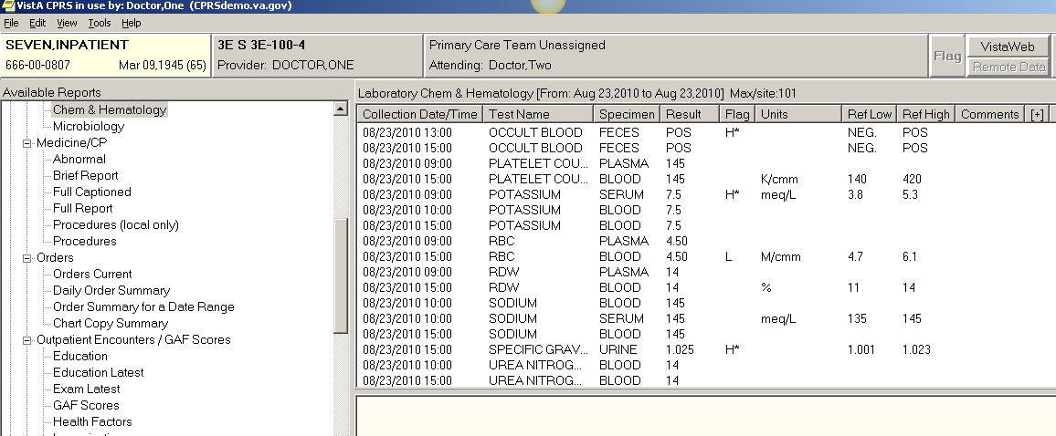

Question #2- On the discharge summary from April 1, 2010, what was the discharge diagnosis?
ANSWER: Influenza and Gastroenteritis
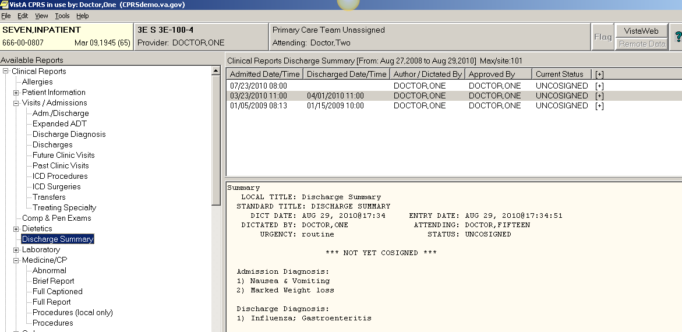

Question #3 - Mr. SEVEN experienced a marked weight loss in March, 2010. Retrieve his vital signs from the period of January 1, 2010 until March 31, 2010. What was Mr. SEVEN’s weight drop from January 22, 2010 to March 23, 2010? What other of Mr. SEVEN’s vital signs also showed a noticeable change?
ANSWER: Mr. SEVEN lost 17 pounds during that time period. I also note that in March he had a fever of 101.6, his pulse was faster (at 82) and his blood pressure was lower (162/82 compared to 196/94). There seem to be minor differences in some of the other values. It looks to me (because I am a clinician) that Mr. SEVEN has some sort of illness when he came to the hospital on March 23. He was probably dehydrated.
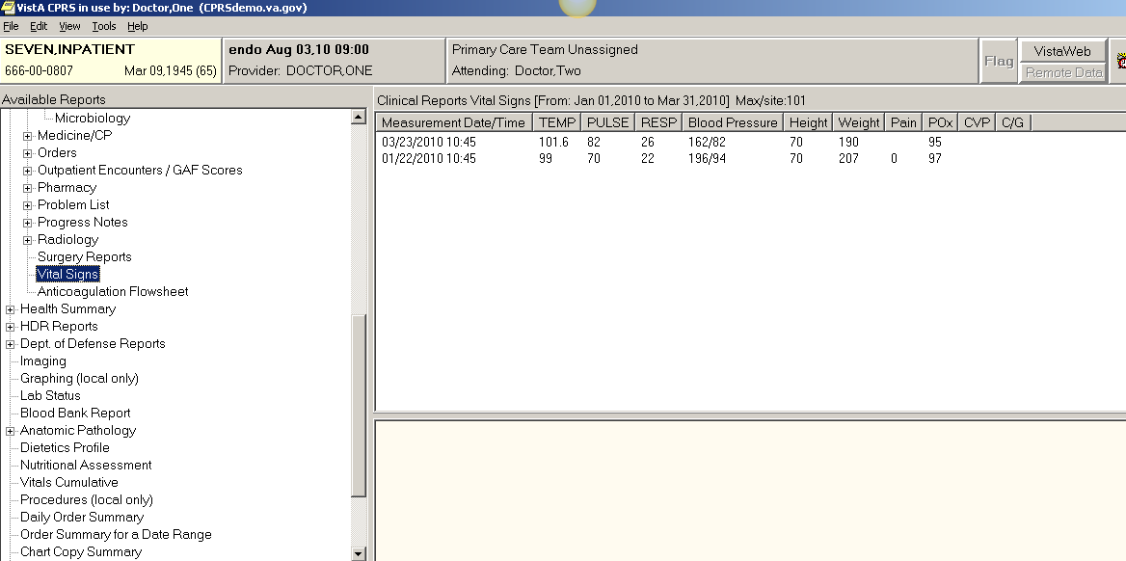

Using HEALTH SUMMARY REPORTS – ADHOC Function construct a report to complete question #4:
Question #4 – Create a report containing only the following items: a.) Active Problems; b.) Lab Tests Selected: Urine Glucose and Blood Sugar ONLY; c.) Allergies; d.) Vital Signs – selected to reflect only his weight ; e.) Progress Note selected to show only the patient’s Ophthalmology Consult Note. Capture & save your work (Copy and Paste).
ANSWER: All five elements are highlighted below:
08/30/2010 20:20
******************** CONFIDENTIAL AD HOC SUMMARY pg. 1 *******************
SEVEN,INPATIENT 666-00-0807 DOB: 03/09/1945
3E NORTH 3E-100-4

--------------------------- ADR - Adv React/Allerg ---------------------------

Title: ALLERGY/ADVERSE REACTION (AR)

Drug:
ALLERGY: KEFLEX (NV/Observed)
HIVES

Originator: ONE DOCTOR
Date/Time: 08/22/2010 15:11

Other:
ALLERGY: PET HAIR (AV/Historical)
ITCHING,WATERING EYES

Originator: ONE DOCTOR
Date/Time: 08/22/2010 15:10

---------- SCL1 - Lab Cum Selected 1 (max 10 occurrences or 1 year) ----------

Collection DT Spec GLUCOSE GLU

08/23/2010 15:00 BLOOD 310 H*
** INSTRUCTOR NOTE: BLOOD or SERUM is correct.
08/23/2010 15:00 URINE 2+
08/23/2010 11:00 SERUM 310 H*
08/23/2010 10:00 BLOOD 310 H*
08/20/2010 13:00 SERUM 300 H

---------- SPN - Selected Prog Notes (max 10 occurrences or 1 year) ----------

08/03/2010 07:13 Local Title: OPHTHALMOLOGIST CONSULT NOTE
Standard Title: OPHTHALMOLOGY CONSULT

HISTORY:
Chief Complaint:
Pressure and Pain in Eyes
Current Medications:

Current General Meds:
ALLERGIES AS DISPLAYED IN VISTA:
PET HAIR, KEFLEX
Patient/family state(s): No new allergies
PMH/FH/SOCIAL HX:
PAST HISTORY:
MEDICAL HISTORY:
Graves Disease
FAMILY HISTORY:
Does parent, sibling, or child have a Hx of glaucoma? no

SOCIAL HISTORY:
ALCOHOL? (+) Alcohol use: 2 or less drinks/day.
TOBACCO? Ex-tobacco user
MARRIED STATUS? Married.

Review of Systems:
Review of Systems
Eyes:
(+)Positive symptoms reported: pain and pressure
eye pain, blurred vision, double vision, eye pain, vision change, double
vision, blurred vision

MENTAL STATUS:
Oriented x3

ADNEXAE/FACE/LIDS:
Exopthalmus
IMPRESSION/ASSESSMENT:

Accelerating Graves Disease with impact on optic. Will confer with
Medicine Service & Endocrinology to change plan of care.

MANAGEMENT/PLAN:
F/U in 2 weeks. Consult with Endocrine/Medicine

Signed by: /es/ ONE DOCTOR
08/30/2010 07:22

------------------- SVS - Vital Signs Selected (max 1 year) -------------------
Measurement DT WEIGHT
LB(KG)[BMI]

08/20/2010 11:30 199(90.26)[29*]
08/03/2010 14:30 197(89.36)[28*]
07/23/2010 09:00 196(88.90)[28*]
06/21/2010 07:30 196(88.90)[28*]
05/06/2010 09:45 192(87.09)[28*]
03/23/2010 10:45 190(86.18)[27]
01/22/2010 10:45 207(93.89)[30*]
11/23/2009 09:45 205(92.99)[29*]
09/23/2009 10:00 201(91.17)[29*]

---------------------------- PLA - Active Problems ----------------------------
4 Active Problems
PROBLEM LAST MOD PROVIDER
Tachycardia, Onset 08/02/2010 08/29/2010 DOCTOR,ONE
Patient presents with tachycardia and
Graves ophthalmopathy

Hypertrophy (Benign) of Prostate without Urinary 08/22/2010 DOCTOR,ONE
obstruction, Onset 00/00/2009

Phlebitis and thrombophlebitis of femoral vein 08/22/2010 DOCTOR,ONE
(deep), Onset 08/00/2010

Graves' Disease, Onset 00/00/2005 08/24/2010 DOCTOR,ONE
Patient requires dietary counseling to
reduce iodine intake.

*** END ************ CONFIDENTIAL AD HOC SUMMARY pg. 1 *******************

Using REPORT Tab, generate a vital signs graph and answer question #5:
Question #5 – In Reports Tab using “Graphing (Local Only)” create a graphical display of Mr. Seven’s Blood Pressure, Pulse, Respirations, Weight & Temperature for the date range of March 1, 2010 through August 31, 2010. Capture & save your work.
ANSWER: Graph should approximate the image below.
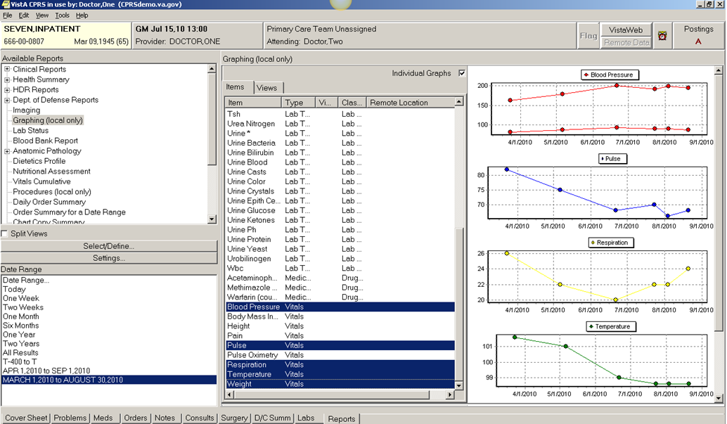
You note that Mr. Seven has a few outstanding reminders. To resolve some of these reminders - create a new note for Mr. Seven and follow the instructions below.
Question #6 –
ANSWER : The student should submit a screen capture for Question 6 and an answer to the following question:
- Describe what happens next, and explain how this is evidence of HIT support for workflow.
What happens next is that the system automatically generates the consult for the ordering provider. This is evidence of support for workflow in that the system automatically generates the consult, reducing the tediousness of doing it manually. This also reduces the cognitive burden on the clinician by removing the onus “one more thing to remember to do”. It supports continuity of care and best practices by supporting the processes and actions that lead to better outcomes. These sorts of actions by HIT will also help with quality measures and meaningful use requirements.
- Click into the “orders tab”, to see the new consult that has been ordered automatically. Take a screen shot of this for submission to instructor.
