Component 17/Unit 5
Application Activities

Activity 1
Students should develop their own mind map of a HIT as follows:
The Director of Nursing at Mayview Hospital has requested a kiosk housing information on selected health disruptions, advanced care directives, medical management, discharge planning, etc. The intent of the kiosk would be to build the system in a friendly, inviting manner so all levels of patients from different backgrounds could retrieve information in the hospital lobby while waiting for their families, during visitation hours, or anytime information may be needed.

Please create a mind map using the concept of a health information kiosk to depict your thoughts and areas needed to be considered in the design and implementation of the equipment.

Objective: Use problem-solving techniques such as a mind map when working in
teams.

Expected Outcome: A mind map
In the middle block in the center of the page is the Health Information kiosk.
Directly to the left would be the personal patient information.
Top left block would be patient insurance information.
Block below would be contact information.
To the bottom left would be visit information.
Each block would have the date of visit, primary care provider and primary
diagnosis.
Directly above the middle block would be Advanced Care Directives.
Each block would hold a different document.
Directly below the middle block would be Discharge Planning.
Each block would hold the specific Discharge instructions correlated with
each patient visit.
Directly to the right of the middle block would be the Patient’s care team.
The Primary Care Provider in the first block.
Additional providers/therapists in the remaining blocks.

Activity 2
The health information kiosk (used in the earlier activity) to be built for the hospital that would be set in the lobby for patients, families, and caregivers to retrieve various types of health information will also be used in this activity.

Now that you have designed your mind map, please do a hypothetical SWOT analysis for the team to consider the strengths, weaknesses, opportunities, and threats in building and implementing such a device.

Objective: Use a SWOT analysis problem-solving technique for this activity.

Expected Outcome:
STRENGTHS  What are the existing strengths?  For Example –  - New up to date archival application.  - Strong Information Technology (IT) department.  - Strong vendor relationship.  What are the competitive strengths?  - Strong leadership for the project.  What are the perceived versus real strengths?  - Perception that the project will be a seamless implementation.  What other internal factors will help the project?  - Having key stakeholders on the team. | WEAKNESSES  What are the existing weaknesses?  - Challenge to be HIPPA compliant.  What are the competitive weaknesses?  - Chosen Kiosk hardware not robust enough to handle heavy traffic (slow server time).  What are the perceived versus real weaknesses?  - Perception that the HIPPA issue will be larger than it actually is.  What other internal factors will hinder the project?  - Unanticipated extra coding for project leading to not budgeted overtime.  - Lack of money to complete project.
OPPORTUNITIES  What current opportunities does the project face?  - To provide timely information to the patient while waiting for appointments.  What future opportunities does the project face?  - Electronic bill payment.  What opportunities does the project face re: competitors?  - Vendors creating state of the art kiosks.  What other external factors will help the project?  - Keeping current with technology and having the vendor upgrade as necessary. | THREATS  What current threats does the project face?  - Budget constraints.  What future threats does the project face?  - Becoming out of date with hardware, servers, application code.  What threats does the project face re: competition?  - That another vendor will have a more patient savvy kiosk.  What other external threats will hurt the project?  - If the vendor changes hands and the contract is no longer valid.  - If the vendor falls behind in current functionality.

Activity 3
Provide student with the following instructions: Your team has been tasked with reducing duplicate workflow with the new computerized provider order entry application. Swim lanes templates are one of the tools that can be used. Processes for each department are listed in the swim lanes. You will easily be able to identify the workflow redundancies and make workflow decisions once the selected computerized provider order entry application is chosen.

Your team leader has asked you to create a swim lane for one of the ancillary department’s interactions with the other departments of the hospital. It will be necessary to contact a local hospital’s Nutrition Department to understand the workflow and interactions that the department has with other departments within the hospital environment.

1. State what hospital was contacted.
2. State the name and role of the person contacted.
3. Write a 3 – 5 page report on the swim lane findings.

Objective: Use swim lane analysis when doing this activity.

Expected Outcome:
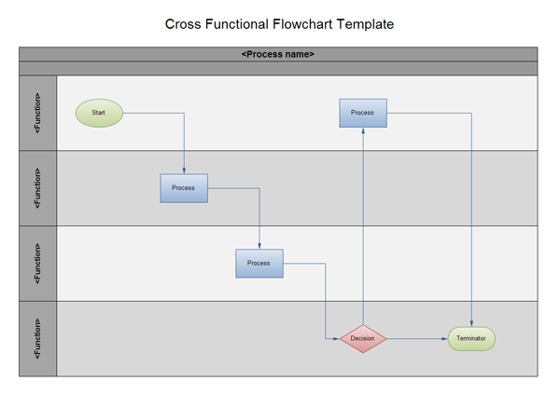

Activity 4
Student Instructions: Your team has been tasked with understanding the impact of implementing a new Radiology Information System (RIS) will have on other departments in a hospital environment. Currently, the Radiology Department does not interact electronically with other applications.

Your team leader as asked you to create a Fishbone Diagram to illustrate the effect of implementing this new Radiology Information System to other departments in the hospital.

1. Contact a Radiology Department in a hospital.
2. State the name of the person and their title that you spoke to.
3. Interview the person and with the information gathered create a Fishbone Diagram.
4. Write a 3 – 5 page report with your findings (include the Fishbone Diagram as one of the pages)

Objective: Use the fishbone diagram problem-solving technique when doing this activity.

Expected Outcome: Use the Radiology Department implementing a new Radiology Information System (RIS). This would be entered in the Problem block of the Fishbone Diagram. The Equipment needed would be entered under the Equipment bone. The Processes would be entered on the Process bone and so on.

Activity 5
Visit a healthcare institution health IT department to obtain an example of a team versus individual project deliverable and responsibilities. Please describe the following in this assignment:

The type of institution you visited,
The project or issue you will provide as an example of both a team project and an individual one,
Your reflection of what you learned from the assignment and 3 take-away points from the activity.

Objective: Differentiate between a team task and an individual task.

Expected Outcome: A 3-5 page paper

