Configuring the EHR
Unit 4: Lab 3 and Exercise 3
Clinical Reminders

This session will focus on providing basic information and hands-on exercises for the Clinical Reminder module within VistA and CPRS. The Clinical Reminder functionality helps caregivers to deliver quality patient care to patients for both preventive health care and management of chronic diseases.

Clinical Reminders assist in the clinical decision-making process by allowing providers to view when specific tests or evaluations were performed and to track and document when care was delivered. The primary goal is to provide relevant information to providers at the Point of Care.

Clinical Reminders are based on age, diagnosis, and other health factor(s). Reminders can also be created for Informational purposes. This session will focus on using Diabetic Clinical Reminders in CPRS.

Clinical Reminder(s) in CPRS

Clinical Reminders will display on the following screens in CPRS:
- Cover Sheet
- Notes Tab
- Reports Tab

CPRS Cover Sheet
Clinical Reminders are displayed on the Cover Sheet. When a user clicks on a specific reminder, details of the specific Clinical Reminder can be viewed from a pop-up window. Reminder definition and reference information will display when the user right-clicks on a specific reminder. See Exhibit 1.
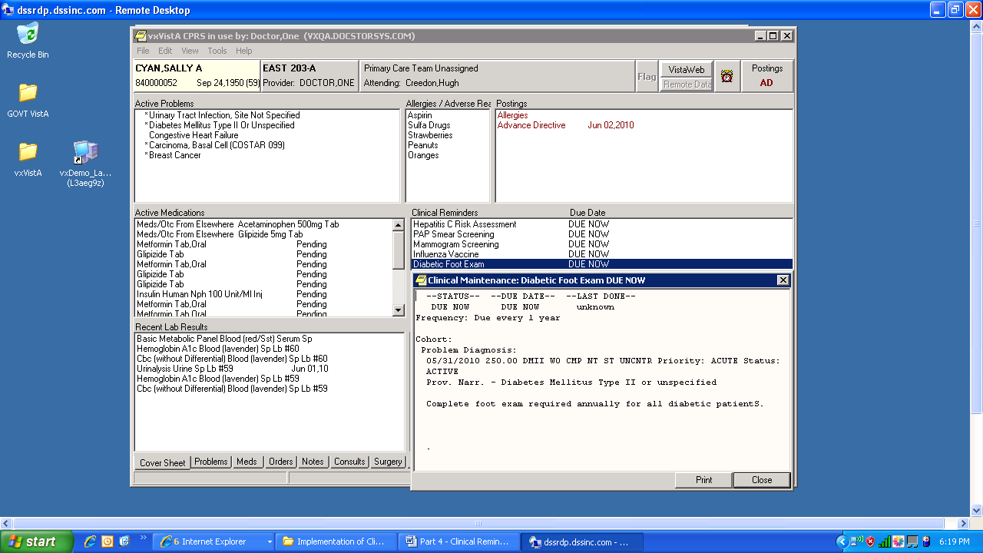

Exhibit 1 – Pop-up Window Displaying Details of Diabetic Clinical Reminder

Notes Tab
When a user selects the Notes tab and opens a new note, a Reminder tab appears (lower left corner). When the user clicks on the Reminder tab, a list of reminders will display. If the user clicks one of the reminders, a dialog window opens; actions are presented to the user to resolve the reminder. See Exhibit 2.

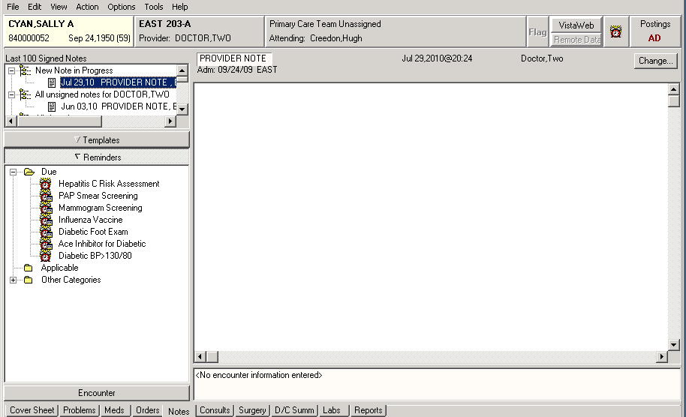
Exhibit 2 – List of Reminders on Notes Tab

Reports Tab
Users can use the Ad Hoc Health Summary functionality to create a report ‘on the fly’ (covered in Unit 5, Lab1 also). The following components are available: Reminders Due, Reminder Brief, Reminder Maintenance, and Reminders Summary. Users can quickly access this information in a report format which can be printed.
To Create an Ad Hoc Report:
- Select a patient (ie. Eight, Patient) and click <OK>
- Select <Reports> tab (at bottom of window)
- Select <Health Summary> (click ‘+’ sign to expand item)
- Select <Adhoc Report>
- Select component(s) and click the <right arrow> to add them to the Component Selection area, i.e. Next of Kin, Advanced Directive, Adverse Reactions/Allergy, Orders Current, Vital Signs, and Pharmacy Unit Dose. Set specific time limits and occurrence limits, as needed.
- Click < OK> (The Health Summary Adhoc Report will display.)

See Exhibit 3.

Note: When a new patient is selected, the report will no longer be available!

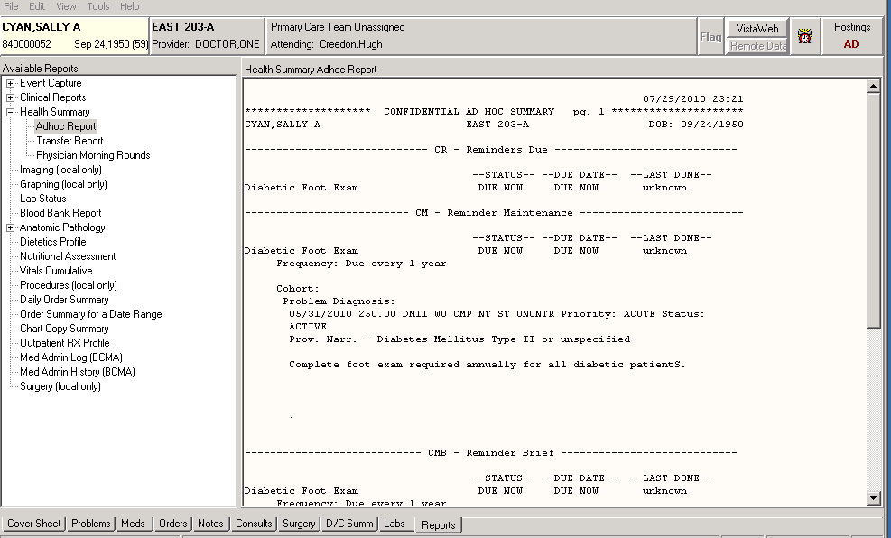
Exhibit 3 – Reminders and Reports Tab – Using Ad hoc Report Functionality

Instructions for Resolving/Processing a Reminder

Reminders can assist clinicians with providing optimal care for patients. For example, patients with diabetes require an annual eye examination (retinal exam).

- Double click on the VistA_Apps folder installed on your desktop.
- Double click the CPRS Chart icon.
- Log on to CPRS using your Clinical Coordinator access and verify codes.
- Select a Patient (try using Eight, Patient), click <OK>.

- Select <Notes>.

- Click <New Note> (bottom left of screen).

- Select ”H&P” (from list) and click <OK>.
- Click <Reminders> (a list of Reminders will display on the bottom left of the screen). Selecting the clock icon at the top right of the screen will bring up a list of reminders.

- Select Diabetic Retinal Exam Reminder. A reminder screen will pop up. (See Exhibit 4) This is an example of a reminder that matches a diagnosis with a test that is appropriate. (<Next> (when available) will take you to more choices and <Finish> will close the screen.)
(Note: Click on the different options to explore the effectiveness of the reminder).

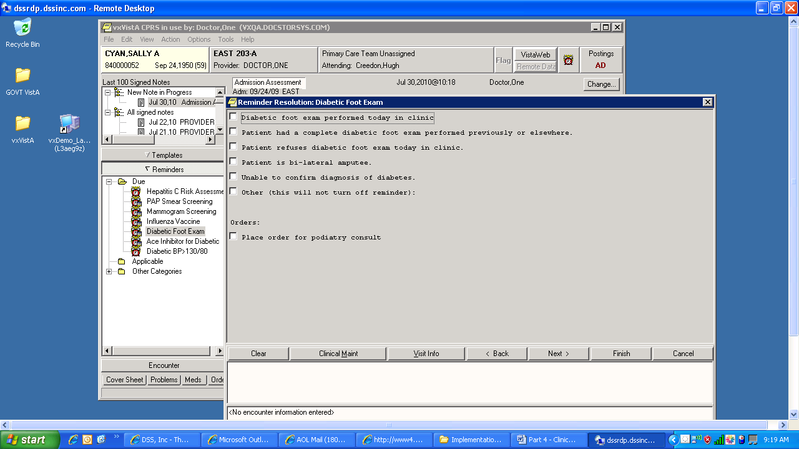

Exhibit 4 – Clinical Reminder Resolution Process

Configuring the EHR
Unit 4: Exercise 3: Clinical Reminders

Log on CPRS as a doctor:
- Double click on the VistA_ Apps folder installed on your desktop.
- Double click the CPRS Chart icon.
- Log on to CPRS Chart using your Doctor access and verify codes.

View Clinical Reminders:
- Open a patient’s record. (Seven, Patient would be a good choice). Click <OK>.
- View Clinical Reminders on Cover Sheet. (Remember – by clicking on a specific reminder the definition will pop up).
- Use Print Screen functionality or another functionality to print the Diabetes related Reminder Definition.
- View Clinical Reminders on Notes Tab.
- Select the Diabetes related note by ZZLABTECH.
- Use Print Screen functionality or another functionality to print information displayed in the dialog window for Diabetes Urinalysis
- (Save in folder to hand in)

Create a Clinical Reminder:
- Access Health Summary reports in CPRS(Reports menu).
- Use Ad Hoc functionality to create a Clinical Reminder report for Diabetes Urinalysis.
- Add the following components: Clinical Reminders Due, Clinical Reminder Brief, Clinical Reminder Maintenance, and Clinical Reminders Summary.
- Use Print Screen functionality or another functionality to print information displayed on report in CPRS. (One option is to select <file> then <print> from the menu. Select Windows printer to print from the desktop).
- (Save in folder to hand in)

