Configuring the EHR
Unit 4: Lab 2 and Exercise 2
Order Checks

This session will focus on providing basic information and a hands-on exercise for Order Checks. Order checking is a component of the Order Entry process. It is based on a system of rules which reviews orders to see if the orders meet defined criteria. If the specific order meets the criteria, an electronic message is transmitted to the ordering provider before the order is completed. Examples are: duplicate order, duplicate drug class order, adverse reaction, and drug-lab interaction. The provider can choose to cancel the order or override the order check by entering a justification and then placing the order.

Order Checks are real-time processes that occur during the placing of an order. Order check messages are displayed during the ordering process. Before orders are transmitted to the Laboratory, Pharmacy and other modules of the EHR, orders are subjected to Order Checking algorithms where the order is evaluated by an expert system rule against data from patient files. If one or more of the rules for the order is met, order check messages are transmitted to the clinician placing the order. For example, if a provider prescribes an antibiotic for a patient, the order is checked to make sure that the patient is not allergic to that medication.

Order Checks can be set as Mandatory order checks. If an Order Check is set as Mandatory, users are not authorized to change the Mandatory status and the order check is available to all appropriate users. Clinical Application Coordinators are given the access to enable Mandatory order checks. If the Order Check is not set as Mandatory, users can remove the Order Check from the list. For example, if the patient has a recorded antibiotic allergy, we do not want to disable an Order Check that would catch this interaction. This session will review the process of users enabling and disabling Order Checks appropriately and viewing the results when a specific Order Check is changed.
___________________________________________________________
Exhibit 1: List of Order Checks

Allergy-contrast Media Interaction
Allergy-Drug Interaction
Aminoglycoside Ordered
Biochem Abnormality for Contrast
Clozapine Appropriateness
Critical Drug Interaction
CT & MRI Physical Limitations
Dangerous Meds for PT > 64
Dispense Drug Not Selected
Duplicate Drug Class Order
Duplicate Drug Order
Duplicate Opioid Medications
Duplicate Order
Error Message
Estimated Creatinine Clearance
Glucophage-Contrast Media
Glucophage-Lab Results
Lab Order Freq Restrictions
Missing Lab Tests for Anglogram
Mp Allergy Assessment
Order Checking Not Available
Polypharmacy
Recent Barium Study
Recent Oral Cholecystorgram
Renal functions Over Age 65
Significant Drug Interaction

Instructions for Users to Enable or Disable Order Checks in CPRS (role: Clinical Coordinators)

- Double click on the VistA_Apps folder installed on your desktop
- Double click the CPRS Chart icon
- Log on to CPRS using your Clinical Coordinator or Doctor Access and Verify codes.
- Select a Patient (or InPatient) and click <OK>
- From the Cover Sheet tab, Select <Tools> from menu bar
- Select <Options>
- Select <Order Checks>
Note: Order Check screen will display

Exhibit 2: CPRS Order Checks

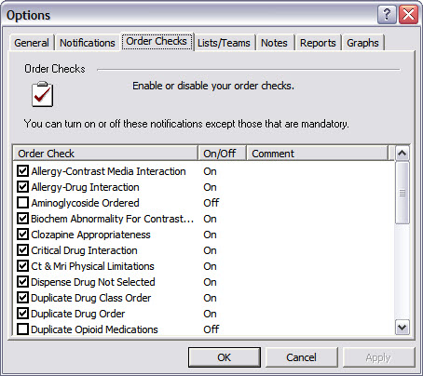

- Users Enable or Disable Order Checks which are not Mandatory by selecting an Order Check or de-selecting the Order Check.

- After you have gone through the Order Check list and made your selections, click <Apply>, then click <OK> (to save the changes).

Instructions for Placing an Inpatient Medication Order(s) (role: Doctor)

- Double click on the VistA_Apps folder installed on your desktop
- Double click the CPRS Chart icon.
- Log on to CPRS using Access and Verify codes of a Doctor.
- Select an Inpatient and click <OK> (An inpatient can be selected by selecting a ward first, and then selecting one of the patients from the ward.)
- Select <Orders> tab (bottom of screen).
- Select <Inpatient Medications> from the Write Orders menu on the LEFT side of the screen.
Note: When medication is entered, the medication will display on Orders tab as an unsigned order.

Note: For Patient Safety purposes, only one user can enter orders on the same patient at the same time; the system will automatically generate an alert displaying the current user placing orders as shown in Exhibit 3.

Exhibit 3 – Ordering Functionality in CPRS (Your screenshot may look different, based on prior interactions with VistA)
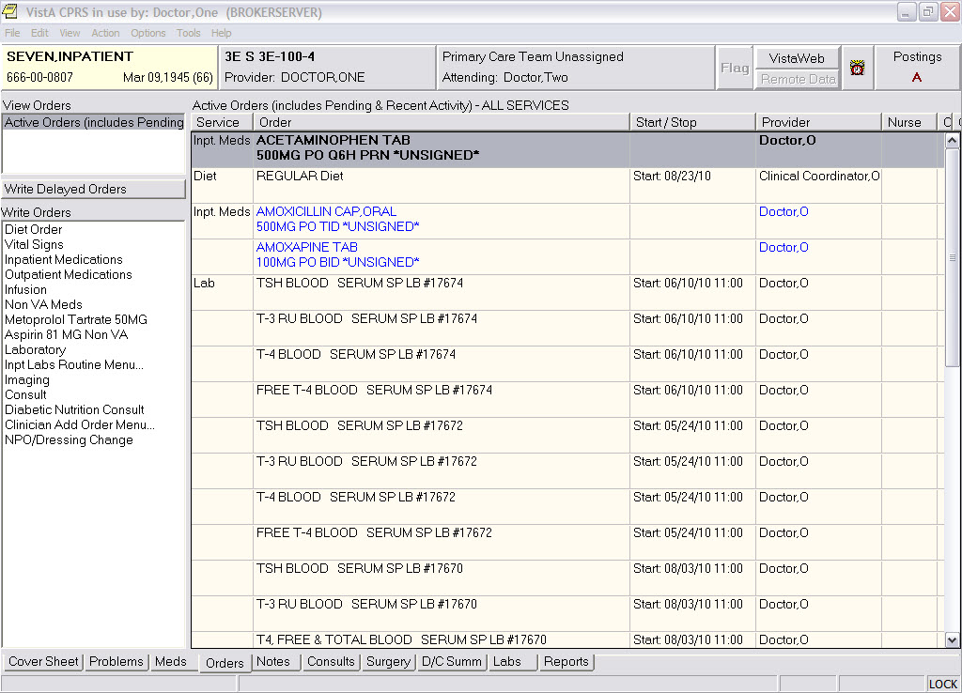

- Select a medication from the Medication Order window that appears.
- <Accept Order> and then <Quit> when you are finished selecting medications.
- Select <File><Exit>.
- A screen will appear where the electronic signature can be entered or the order can be cancelled.
- Feel free to repeat the process of selecting different medications to get a feel for how the functionality works. Keep in mind that different medications have different parameters for prescribing.

Configuring the EHR
Unit 4: Exercise 2: Order Checks

Log into CPRS as a doctor:
- Double click on the VistA_ Apps folder installed on your desktop.
- Double click the CPRS Chart icon.
- Log on to CPRS Chart using your Doctor Access and Verify codes.

Configure and Test Order Checks:
- Select an Inpatient.
- Review Order Checks
- Enable - Duplicate Drug Order (if this order check is not enabled).
- Place two separate orders for Glipizide Tab. Check the inpatient medication menu to see if it is available. If not, you will have to order from the outpatient medication menu.
- Use Print Screen functionality or another functionality to print Order Check message in CPRS.
- Do Not Process orders – Cancel/Discontinue orders.
- Select an Inpatient. (Nine, Patient is a good one to work with as he has a good selection of associated clinical information).
- Place an Inpatient order for a multivitamin injection from Inpatient Medication menu item.
- Use Print Screen functionality or another functionality to print Order Check message(s) in CPRS.

