Configuring the EHR
Unit 4: Lab 1 and Exercise 1
Alerts/Notifications

This session will focus on providing basic information and hands-on exercises related to alerts/notifications. The Alerts/Notifications components in CPRS generate clinical alerts/notifications regarding patient information from packages such as Laboratory, CPRS, and Consults. Alerts/notifications furnish providers with timely feedback regarding clinical events such as medication interactions, abnormal laboratory results, communication from other providers or patients, or medical orders that need to be signed by the provider.

Some alerts/notifications allow the user to perform a follow-up action while other alerts/notifications are displayed as Informational alerts/notifications. Informational alerts/notifications will disappear after the alert is viewed. Alerts/notifications which require follow-up action will not be removed until action is taken.

Alerts/notifications can be set as Mandatory alerts/notifications. If an Alert/notification is set as Mandatory, users are not authorized to change the Mandatory status and the alert/notification is available to all appropriate users. Clinical Application Coordinators and Doctors are given the access to turn on Mandatory alerts/notifications. If the Alert/Notification is not set as Mandatory, users can turn off the Alert/notification from the list. This session will review the process of users turning on and turning off Alerts/notifications appropriately and viewing the results when a specific Alert/notification is turned off.

Instructions for Users to Turn on and Turn off Notifications in CPRS

- Double click on the VistA_Apps folder installed on your desktop.
- Double click the CPRS Chart icon.
- Log on to CPRS using your Doctor access and verify codes provided by your instructor.

Note: Patient Selection screen will display as per Exhibit 1 below.
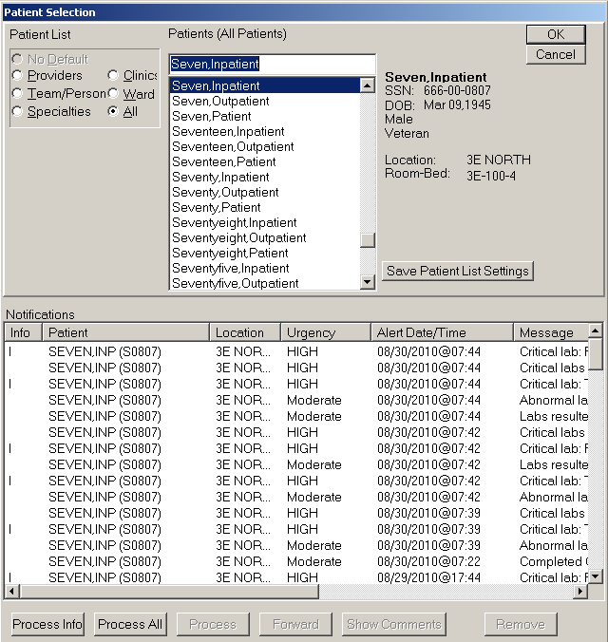
Exhibit 1: Patient Selection Screen

- Select a patient or inpatient and click <OK>.

- From the Coversheet tab, Select <Tools> from menu bar.
- Select <Options>.
Select <Notifications>

Note: Notifications screen will display as per Exhibit 2 below.
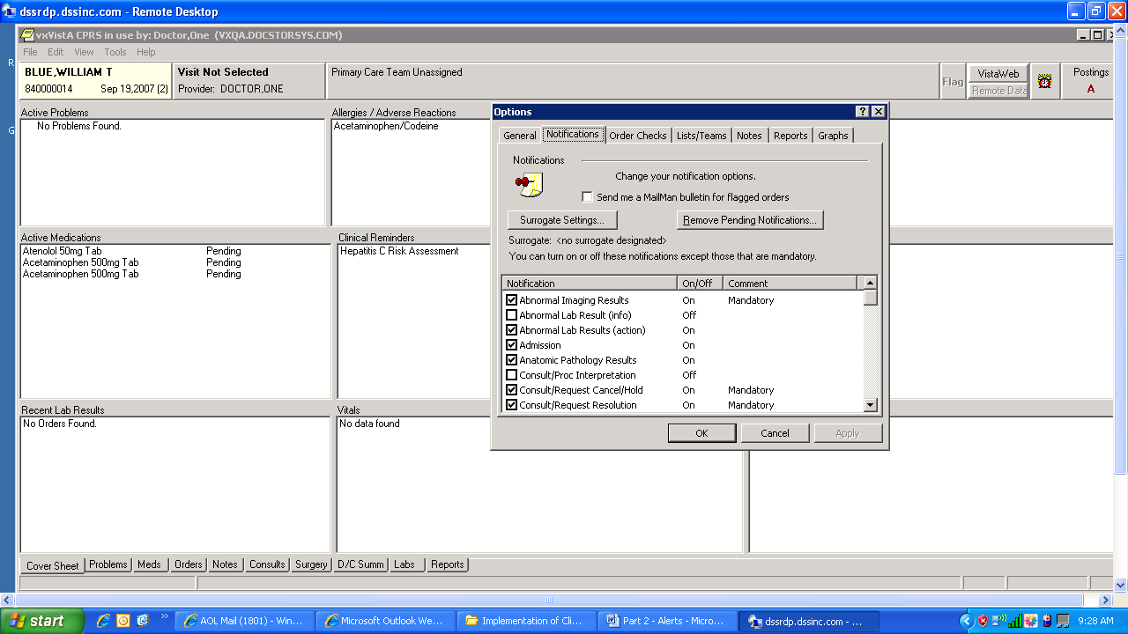

Exhibit 2: CPRS Notifications

8. You may Turn On or Turn Off Notifications that are not mandatory by selecting a Notification or de-selecting the Notification.
9. Click <Apply> and then <OK> (to save your changes).

Review the Notifications for Users:
- Select a new patient or inpatient: click <File> <Select New Patient>.
- The Patient Selection Screen appears. DO NOT CLICK “OK” -- double click on a patient. Notifications are listed at bottom of Screen for all patients. Note: this screen will look the same for Clinical Coordinators and Doctors.
Alerts/notifications typically appear on the screen to notify the provider. Too many alerts/notifications can be distracting. The notification screen allows providers to select the quality and quantity of notifications they receive. For example, providers may want drug-drug interaction alerts/notifications to be enabled all the time because they are important. They might not want “Flagged OI order-Inpt” selected if they are outpatient providers, since this is an inpatient notification.
- Try selecting a different patient if the one you selected does not have any notifications.

- Highlight a notification and click on “Process”

Exhibit 3: Select Paticent Screen with Notifications
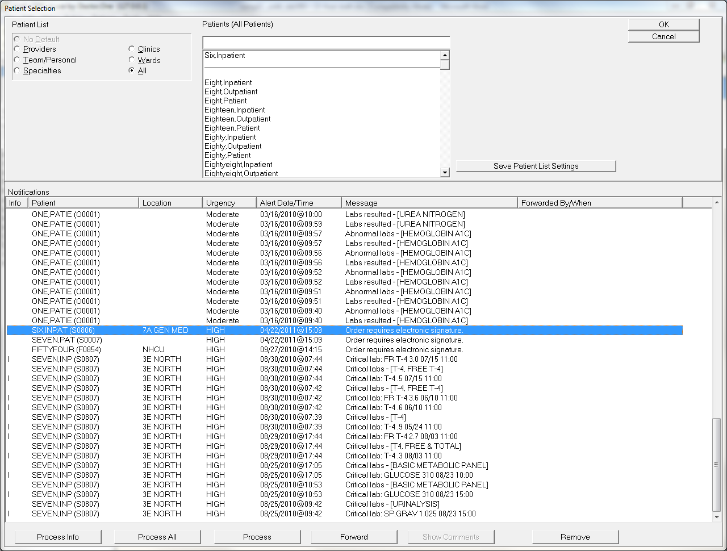

Exhibit 4: Processing Screen for unsigned lab order
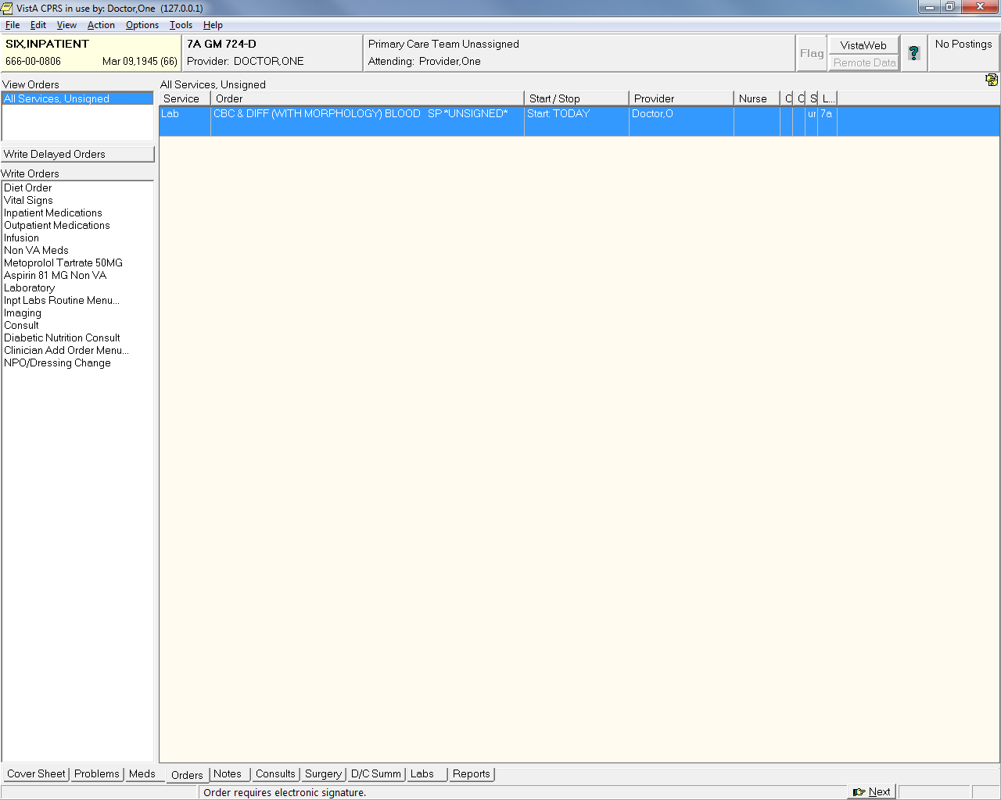
___________________________________________________________________
Exhibit 1 – List of Notifications in CPRS

Abnormal Imaging Results
Abnormal Lab Result (Info)
Abnormal Lab Results (Action Required)
Admission
Anatomic Pathology Results
Consult/Procedure Interpretation
Consult/Request Cancel/Hold
Consult/Request Resolution
Consult/Request Updated
Critical lab Result (Info)
Critical Lab Results (Action Required)
DC Order
Deceased Patient
Discharge
DNR Expiring
Error Message
Flag Order for Clarification
Flagged OI Expiring – Inpt
Flagged OI Expiring – Outpt
Flagged OI Order – Inpt
Flagged OI Order – Outpt
Flagged OI Results – Inpt
Flagged OI Results – Outpt
Food/Drug Interaction
Free Text
Imaging Patient Examined
Imaging Request Cancel/Held
Imaging Request Changed
Imaging Results
Imaging Results Amended
Lab Order Canceled
Lab Results
Lab Threshold Exceeded
Mammogram Results
Medications Expiring – Inpt
Medications Expiring – Outpt
New Order
New Service Consult/Request
NPO Diet More Than 72 Hrs
Order Check
Order Requires Chart Signature
Order Requires Co-Signature
Order Requires Electronic Signature
Orderer-Flagged Results
Pap Smear Results
Service Order Req Chart Sign
Stat Imaging Request
Stat Order
Stat Results
Transfer from Psychiatry
Unscheduled Visit
Unverified Medication Order
Unverified Order
Urgent Imaging Request

Configuring the EHR
Unit 4: Exercise 1: Alerts/Notifications

Log into CPRS as a doctor:
- Double click on the VistA_ Apps folder installed on your desktop.
- Double click the CPRS Chart icon.
- Log on to CPRS Chart using your Doctor access and verify codes.

Select a patient and check on Notifications:
- Select an inpatient (Seven, Inpatient for example).
- Review Listing of Notifications Turned On and Turned Off.
- Check to see if “Order Requires Electronic Signature” is turned on.
- Click on <Orders> tab
- Click on “Laboratory in the Write Orders menu (on the left)
- Select “CBC & DIFF (WITH MORPHOLOGY)” from the list of Available Lab Test
- Click “Accept Order”
- Click “Quit”
- Select a New Patient (Select File, Select New Patient).
- Do Not Sign Lab Order.
- Use Print Screen functionality or another functionality to print Alert/Notification as shown on Patient Selection Screen in CPRS.

(Save printout in your work file)

Process a Notification:
- Bring up the notifications by going to the patient selection screen.
- Select the notification generated for – Order Requires Electronic Signature for the Inpatient selected in the previous exercise.
Note: Electronic signatures can be signed by typing in “DOCTORX” (where X is the number of the id you are using e.g. DOCTOR9 – all capitals)
- Process the notification (at bottom of screen) or right click on the notification
- Use Print Screen functionality or another functionality to print steps taken to process Alert/Notification. (One can also select <file> then <print> from the menu. Select Windows printer to print from the desktop).

(Save printout in your work file)

Experiment with turning notifications on/off and processing them. What happens when you process the notifications?

