Component 7/Unit 7
Application Activity with Answer Keys

Complete the step-by-step activity outlined below, which has you complete certain tasks using the CPRS system. As you complete the activity, pay attention to features or functions that have been implemented that are examples of safeguards covered in the unit presentation. Describe the safeguard(s) that you observe in the space provided. In some cases you are also asked specific questions about what safeguards could be considered to improve the security of the system, related to the particularly activity.

Objective: Explain and illustrate privacy, security, and confidentiality in HIT settings.

CPRS Activity:

- Launch CPRS Chart. 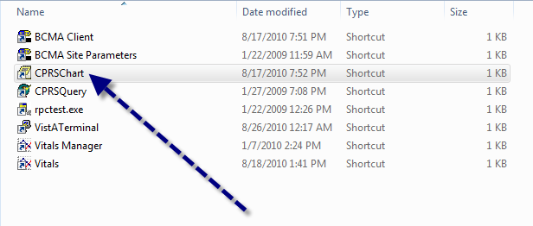Make note of any security features you see on the login screen. Login using the access code "DOCTOR1" (the access, verify, and electronic signature codes for all accounts should have been provided to you by the instructor), but purposefully type the wrong verify code. Attempt to log into the system using the same access code but a wrong verify code 5 times. 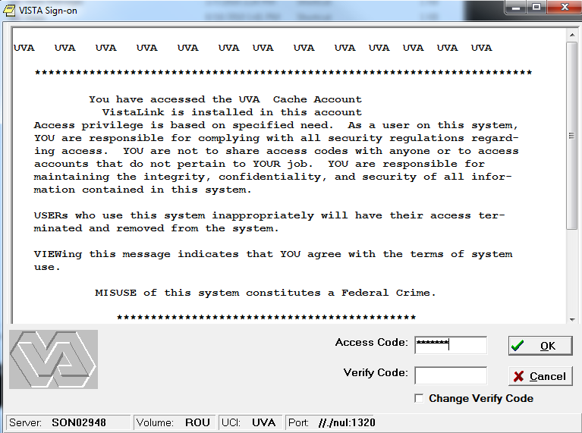
Safeguard(s) observed:

Answer: Login screen includes notice of user responsibility for ensuring the security and confidentiality of user information contained in the system. Access code and verify code are masked using asterisks to prevent an unauthorized user from being able to see the codes. Incorrect verify code displays a warning, and after 5 failed attempts the application is shut down with an error indicating that the account/workstation is locked out.
- Log in to CPRSChart using “DOCTOR1”, but this time provide the correct password. 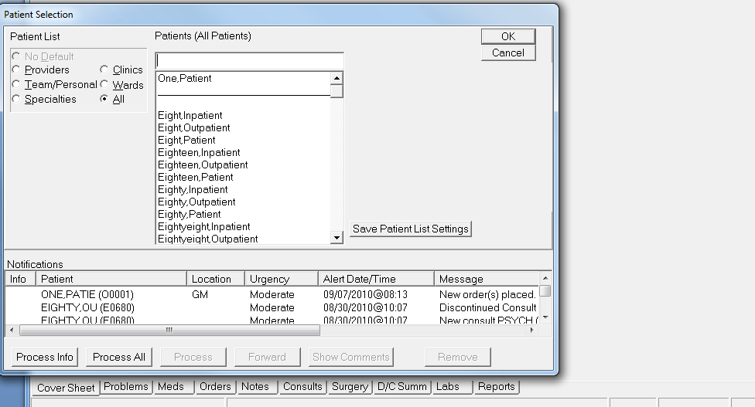
Suppose this is the first time that “Doctor,One” has logged into the system. What additional safeguards could be put into place to improve the security of the login function?
Answer: A user logging into the system for the first time could be prompted to immediately change the verify code. The function to change the verify code could be configured to enforce a strong password requirement (e.g., a password at least 8 characters long, using a mix of alphanumeric and numeric characters, etc.). Two-factor authentication could also be employed, requiring a smart card, biometric device, or other form of authentication in addition to the verify code.
- After logging in, select “Fifty,Patient”. Click the Orders tab. 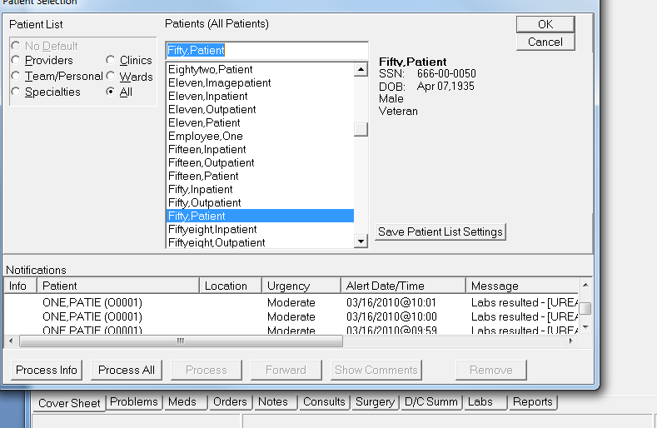 Under Write Orders, click “Laboratory.” When prompted for “Location for Current Activities” choose the first clinic appointment listed and click “OK”. In the list of Available Lab Tests, type “urinalysis” or scroll to this in the list, then click on “URINALYSIS”. Accept the default options by clicking the “Accept Order” button. The new order should now show up in the list of orders highlighted as “UNSIGNED”. Click on the order to select it, then right click on the order and choose “Sign…” Sign the order with the electronic signature code for DOCTOR1 (provided to you by your instructor, most likely this is “DOCTOR1” and is case sensitive).
Safeguard(s) observed:
Answer: Additional authentication required for critical tasks (electronic signature code).

- Shut down CPRS. Restart CPRS, and log in as “CLINCOORD1”. Open up the chart for “Fifty,Patient”. Click the “Meds” tab, click “Action” in the menu bar and then click “New Medication…” If prompted for “Location for Current Activities” choose the first clinic appointment listed and click “OK”. Note the message you receive.
Safeguard(s) observed: ____________________________________

Answer: Access to functions in the system defined based on role. CLINCOORD1 does not have the ability to order medications (message is “ONE CLINCAL COORDINATOR is not authorized to write medication orders”).

- 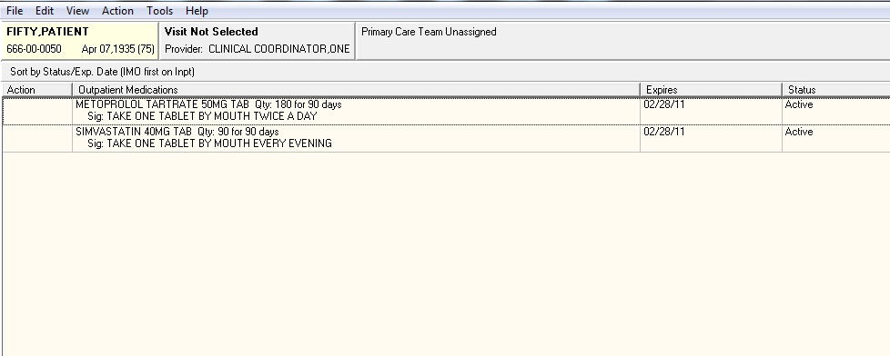

- While still logged in as CLINCOORD1, click on the “Notes” tab for “Fifty,Patient”. Click on the signed note dated September 29, 2010. What text is contained in the body of this note?

Answer: The note for “Fifty,Patient” is not viewable by CLINCOORD1. The body of the note says, “You may not VIEW this COMPLETED MENTAL HEALTH NOTE.”

- Shut down CPRS. Restart CPRS and log in as “DOCTOR1” and select “Fifty,Patient”. Click on the “Notes” tab. Click on the signed note dated September 29, 2010 (same note you viewed in step 5 as CLINCOORD1). What test is contained in the body of this note? Does it differ from what you saw in step 5? What could account for the discrepancy/what privacy safeguard does this demonstrate?

Answer: The note for “Fifty,Patient” contains results for a mental health assessment. This content of the note was hidden from CLINCOORD1, so the note differs from what was seen in step 5. The note contains especially sensitive information about the patient’s mental health, so was configured to be viewable only by a subset of users in the VistA system, and consequently could not be viewed by the user “CLINCOORD1”. This demonstrates the ability of the system to restrict access to information to specific users or types of users, safeguarding the privacy of particularly sensitive patient information.

