Configuring the EHR
Lab 1: Alerts/Notifications

This session will focus on providing basic information and hands-on exercises related to alerts/notifications. The Alerts/Notifications components in CPRS generate clinical alerts regarding patient information from packages such as Laboratory, CPRS, and Consults. Alerts furnish providers with timely feedback regarding clinical events.

Some alerts allow the user to perform a follow-up action while other alerts are displayed as Informational alerts. Informational alerts will disappear after the alert is viewed. Alerts which require follow-up action will not be removed until action is taken.

Alerts can be set as Mandatory alerts/notifications. If an Alert is set as Mandatory, users are not authorized to change the Mandatory status and the alert is available to all appropriate users. Clinical Application Coordinators are given the access to turn on Mandatory alerts. If the Alert is not set as Mandatory, users can turn off the Alert from the list. This session will review the process of users turning on and turning off Alerts appropriately and viewing the results when a specific Alert is turned off.

Instructions for Users to Turn on and Turn off Notifications in CPRS

- Double click on the Vista Applications folder installed on your desktop.
- Double click the CPRS Chart icon.
- Log on to CPRS using your Clinical Coordinator access and verify codes.
- Select a patient and click <OK>.
- From Coversheet tab, Select <Tools> from menu bar.
- Select <Options>.
- Select <Notifications>.

Note: Notifications screen will display as per Exhibit 2 below.
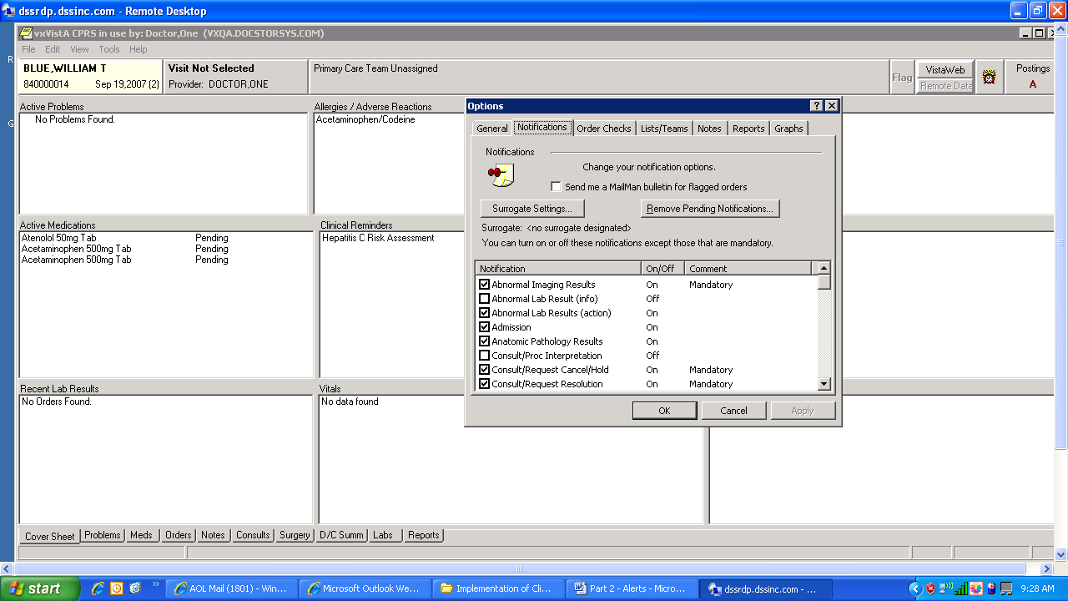

Exhibit 2 –CPRS Notifications

6. Users can Turn On or Turn Off Notifications which are not mandatory by selecting a Notification or de-selecting the Notification.
7. Click <Apply> and then <OK> (to save the changes).

Review the Notifications for Users:
- Double click on the Vista Applications folder installed on your desktop.
- Double click the CPRS Chart icon.
- Log on to CPRS using the access and verify codes for a Doctor.
- Patient Selection Screen – Notifications are listed at bottom of Screen for all patients. If the patient you selected required notification for any of the items selected, s/he will be listed with the appropriate notification. You will notice that some patients have multiple notifications. Try selecting a different patient if the one you selected does not have any notifications.

___________________________________________________________________
Exhibit 1 – List of Notifications in CPRS

Abnormal Imaging Results
Abnormal Lab Result (Info)
Abnormal Lab Results (Action Required)
Admission
Anatomic Pathology Results
Consult/Procedure Interpretation
Consult/Request Cancel/Hold
Consult/Request Resolution
Consult/Request Updated
Critical lab Result (Info)
Critical Lab Results (Action Required)
DC Order
Deceased Patient
Discharge
DNR Expiring
Error Message
Flag Order for Clarification
Flagged OI Expiring – Inpt
Flagged OI Expiring – Outpt
Flagged OI Order – Inpt
Flagged OI Order – Outpt
Flagged OI Results – Inpt
Flagged OI Results – Outpt
Food/Drug Interaction
Free Text
Imaging Patient Examined
Imaging Request Cancel/Held
Imaging Request Changed
Imaging Results
Imaging Results Amended
Lab Order Canceled
Lab Results
Lab Threshold Exceeded
Mammogram Results
Medications Expiring – Inpt
Medications Expiring – Outpt
New Order
New Service Consult/Request
NPO Diet More Than 72 Hrs
Order Check
Order Requires Chart Signature
Order Requires Co-Signature
Order Requires Electronic Signature
Orderer-Flagged Results
Pap Smear Results
Service Order Req Chart Sign
Stat Imaging Request
Stat Order
Stat Results
Transfer from Psychiatry
Unscheduled Visit
Unverified Medication Order
Unverified Order
Urgent Imaging Request

