Configuring the EHR
Lab 2: Shared Template(s)

This session will focus on creating Shared Templates. Access to the Shared Template functionality is limited to Clinical Application Coordinators (CAC). The previous lab (Document Template: Instructions for Providing Access to Template Editor) provided the necessary instructions for acquiring appropriate access to create and maintain Shared Template(s) using Template Editor.

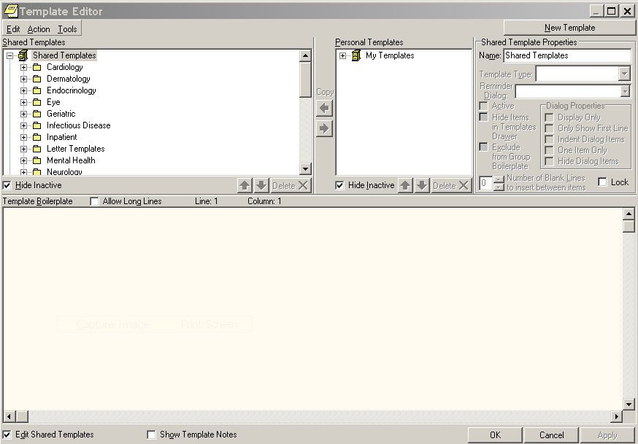
Exhibit 1 – Template Editor View of Shared Templates List

Shared Templates in CPRS are available to all users. This functionality streamlines the documentation process. As the clinician is entering documentation, a specific Shared Template can be selected and inserted as shown in Exhibit 2.

Exhibit 2 – List of Shared Templates Available for Users in CPRS
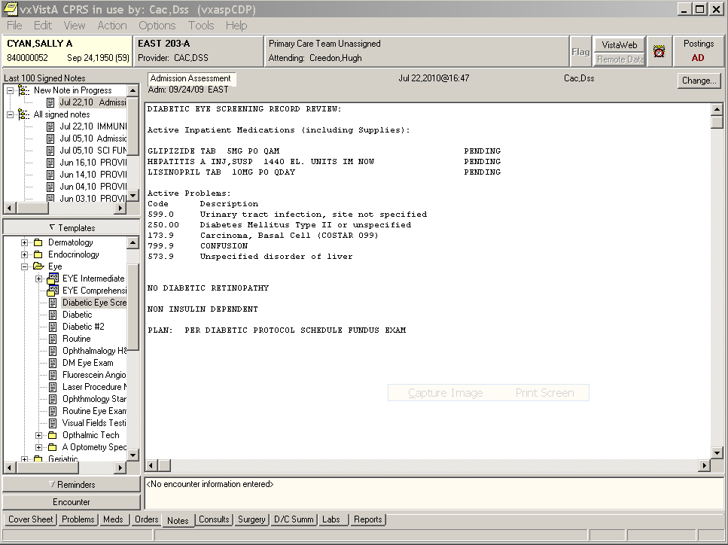

Instructions for Creating Shared Template(s)
- Double click on the Vista Applications folder installed on your desktop
- Double click the CPRS Chart icon
- Log on to CPRS Chart using your Clinical Coordinator access and verify codes.
- Select a patient and click <OK>.
- Select <Notes> (bottom tab)
- Start the Template Editor by selecting <Options> (from top menu bar)
- Select <Edit Shared Templates> option
- Highlight “Shared Template” item
- Click <New Template> (top right)
- Enter New Template name in ‘Name: _____ box’ and click <Apply>.

NOTES: You are now ready to enter the body of the template using text, patient data objects and template fields, including the fields you created! As you are entering information, remember to click <Apply> so that your information will be saved and updated during the entry process.

You can type in text, add Template Fields, and/or add Patient Data Objects. Right click mouse to access Template fields and Patient Data Objects or go to the edit menu and choose “insert patient objects” or “insert template fields”. You can also manipulate objects in the template using the standards of “control + x” to cut, “control + c” to copy and “control + V” to paste.

