Failure: The Backdoor to Success….

Life = Risk -- Motivation
http://www.youtube.com/watch?v=0yetHqWODp0

DEFINING FAILURE

a : _______________________________ b : a failing in business : bankruptcy

a : a falling short : ____________________ <a crop failure> b : deterioration, decay

: one that has failed

http://www.merriam-webster.com/dictionary/failure

How we Define Failure

Failing a class.

Failed Marriage

Being fired from a job

Your business fails

Feeling a failure as a parent

Failing in a relationship

Not having “enough” wealth

Not reaching your goals

Not having an expected

outcome

Defining SUCCESS

a : degree or ____________________________________ b : favorable or desired outcome; also : the attainment of wealth, favor, or eminence

: one that succeeds

What standards measure success?

____________________________: Under what perspective do we see the actual issue?

______________________________: By what gauge are we using to measure success?

__________________________: What ability and motivation are we giving to achieve the outcome?

______________________: By who’s standards are we calculating the outcome?

___________: Are we willing ourselves to achieve the outcome or is this controlled by someone else?

____________________: Do we have motivation to achieve the outcome?

Where is YOUR focus?

Getting Perspective:

Maybe you’re ______________________________________ else.

Maybe you’re not happy because you just haven’t found the right job fit.

Maybe you are ________________________ for something that isn't’ your fault.

Maybe your ____________________________________________________________…

Maybe ____________________________________ or skill or will power.

Maybe you _____________________________ because it just doesn’t work for you.

Maybe you ____________________________________ with yourself or others about what you want vs. what they want.

Maybe you ___________________________________ because it wasn’t yours to being with?

Maybe the thing the your want actually requires God-given talent, and you don’t have it. Maybe you haven’t discovered what yours is yet!

Maybe your heart just isn’t in it? …And it doesn’t feel right!

Maybe you need to ____________________________________________________ and _________________________________ with those in your life!!!

Questions?

As for “failure,” to what degree are you going to let this have an effect on your life?

To what degree are you going to measure happiness and success?

To what degree are you willing to stop trying to please everyone else in your life and start LIVING your life as you were intended to live it?

Don't aim for success if you want it; just do what you love and believe in, and it will come naturally.
David Frost
Reality Check….

Everyone goes through struggles…

Everyone will fail at something…

Everyone will find difficulty in life at one point or another…

Everyone will know, to a certain degree what it is like to lose something precious…

Because you are human, you must run the race…

Good Quotes to take with you…

“I honestly think it is better to be a failure at something you love than to be a success at something you __________. “

George Burns
“________________________________ from failures. Discouragement and failure are two of the surest stepping stones to success.
Dale Carnegie

“but I’m not good enough…” Taking a bite out of the original pity party!

I DON’T HAVE WHAT IT TAKES…

REALLY?

Two Book Recommendations:
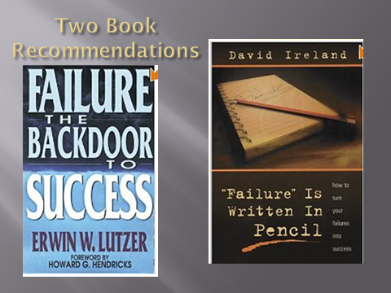

Good Quotes to take with you…

Success _____________________________. It seduces smart people into thinking they can't lose.
Bill Gates

Success is getting what you want. Happiness ______________________________________.
Dale Carnegie

“If failure is the back door to success, try the back door!”

Nancy Holland

