BA 33 Chapter 6 Notes

Understanding Behavior,
Human Relations, and Performance

Conflict

When two or more parties are in disagreement.

It can harm productivity

It can harm creativity

Sources of Conflict:

Personal _________________

Information

Different ____________________

_________________________ Factors

Passive, Assertive, and Aggressive Behaviors:

Passive: (Nonassertive) use self-limiting qualifying expressions _________________ stating their position/needs. “Wall-flowers”

Assertive: (______________________________ without violating others’)

Assertive/Aggressive: A combination of being __________________________, violent or vicious in their attempt to “get what they want.”

Aggressive speakers (______________________________________using “you messages” and absolutes)

Passive-aggressive (speakers may _________________________________________, may switch immediately after the situation, or may build hostility while behaving passively)

Article from FINS Finance

Ten Ways to Keep from Flipping Out

Pick up on the Signs

_____________ Ignore it

_____ Someplace Else

Don't Completely ____________

_______________ of the Keyboard

Be __________________, Not Aggressive

Consider Your ________________________

_______________ on it

Distract your mind with something else…

Transactional Analysis (I)

Transactional analysis (TA): a method of understanding behavior in interpersonal dynamics.

The __________ ego states

Parent

___________________ parent

____________________parent

Child

________________ child

________________child

Adult

The three types of transactions

C___________________________

C____________________________

U____________________________

Adapted Child

Terrible “2’s”

When you behave and respond with confronting, advising responses:

Rebelliousness

Pouting

Childish/Unfounded Anger

Fear

Anxiety

Inadequacy

Procrastination

Finger-Pointing

Blame

Jealousy

Mockery

Transactional Analysis (II)

Complementary transaction

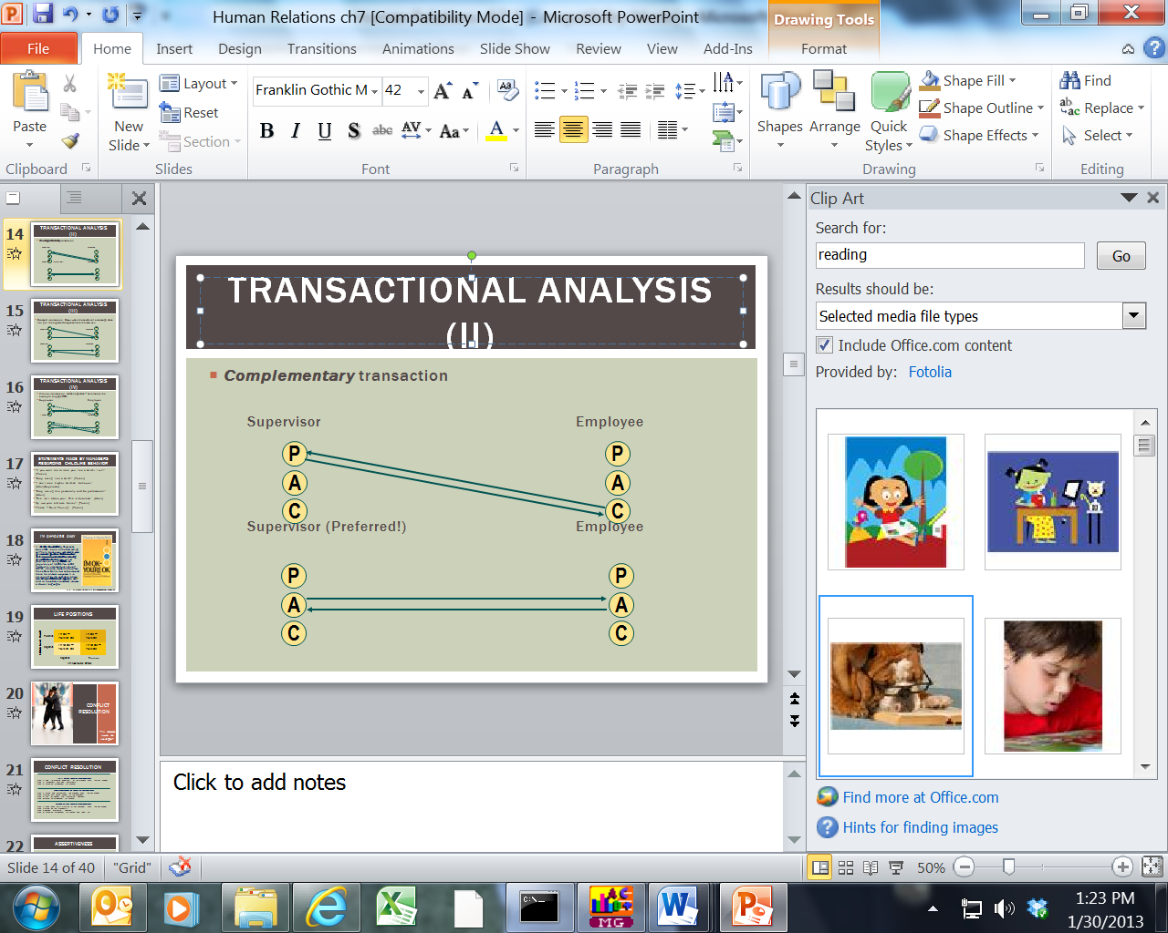

Transactional Analysis (III)

Crossed transaction: Occur when the sender of a message does not get the expected response from the receiver.

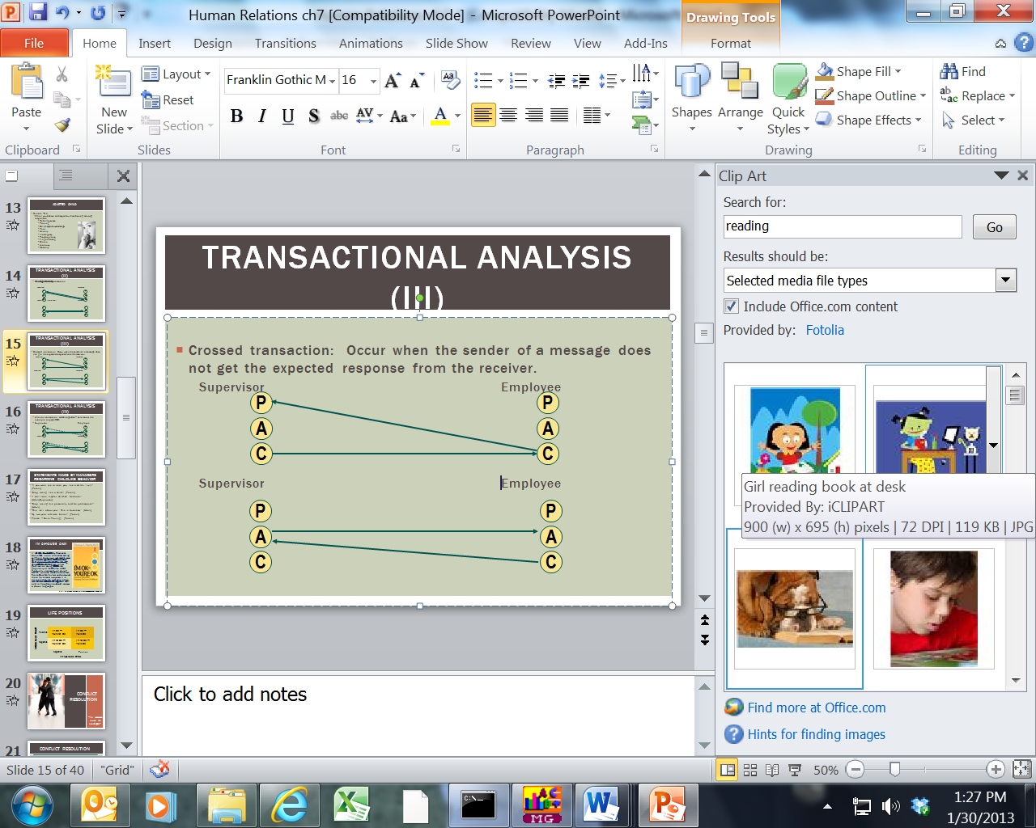

Transactional Analysis (IV)

Ulterior transaction: Hidden agendas – Lets look at the example on page 200.

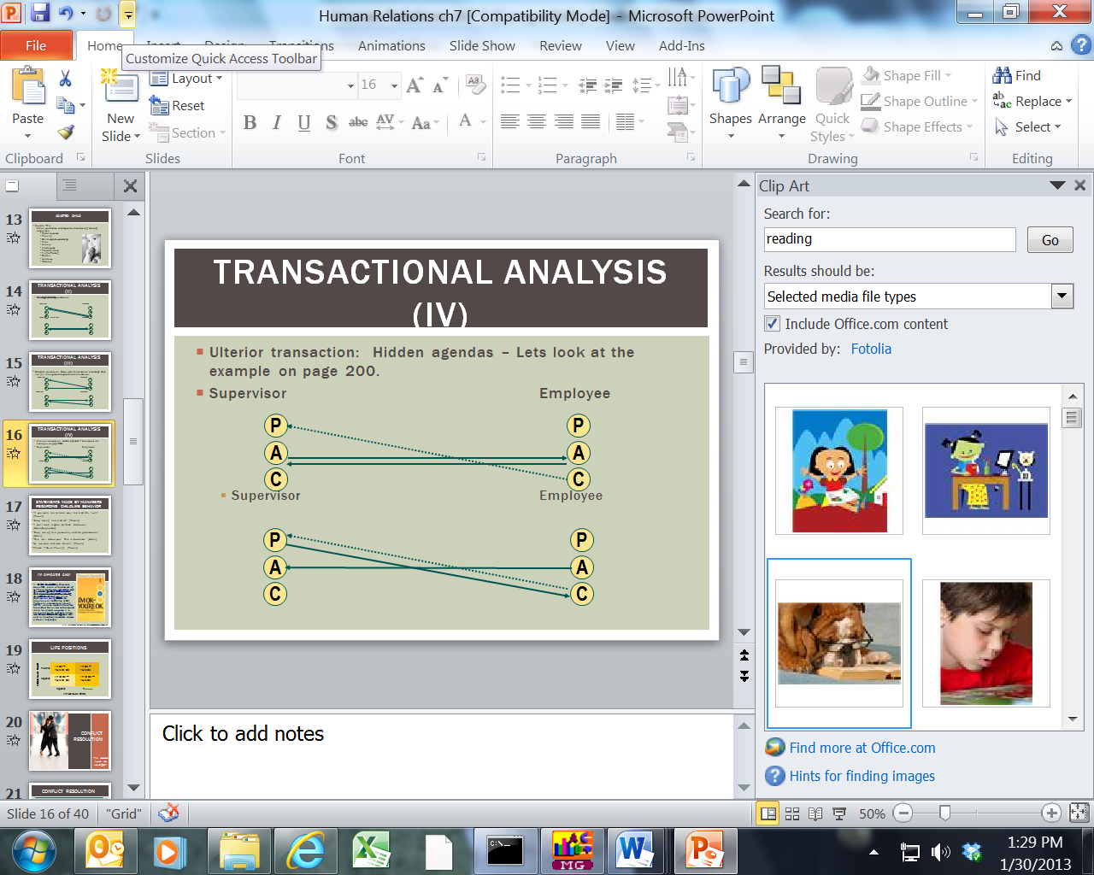

Statements Made by Managers regarding Childlike Behavior

“If you want me to treat you like a child… I will!” (Parent)

“Stop acting like a child!” (Parent)

“I can’t take his/her childish behavior.” (Adult/Supervisor)

“Stop taking this personally and be professional!” (Adult)

“This isn’t about you! This is business.” (Adult)

My two year old acts better!” (Parent)

Please – Quite Pouting! (Parent)

I’m Ok-You’re Okay (Book)

Life Positions
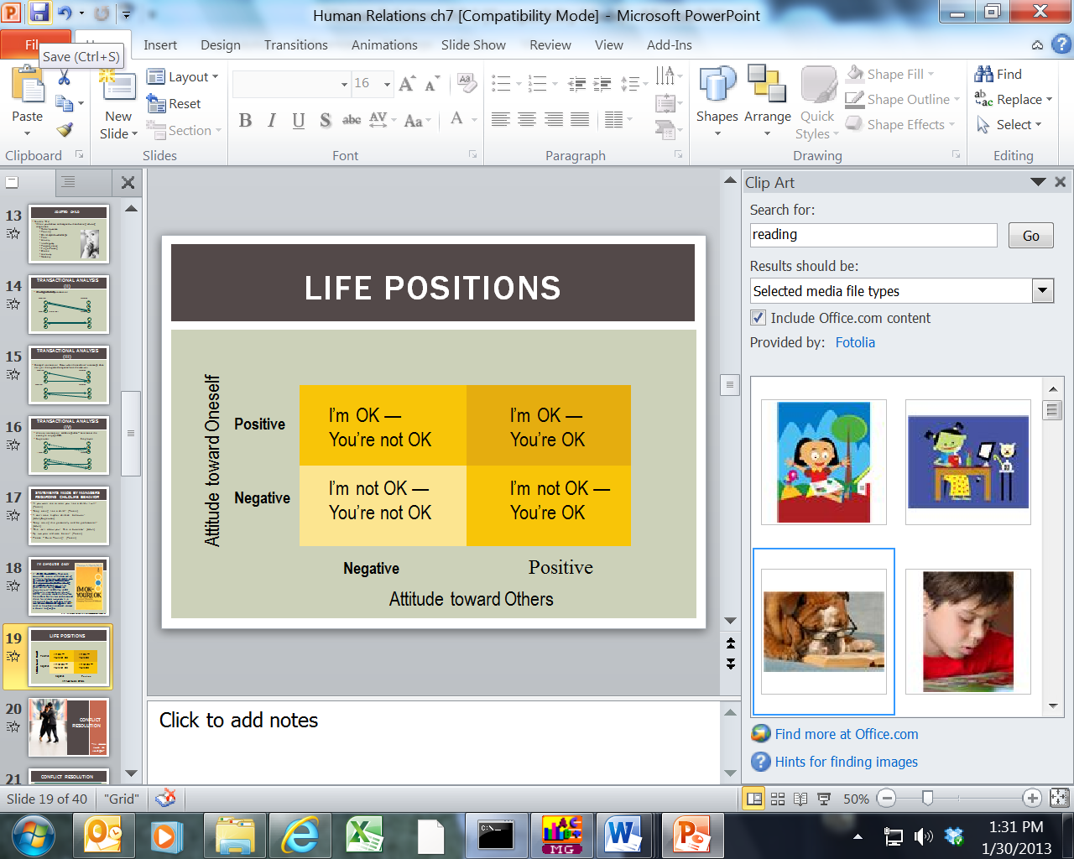

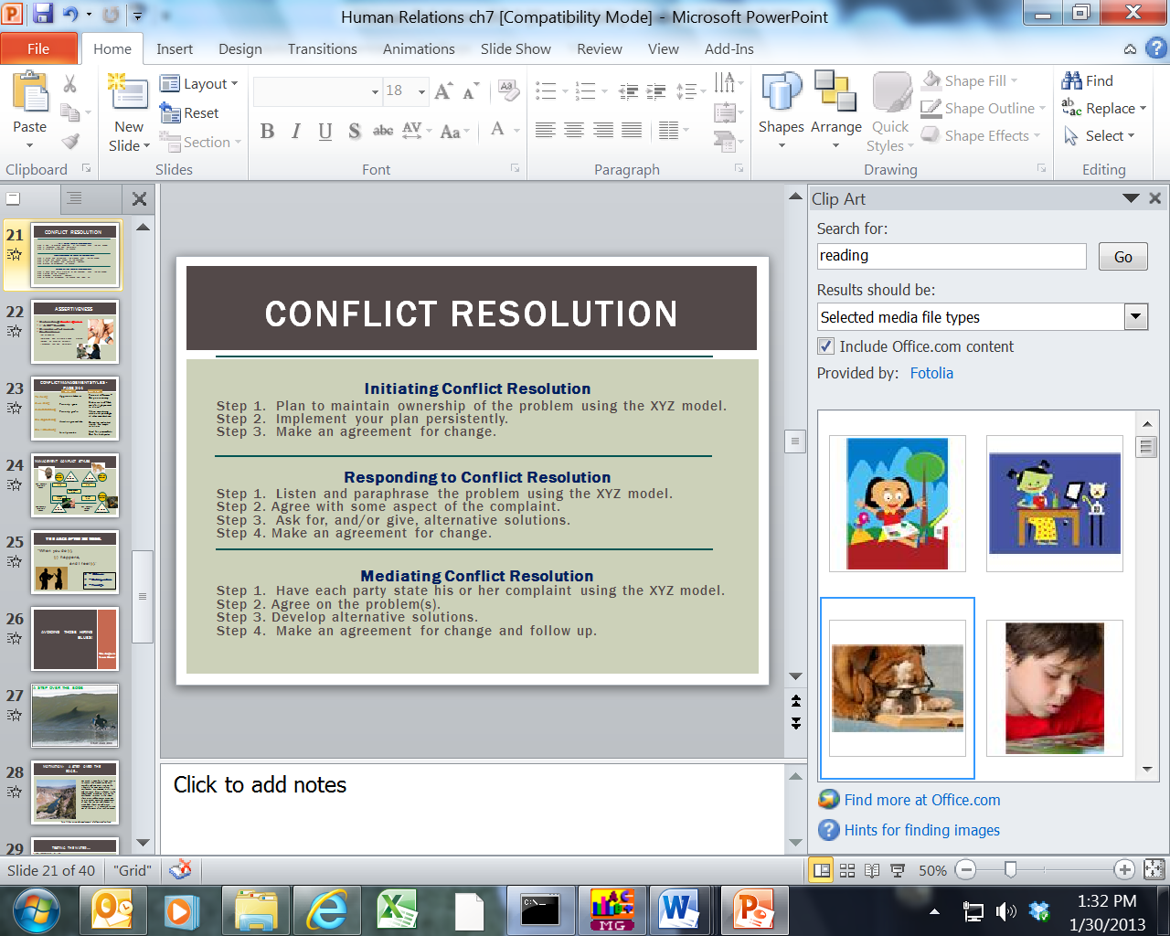

“It takes two to tango!”

Conflict Resolution

ASSERTIVENESS

Comes through the adult ego state

I’m OK — You’re OK.

Creates a win-win situation.

To be assertive:

Set an __________________

Determine how to create a ________________ situation.

Develop an ______________________(s).

Implement your plan persistently.

Conflict Management Styles -Page 244

Management Conflict Styles
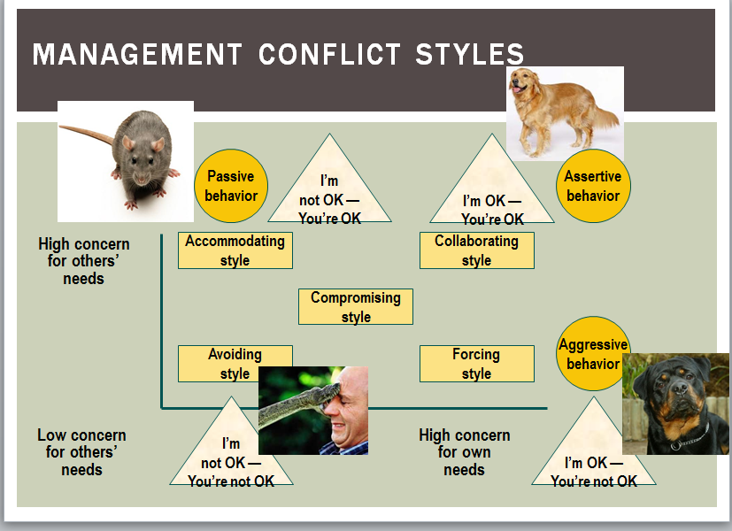

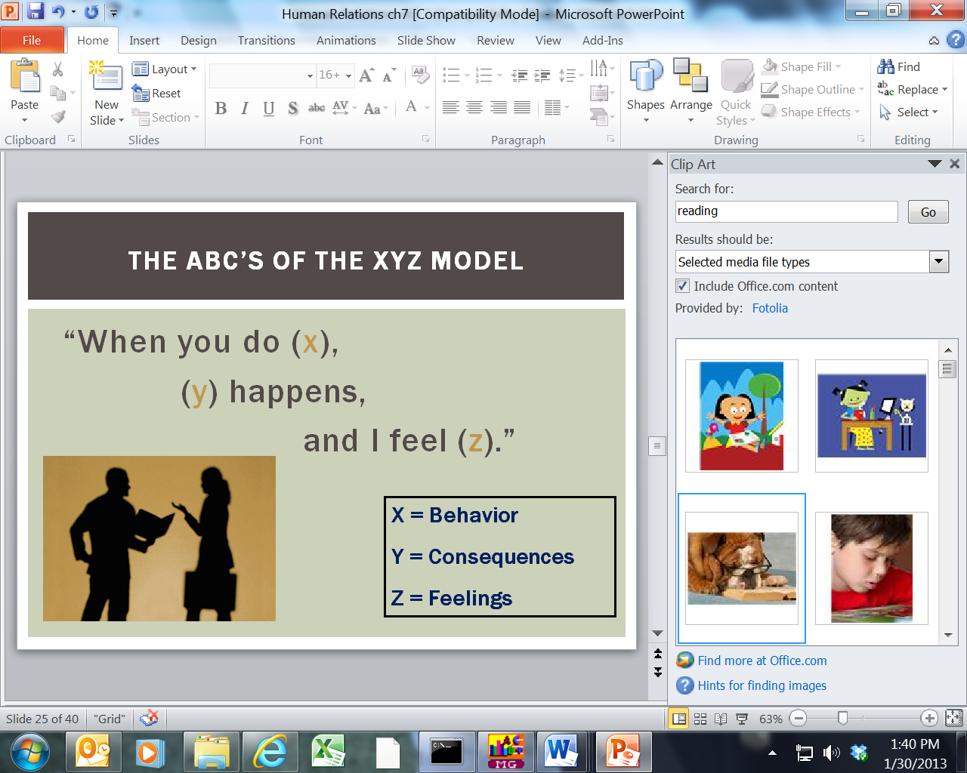

Avoiding Those Hiring Blues!

Manager’s Note Book!

A STEP OVER THE EDGE

Managers Notebook!

Avoid Hiring the Nightmares!
Take ___________________________________________________ Human Relations and HR courses

Learn how to ______________________________________ and how to look for red flags that could be signaling to you that this applicant is bad news!

Ask for _______________________________________ and have the applicant give you _________________authorization to contact their references.

Don’t be afraid to _________________________…

Screen applicants using profiles that measure:

Ability

Aptitude

Experience

Attend seminars and workshops that deal with the topic of management skills.

Take a good documentation course that will teach you the skills of employment documentation.

Keep up with the employment laws and regulations. Know your rights and responsibilities!

If you run into legal troubles, get help!!!

Highly recommended books…

The Cowards Guide to Conflict

DISCOVER:

--Why you must know how to handle conflict

--How to recognize conflict before it happens

--The best ways to deal with difficult people

--How to build strength by overcoming problems

--Secrets to impacting and leading others

--Tools to guide you past conflict

Boundaries

Defining what boundaries are…

Helping you set healthy boundaries with parents, spouses, children, friends, co-workers, and even yourself

Taking back your control and power over situations and people when boundaries are necessary.

Learning when to say, “Yes” and when to say, “No” in situations.

Taking control of your life.

Necessary Endings…

The pruning effect

“The caretaker constantly examines the bush to see which buds are worthy of the plant’s limited fuel and support, and cuts the others away. He prunes them. Takes them away, never to return. He ends their role in the life of the bush and puts an end to the bush’s having to divert resources to them.” Necessary Endings, p. 16

Safe people

Gives us advice on discernment in finding people who are “Safe” and those who are “unsafe” or even toxic to be around.

Categorizes personal traits of those people to are takers, critics or irresponsible, and gives the reader a guidepost on how to spot those types in unhealthy relationships.

Notes:

