Organizational Change and Culture
BA 33 - Human Relations
Chapter 12 Student Notes:

SHIFT HAPPENS…. DID YOU KNOW?
- http://www.youtube.com/watch?v=YmwwrGV_aiE

Attitudes Towards Change
- The conflict can lie between the ______________________ and ____________ being proposed.

FORCE FIELD ANALYSIS:
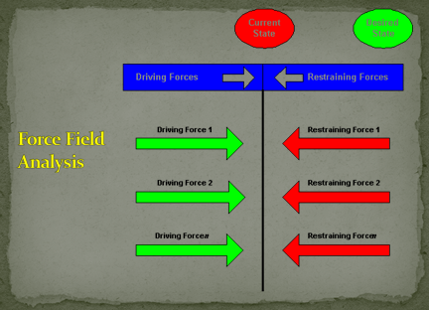

_____________ about change
_____________ about change
____________ for change
___________ Change
____________ as to why change is needed

Stages in the Change Process
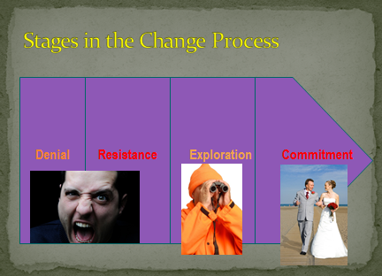

Overcoming Resistance to Change
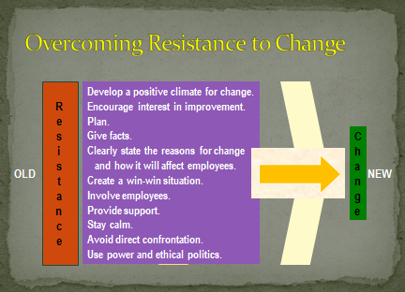
Change Models
Lewin’s Change Model

Also known as “___________________”

Step 1. Unfreezing

Step 2. Moving

Step 3. Refreezing
Lussier’s Change Model –
Most used in business.

Step 1. ____________ the change.
Step 2. ______________ possible resistance to change.
Step 3. _________the change.
Step 4. ____________ the change.

      - Give the facts.
      - Involve employees.
      - Provide support.

Step 5. ____________ the change (reinforcement of change.)
Responding to Resistance
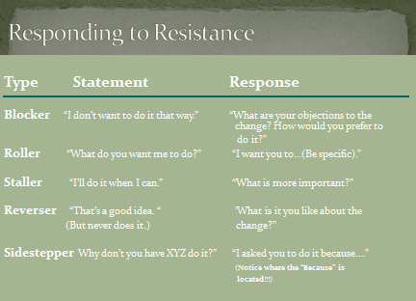
Organizational Development (OD)
…is the ___________________________ of change used as a means of improving the organization’s effectiveness in solving problems and achieving its objectives.
OD techniques
- Training and development
- Grid OD
- Survey feedback
- Force field analysis
- Team building
Training and Development
Step 1. ____________________________
Step 2. Set __________________
Step 3. Prepare for _______________
Step 4. Conduct the training
Step 5. _____________________ training results
Grid OD: a six-phase program designed to improve management and organizational effectiveness.
Phase 1. Training
Phase 2. Team development
Phase 3. _______________ development
Phase 4. Organizational goal setting
Phase 5. Goal attainment
Phase 6. ______________________

Survey feedback: an OD technique that uses a questionnaire to gather data that are used as the basis for change.
1. Management and the change agent do some preliminary planning to develop an appropriate survey questionnaire.
2. The questionnaire is __________________________________ of the organization/unit.
3. The survey data are analyzed to uncover problem areas for improvement.
4. The change agent feeds back the results to management.
5. Managers evaluate the feedback and discuss the results with their subordinates.
6. Corrective action plans are developed and implemented.
Teamwork:
http://wilderdom.com/games/InitiativeGames.html
The Big Book of Team-Motivating Games:
Quick Team-Building Activities for Busy Managers:
Harvard Business Review on Building Better Teams [Paperback]

NOTES:

