Understanding Behavior,
Human Relations, and Performance

Chapter 1

(Human Relations)

Why Human Relations?

People are the ____________________________.

________________________________________ employee clashes.

Important factor in __________________ competition.

Affects _________________________________.

Managers _________________with people.

The Goal of Human Relations

to _________________________________________________ by satisfying employee needs while achieving organizational objectives.

First Time Management
Roles

Here’s the situation

Laundry List Continued

Job Fit?

Total person approach:

Does the individual fit within the organization? Culture?

You get the whole person – not just one aspect of that individual.

Can the individual separate work from personal problems?

From a legal standpoint – Does the person create a ________________________________ for others because of personal issues outside or in the workplace?

TERMS YOU NEED TO KNOW…

Organization: ______________________________________________________

Organizational behavior: the _____________ behavior of the organization’s individuals and groups.

Performance: the extent to which _________________________________________________ have been met.

Systems effect: __________________ in the organization are effected by at least one other person, and _____________________________ affects the whole group/organization.
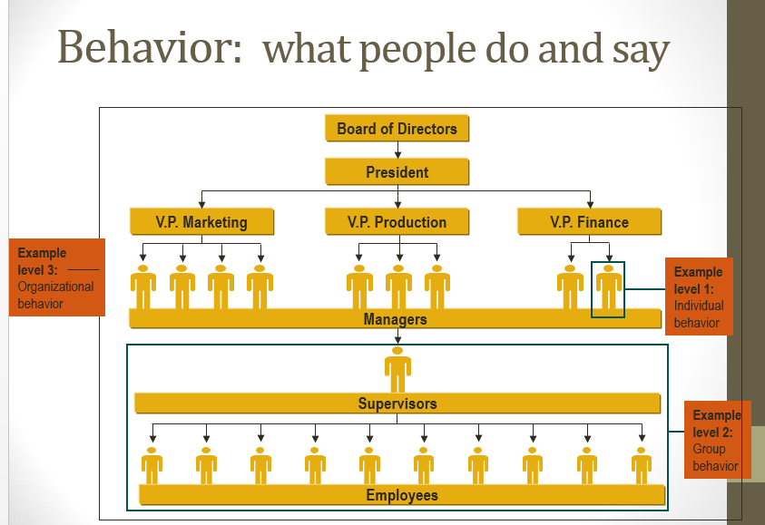

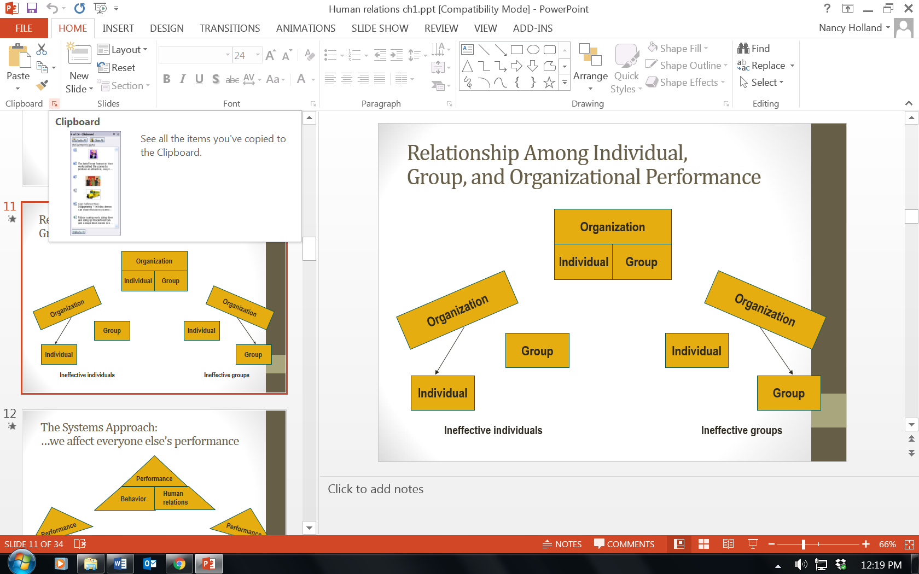

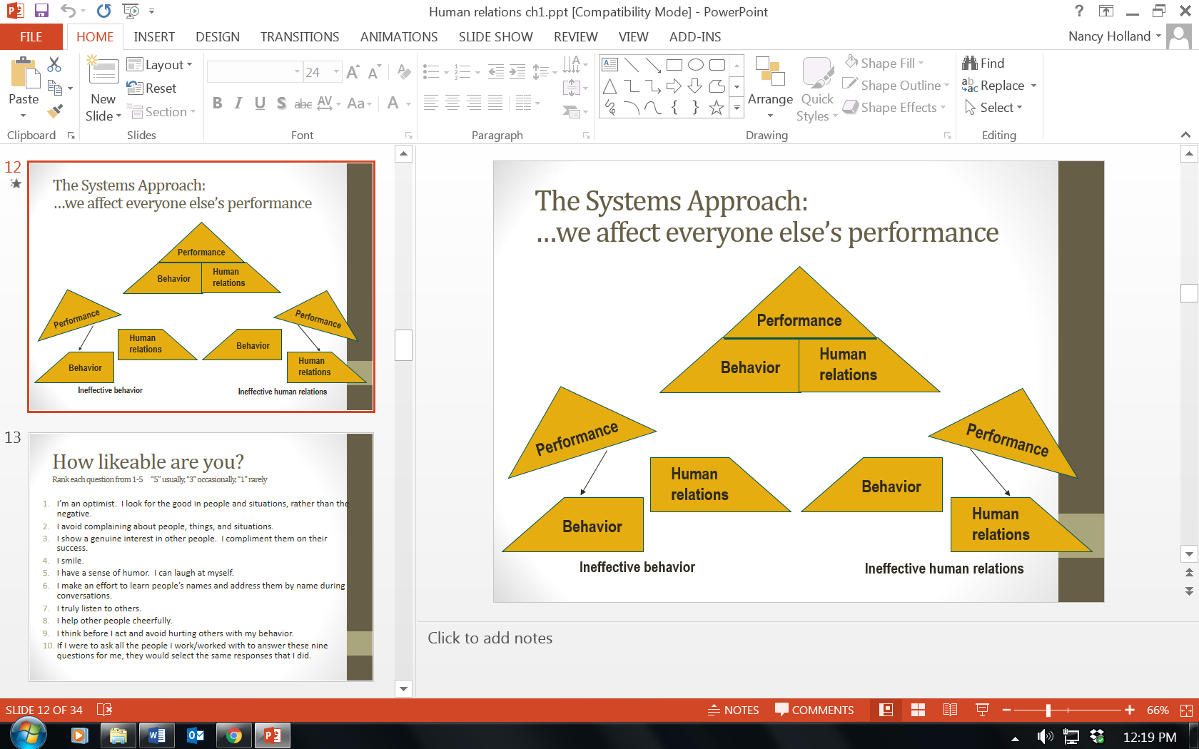

How likeable are you?
Rank each question from 1-5 “5” usually, “3” occasionally, “1” rarely

I’m an optimist. I look for the good in people and situations, rather than the negative.

I avoid complaining about people, things, and situations.

I show a genuine interest in other people. I compliment them on their success.

I smile.

I have a sense of humor. I can laugh at myself.

I make an effort to learn people’s names and address them by name during conversations.

I truly listen to others.

I help other people cheerfully.

I think before I act and avoid hurting others with my behavior.

If I were to ask all the people I work/worked with to answer these nine questions for me, they would select the same responses that I did.

The Nine Human Relations Guidelines

Be ___________________. Be Positive.

Be genuinely ___________________________________.

Smile and develop a sense of __________________.

Call people by _______________

_______________to people.

____________ others.

____________ before you act.

Create a ______________ situation.

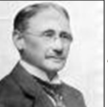
Understanding Behavior, Human Relations and Performance –

From a Scientific Analysis

Human Relations: Past,
Present and Future
_____________________________________________
Fredrick W. Taylor

Late ____________________________

Mass Production

_____________________________ studies

“______ best way”

Focus on Production and quotas, not people

Assumed Money was Key with workers

FREDERICK TAYLOR’S - SCIENTIFIC MANAGEMENT - TIME PERIOD = _______________

1. IDENTIFY ________________________ TO DO A JOB.

2. SELECT AND __________________________________________.

3. ______________________ OF EACH WORKER - HE OR SHE KNEW PRECISELY HOW TO ACCOMPLISH THE WORK/TASK.

4. A HIGH DEGREE _______________________________ BETWEEN LABOR AND MANAGEMENT.

Pit Falls of Taylor’s Work

Failed to recognize the social needs of employees.

Employees were _________________________in the jobs.

___________________with human behavior

Workers working conditions were not considered.

IN CONTRAST TO FREDERICK TAYLOR’S - SCIENTIFIC MANAGEMENT

BUREAUCRACY -


1. TASKS ARE DIVIDED INTO ________________________ - WORKERS ARE EXPECTED TO ONLY PERFORM THOSE TASKS OUTLINED TO THEM AT THE DATE OF HIRE.

2. “____________________________________________” - ATTITUDE

3_________________________ WITH A CLEAR DEFINITION OF REPORTING - ____________________________________________

BUREAUCRACY (Continued)-

4. _________________________ POLICY - ________________ ENVIRONMENT

5. INITIAL PLACEMENT AND ADVANCEMENT IN ORGANIZATION IS BASED ON ________________________________________________________.

6. ________________________ IS A THREAT TO ALL SYSTEMS

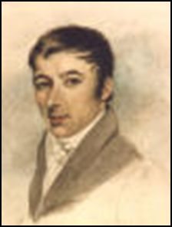
Robert Owen
1800’s – 1920’s

The first manager-entrepreneur to understand need to improve work environment and overall situation

Called “_______________________________________________”

Profit based on employee environment, situation

Against child labor of children under the age of 11.

Cleanliness and order

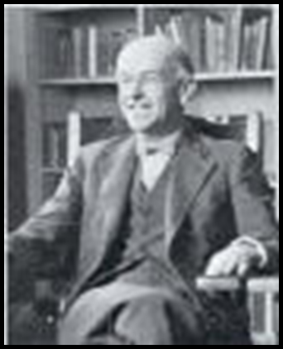
The _____________________________

1927 – 1932

Elton Mayo

_____________________________ Movement

Employees have many needs ________ those satisfied by __________.

__________________ groups have powerful influence.

Many employee needs are satisfied off the job.

Employee relations affect employee performance.

_________________________ Hawthorne Studies

Mid ________________________

HAWTHORNE EFFECT

STUDIES BY ELTON MAYO

“____________________________________”

...OCCURS WHEN PEOPLE ARE ______________________________ TO PERFORM AT A HIGHER LEVEL THAN THEY MIGHT OTHERWISE.
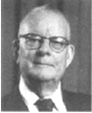

W. Edwards Deming
1950’s

14 STEPS MANAGEMENT MUST TAKE

1. CREATE __________________________ TOWARDS IMPROVING PRODUCT AND SERVICE.

2. ADOPT THE NEW PHILOSOPHY: ___________ TO THE CHALLENGE;

___________RESPONSIBILITIES; _______________ LEADERSHIP IN ORDER TO BRING

ABOUT ________________.

3. CEASE DEPENDENCE OF INSPECTION TO ACHIEVE _____________.

4. END THE PRACTICE OF AWARDING BUSINESS ON THE BASIS OF THE PRICE TAG. INSTEAD MINIMIZE TOTAL COST. MOVE TOWARDS A SINGLE SUPPLIER AND DEVELOP LONG-TERM RELATIONSHIPS. GOAL= J.I.T.

5____________________________________________________________________________

_______________________________________________.

INSTITUTE ____________________ ON THE JOB.

INSTITUTE LEADERSHIP

DRIVE OUT _________________

____________________________________ BETWEEN DEPARTMENTS

10. ___________________SLOGANS, EXHORTATIONS, TARGETS THAT DEMAND ZERO DEFECTS AND NEW LEVELS OF PRODUCTIVITY.

11. ELIMINATE WORK STANDARDS (QUOTAS) AND SUBSTITUTE THEM WITH ___________________. ELIMINATE MANAGEMENT BY OBJECTIVES.

12. REMOVE BARRIERS THAT ROB THE HOURLY WORKER OF HIS RIGHT TO _________________________________________________________

13. INSTITUTE A _____________________________________________ AND SELF-IMPROVEMENT

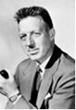
14. ___________________________ IN THE COMPANY _______________ TO ACCOMPLISH THE TRANSFORMATION...

THE TRANSFORMATION IS

EVERYONE’S JOB”

Human Relations:
Past, Present, and Future …

1930s and 1940s: Unions forced management to recognize employee needs

1960s: Theory X & Y developed by Douglas Macgregor while Eric Berne introduced Transactional Analysis.

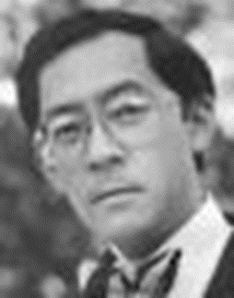
1970s: Human relations began to be called organizational behavior. Americans began to look to their competition for ways to increase performance.

1980s: William Ouichi developed Theory Z

Human Relations:
Past, Present, and Future

1980s: In Search of Excellence

Peters and Waterman researched the characteristics of successful organizations:

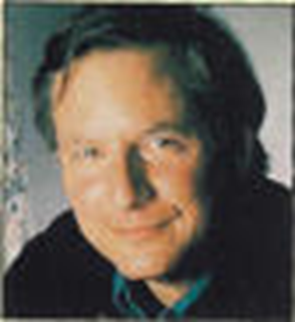
They have a bias for action.

They are ____________________________.

They are use ______________________________.

They attain _____________________ through people.

They are _________________ and value-driven.

They ___________________________ and do not diversify greatly.

They use a __________________ with a lean staff.

They have simultaneous ________________________________

Worker involvement dominates human resource issues.

Trends and Challenges

External Environmental Forces

Litigation

A service economy

A global economy

Quality and productivity

Cost and reorganization’

Innovation and speed

Diversity

Race/ethnicity

An aging work force

Sex Family Changing educational levels

