Employee Testing and Selection

Chapter 6

After studying this chapter, you should be able to:

Explain what is meant by reliability and validity.

Explain how you would go about validating a test.

Cite and illustrate our testing guidelines.

Give examples of some of the ethical and legal considerations in testing.

List eight tests you could use for employee selection, and how you would use them.

Explain the key points to remember in conducting background investigations.

The Importance of Selecting the Right Employees

Why Careful Selection is Important

Hiring costs….
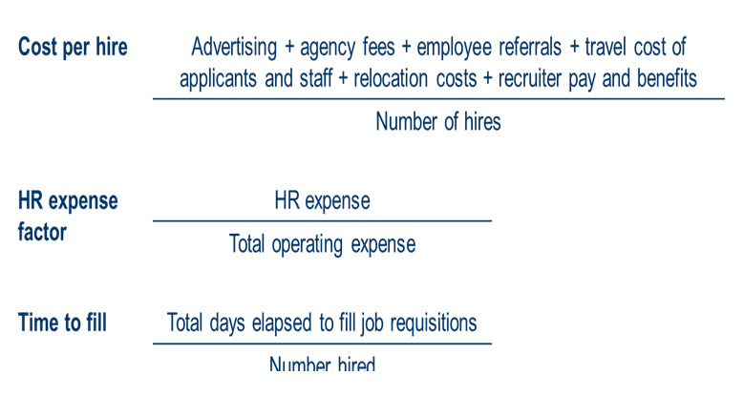

Application Criteria

Avoiding Negligent Hiring Claims

___________________ Checks

___ Checks

____________Records

__________ Examinations

_________________________ Screening

Resume Lies….

Avoiding Negligent Hiring Claims

_________________________ on employment applications.

Get _________________________________ for reference checks, and check references.

________________________ and information about the applicant.

Reject applicants _______________________________________________ for offenses related to the job.

Balance the applicant’s privacy rights with others’ “_________________________.”

_________________________________________ if problems arise.

Background Investigations and Reference Checks

Investigations and Checks

Reference checks

Background employment checks

Criminal records

_____________records

________________checks

Why?

To verify _______________ information provided by applicants.

To ___________________________ information.

Making Background Checks More Useful

Include on the application form a statement for applicants to sign explicitly authorizing a background check.

Use telephone references if possible.

Be _________________________ in obtaining information.

Use references provided by the candidate as a source for other references.

Ask _________________ questions to elicit more information from references.

U.S. Small Business Administration Website

Obtaining Credit Checks:

Credit Reports Under the Fair Credit Reporting Act (FCRA) employers must obtain an employee's ___________________before seeking an employee's credit report. If you decide not to hire or promote someone based on information in the credit report, you must provide a copy of the report and let the applicant know of his or her right to challenge the report under the FCRA. Some states have more stringent rules limiting the use of credit reports. Using Consumer Credit Reports: What Employers Need to Know details the Fair Credit Reporting Act's impact on pre-employment checks.

Criminal Records

To what extent a private employer ________________________________________ in making hiring decisions varies from state to state. Because of this variation, you should consult with a lawyer or do further legal research on the laws of your state before probing into whether or not an applicant has a criminal past.

For Federal Bureau of Investigation (FBI) checks, consult these resources:

•FBI Services for Businesses Offers assistance to businesses in the areas of employee background investigation, antitrust investigation, trade secret and intellectual property protection, cyberspace patrol, economic espionage and anti-terrorism.

•FBI Criminal History Checks for Employment and Licensing Advises employers to contact the agency requiring the background check or the appropriate state identification bureau (or state police) for the correct procedures to follow for obtaining an FBI fingerprint background check for employment or licensing purposes.

•FBI Checks on Employees of Banks and Related Entities Provides information on conducting criminal history background checks on employees of banking-related institutions.

Physical Examination

Reasons for preemployment medical examinations:

To verify that the applicant meets the __________________ of the position.

To ____________________________________________ to be taken into account in placing the applicant.

To establish a record and baseline of the applicant’s health for future insurance or compensation claims.

To reduce _______________________________________________.

To detect ______________________________ that may be unknown to the applicant.

Substance Abuse Screening

Types of Screening

Before formal hiring

After a work accident

Presence of obvious behavioral symptoms

Random or periodic basis

Transfer or promotion to new position

Types of Tests

__________________

_________________ testing

Substance Abuse Screening (cont’d)

Testing & Validation

Basic Testing Concepts

Types of Validation

How to Validate a Test

Expectancy Chart

Testing Program Guidelines

Test Takers’ Individual Rights and Test Security

Legal Privacy Issues

Types of Tests

Basic Testing Concepts

Reliability

____________________________________________ when retested with identical or equivalent tests.

Are test results _____________over time?

Validity

Indicates whether a test is measuring what it is supposed to be measuring.

Does the test ______________ what it is intended to measure?

Types of Validity

Validity

___________________ – Does this test measure what it’s supposed to measure?

_________________ – Demonstration of ability on paper vs. on the job. The extent to which high scores determine performance on the job.

______________________ – Does the test constitute a fair sample of the jobs actual content.

How to Validate a Test

FIGURE 6–2 Examples of Web Sites Offering Information on Tests or Testing Programs

FIGURE 6–3 Expectancy Chart

TABLE 6–1 Testing Program Guidelines

Test Takers’ Individual Rights and Test Security

Under the APA’s standard for educational and psychological tests, test takers have the right:

To _________________________________________.

To the _____________________________ of test results.

To _________________________ regarding use of these results.

To expect that only people qualified to interpret the scores will have access to them.

To expect the test is __________________.

Legal Privacy Issues

Defamation

____________________________ of employees or former employees by an employer.

Avoiding Employee Defamation Suits

____________________________ regarding the importance of employee confidentiality.

Adopt a “____________________” policy.

Disclose procedures impacting confidentially of information to employees.

Types of Tests

Types of Tests

The “Big Five”

Testing Opportunities

Using Tests at Work

Major Types of Tests

Basic skills tests

Job skills tests

Psychological tests

Why Use Testing?

Increased work demands = more testing

Screen out bad or dishonest employees

Reduce turnover by personality profiling

FIGURE 6–4 Sample Test

Computerized and Online Testing

Online tests

Telephone prescreening

Offline computer tests

Virtual “inbox” tests – “Submissions”

Online problem solving tests

Types of Tests

Specialized work sample tests

Numerical ability tests

Reading comprehension tests

Clerical comparing and checking tests

FIGURE 6–5 Type of Question Applicant Might Expect on a Test of Mechanical Comprehension

FIGURE 6–1 Sample Picture Card from Thematic Apperception Test

FIGURE 6–6 Sample Personality Test Items

FIGURE 6–7 Example of a Work Sampling Question

Work Samples and Simulations

TABLE 6–2 Evaluation of Assessment Methods on Four Key Criteria

Portfolio Requests
Work Samples

Samples of other work performed

Certifications

Awards & Honors

Photos

Graphics & Charts

Letters of Reference

Various samples of work and collections

Other Types of Testing…

FIGURE 6–8

Reference Checking Form

Background Investigations and Reference Checks (cont’d)

Limitations on Background Investigations and Reference Checks

Using Preemployment Information Services

TABLE 6–3 Collecting Background Information

The Polygraph and Honesty Testing

_____________________________ Act of 1988

Generally prohibits polygraph examinations by all private employers unless:

The employer has suffered an _____________________________________.

The employee in question had ______________________________.

There is a reasonable __________________________________.

The employee is told the details of the investigation, as well as questions to be asked on the polygraph test itself.

Exceptions:

Private security employees

Employees with access to drugs

National defense and security (FBI, DOE, and DOJ)

Honesty Testing Programs:
What Employers Can Do

Antitheft Screening Procedure:

Ask blunt questions.

Listen, rather than talk.

Do a credit check.

Check all employment and personal references.

Use paper-and-pencil honesty tests and psychological tests.

Test for drugs.

Establish a search-and-seizure policy and conduct searches.

FIGURE 6–9 Handwriting Exhibit Used by Graphologist

FIGURE 6–10 Procedure in Complying with Immigration Law

K E Y T E R M S

negligent hiring

reliability

test validity

criterion validity

content validity

expectancy chart

interest inventory

work samples

work sampling technique

management assessment center

situational test

video-based simulation

miniature job training and evaluation

