Job Analysis

BA 31 Chapter 4

After studying this chapter, you should be able to:

Discuss the nature of job analysis, including what it is and how it’s used.

Use at least three methods of collecting job analysis information, including interviews, questionnaires, and observation.

Write job descriptions, including summaries and job functions, using the Internet and traditional methods.

Write job specifications using the Internet as well as your judgment.

Explain job analysis in a “jobless” world, including what it means and how it’s done in practice.

Situational Leadership

KEEPING YOU FROM HIRING NIGHTMARES!

Types of Information Collected

Use of Job Analysis Information

FIGURE 4–1 Uses of Job Analysis Information

Job Analysis…

(SOC) - Standard Occupational Classification

Steps in Job Analysis

Methods of Collecting Job Analysis Information: The Interview

Information Sources

Individual employees

Groups of employees

Supervisors with knowledge of the job

Advantages

Quick, direct way to find overlooked information

Disadvantages

Distorted information

Interview Formats

Structured (Checklist)

Unstructured

FIGURE 4–3
Job Analysis Questionnaire for Developing Job Descriptions

FIGURE 4–3
Job Analysis Questionnaire for Developing Job Descriptions (cont’d)

Job Analysis: Interviewing Guidelines

The job analyst and supervisor should work together to identify the workers who know the job best.

Quickly establish rapport with the interviewee.

Follow a structured guide or checklist, one that lists open-ended questions and provides space for answers.

Ask the worker to list his or her duties in order of importance and frequency of occurrence.

After completing the interview, review and verify the data.

Methods of Collecting Job Analysis Information: Questionnaires

Information Source

Have ____________________________ to describe their job-related duties and responsibilities

Questionnaire Formats

________________ checklists

_____________ questions

Advantages

Quick and efficient way to gather information from large numbers of employees

Disadvantages

Expense and time consumed in preparing and testing the questionnaire

Methods of Collecting Job Analysis Information: Observation

Information Source

_____________________ the physical activities of employees as they go about their jobs

Advantages

Provides ________________________

Reduces distortion of information

Disadvantages

________________________________

Difficulty in capturing entire job cycle

Of little use if job involves a _________________________________

Methods of Collecting Job Analysis Information: Participant Diary/Logs

Information Source

Workers keep a ________________________________________ of what they do and the time spent on each activity

Advantages

Produces a _____________________________ of the job

Employee _____________________________

Disadvantages

________________________________________

Depends upon employees to accurately recall their activities

FIGURE 4–4
Example of Position/Job Description Intended for Use Online

FIGURE 4–4
Example of Position/Job Description Intended for Use Online (cont’d)

FIGURE 4–4
Example of Position/Job Description Intended for Use Online (cont’d)

Competency-Based Job Analysis

Competencies

_______________________ of a person that enable performance of a job.

Reasons for Competency-Based Job Analysis

To support a high-performance work system.

To create strategically-focused job descriptions.

To support the performance management process in fostering, measuring, and rewarding:

General competencies

Leadership competencies

Technical competencies

Job Specifications….

Writing Job Specifications

Steps in the Statistical Approach

***Analyze the job and ______________________________________

***Select _________________________ that you believe should predict successful performance.

__________________________ for these traits.

Measure the candidates’ subsequent job performance.

Statistically analyze the relationship between the ______________________________________________________

Writing Job Specifications

DEFINING YOUR CORPORATE CULTURE…..

The Disney look….

Examples of Personal Traits

Organized

Self-Starters

Positive/Friendly Personality

Teachable

Coachable

Attention to detail

Type A personality

Type B personality

Responsive

Motivated

Employment Personality Tests

The EEOC does not validate pre-employment assessments nor does the Office of Federal Contract Compliance. As far as employment assessments are concerned, the extent of their authority is to audit or investigate unacceptable procedures when a discrimination charge has resulted from adverse impact. Their investigation pertains to all employee selection procedures. There have been very few disparate impact cases involving pre-employment assessments because those assessments generally do not have an adverse impact on any protected group. That does not preclude misuse of an employment assessment by requiring unreasonably high or restrictive standards that would not be a bona fide occupational qualification.

Working Conditions: OSHA ISSUES?

Extreme weather conditions

__________________________________

Noise (Airport)

_____________ Spaces

Extreme Altitudes

________________ conditions

Woodworking (Shavings)

Heavily perfumed areas

__________________ (allergy)

Job Analysis in a “Jobless” World

Job Analysis in a “Jobless” World (cont’d)

Writing the job Description

Writing Job Descriptions

Using the Internet for Writing Job Descriptions

O*NET™ Online

http://www.biztrain.com/products/descriptionsnow.htm

Occupational Employment and Wage Estimates…

http://www.bls.gov/

What are Occupational Codes?

TABLE 4–2 SOC Major Groups of Jobs – Standard Occupational Codes

FIGURE 4–9
Marketing Manager Description from Standard Occupational Classification
(SOC CODE) =
(US federal job classification system)

Mean and Median – What’s the Difference???

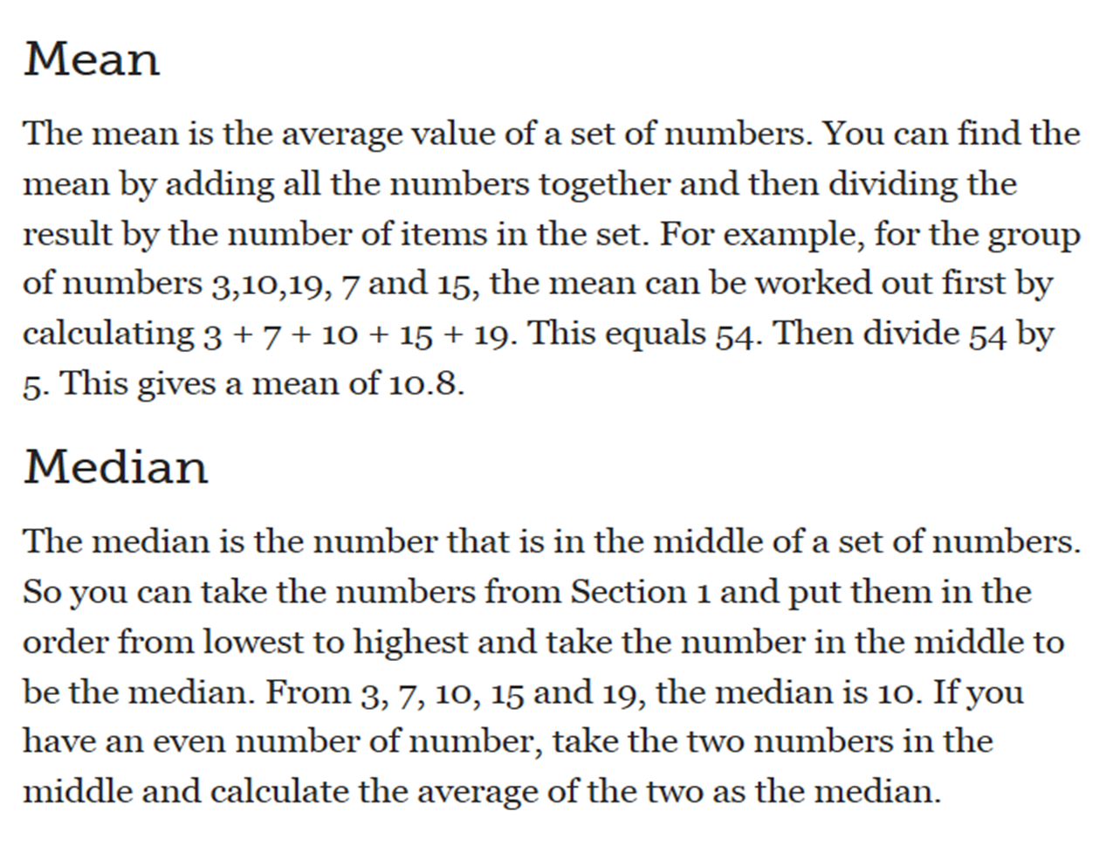

Wage Range:

Wage/Hour information from DOL…

DETERMINING THE STATUS OF THE POSITION….

EXEMPT

Exempt v. Non-Exempt?

The audit: test your compliance

Contractor? Employee?

Recap – summary and steps:

The Job Description Summary

Job Identification

Job title

*FLSA =__________________________________status section – Exempt/Non-Exempt?

Wage

Job Summary

General nature of the job

Major functions/activities

Relationships

Reports to:

Supervises:

Works with:

Outside the company:

Major Responsibilities and Duties

Major responsibilities and duties (essential functions)

Decision-making authority

Direct supervision

Budgetary limitations

Standards of Performance and Working Conditions

What it takes to do the job successfully

Written Job Description

________________________________

Writing Job Descriptions: Steps

Step 1. Decide on a Plan

Step 2. Develop an Organization Chart

Step 3. Use a Job Analysis/Description Questionnaire (Done)

Step 4. Obtain Lists of Job Duties from O*NET

Step 5. Compile the Job’s Human Requirements from O*NET – SOC code?

Step 5 Determine Wage/Hour – Exempt – Non-Exempt

Step 6. Complete Your Job Description

