Chapter 18
Agency: Liability for Contracts

Agent’s Duties to the Principal
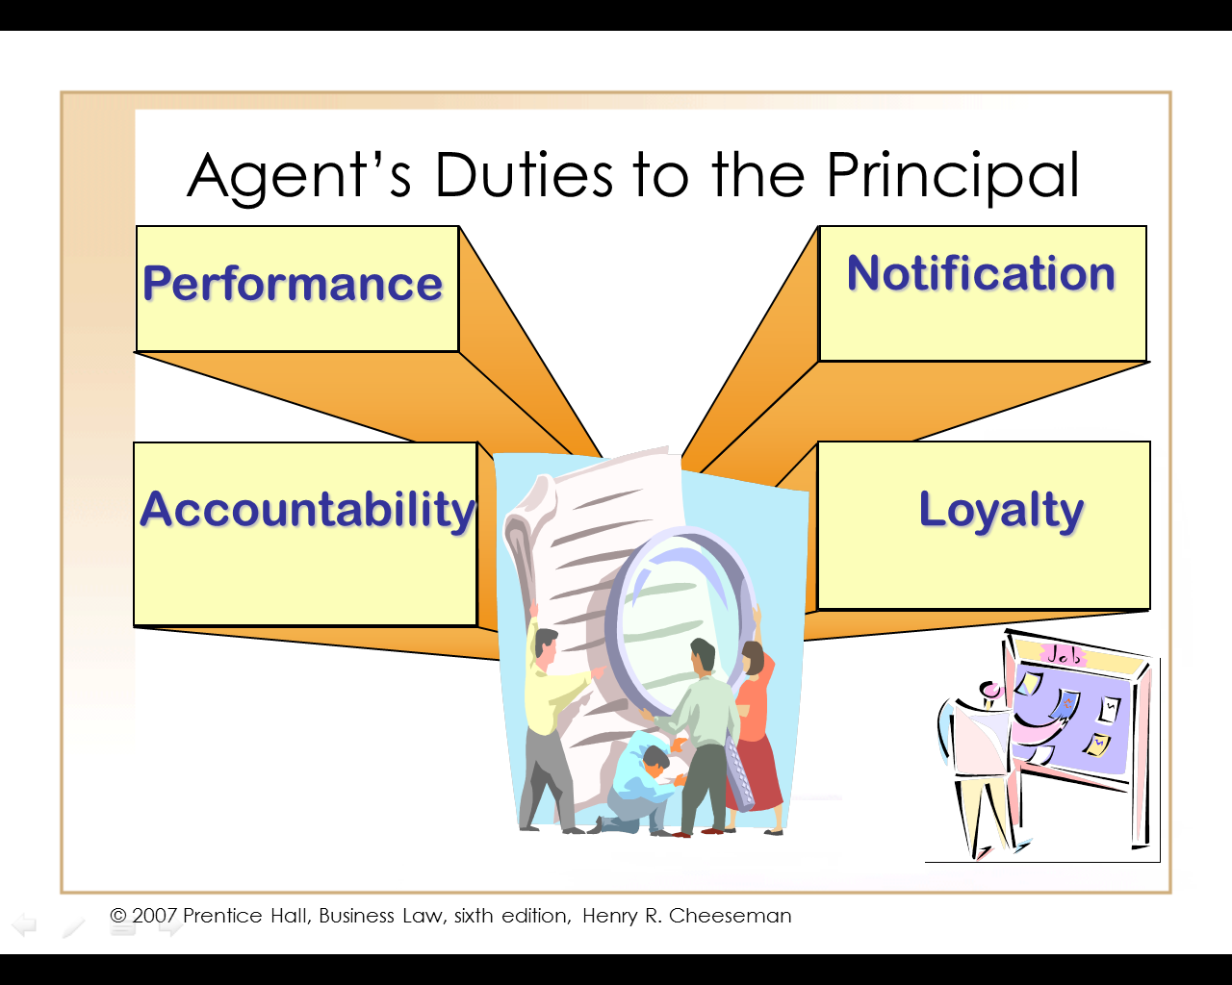

Agent’s Duty of Loyalty to Principal

An agent owes a _______________ not to act adversely to the interests of the principal. Common breaches include:

Self-Dealing

Agents are generally prohibited from ________________________ with the principal.

Usurping an Opportunity

An agent cannot ____________________________ that belongs to the principal.

Agent’s Duty of Loyalty to Principal (continued)

Competing with the Principal

Agents are prohibited from ____________________________________l.

Misuse of Confidential Information

The agent is under ______________ not to __________________________________ during or after course of the agency.

Dual Agency

An agent cannot meet a _________________ to two parties with conflicting interests.

Contract Liability to Third Parties

A principal who authorizes an agent to enter into a contract with a third party is liable on the contract.

The third party can ____________________________________________ from the principal .

Contract Liability to Third Parties (continued)

The agent can be held liable in some circumstances.

_____________ disclosed agency

______________ disclosed agency

____________ agency

Fully Disclosed Agency

When the third party entering into the contract knows:

That the agent is acting as an agent for a principal, and

The actual identity of the principal

The principal is liable to the third party.

The agent is not liable.

Partially Disclosed Agency

An agency that occurs if:

The agent discloses his or her agency status but does not reveal the principal’s identity, and

The third party does not know the principal’s identity from another source

Both the principal and the agent are liable to the third party if the principal fails to perform the contract.

Undisclosed Agency

An agency that occurs when the third party is unaware of either:

The ___________________, or

The _________________________

Both the principal and the agent are liable to the third party if the principal fails to perform the contract.

Agent Exceeding the

Scope of Authority

An agent who enters into a contract on behalf of another party impliedly warrants that he or she has the authority to do so.

If the agent exceeds the scope of his or her authority, the principal is not liable on the contract unless the principal ratifies it.

The agent is liable to the third party for breaching the implied warrant of authority.

Tort Liability to Third Parties

The principal and the agent are each personally liable for their own tortious conduct.

The principal is liable for the tortious conduct of an agent who is acting within the scope of his or her authority.

The agent only is liable for the tortious conduct of the principal if he or she directly or indirectly participates in or aids and abets the principal’s conduct.

Negligence

Principals are liable for negligent conduct of agents acting within the scope of their employment.

Liability is based on the common law doctrine _____________________

This doctrine rests on the principle that if anyone (principal) expects to derive certain benefits from acting through others (agent), that the person should also bear the liability for injuries caused to the third party by the negligent conduct of an agent who is acting within the scope of their employment.

Negligence (continued)

__________________

Agents sometimes do things during the course of his or her employment __________________________________, rather than the principal’s.

“____________________” Rule

Principal is generally not liable for injuries caused by its agents and employees while they are on their way to or from work.

___________________ Mission

An errand or other act that principal requests of an agent while the agent is on his or her own personal business.

Intentional Torts

The principal is not liable for intentional torts of agents and employees that are committed outside the principal’s scope of business.

Two tests to determine the scope of employment boundaries:

_____________ Test

______________ Test

Motivation Test

If the agent’s motivation in committing an intentional tort is to promote the principal’s business, the principal is liable for injuries caused by the tort.

If agent’s motivation is personal, principal is not liable.

Work-Related Test

Only applied in some jurisdictions

If agent commits intentional tort within a work-related time or space, the principal is liable.

Agent’s motivation immaterial.

Misrepresentation

A principal is _____________________________________________________ made by an agent within the scope of employment.

Intentional misrepresentation occurs when an agent makes statements that he or she knows are untrue.

Innocent misrepresentation occurs when an agent negligently makes a misrepresentation to a third party.

Tort Liability of Principals and Agents to Third Parties (1 of 2)

Tort Liability of Principals and Agents to Third Parties (2 of 2)

Independent Contractor

Principals often ________________________ (persons or businesses who are not employees) to perform certain tasks on their behalf.

Liability for Independent Contractor’s Torts

A principal is generally ________________________________________________________________ it hires.

Independent contractors are ___________________________________________.

The rationale behind this rule is that principals do not control the means by which the results are accomplished.

Liability for Independent Contractor’s Torts (continued)

A principal is, however, liable for the tortious conduct of an independent contractor involving:

___________________________________.

_______________________________________________________

Crucial factor is degree of ___________

