Warranties and Product Liability

Chapter 16

Interactive

INTENTIONAL MISREPRESENTATION/FRAUD

Element of scienter and intent to deceive.

1. Misrepresents the ___________________________________.

2. _________________________ a defect in it.

“AS IS”

adj. description of a condition in a sales contract in which the buyer agrees to take the property (e.g. house, horse, auto, or appliance) without the right to complain if it is faulty. However, the buyer must _______________________________, so that he/she has a chance to find any obvious deficiency. Intentionally ________________________ will make a ___________ liable for fraud and serves to cancel the "as is" provision.

Black’s Law Dictionary

Product Liability

Restatement of the Law Third, Torts: Products Liability

Deals with the liability of commercial product sellers and distributors for harm caused by their products.

Question: Ever wonder why some products have strange warning labels?

Doctrines of Negligence and Strict Liability Compared
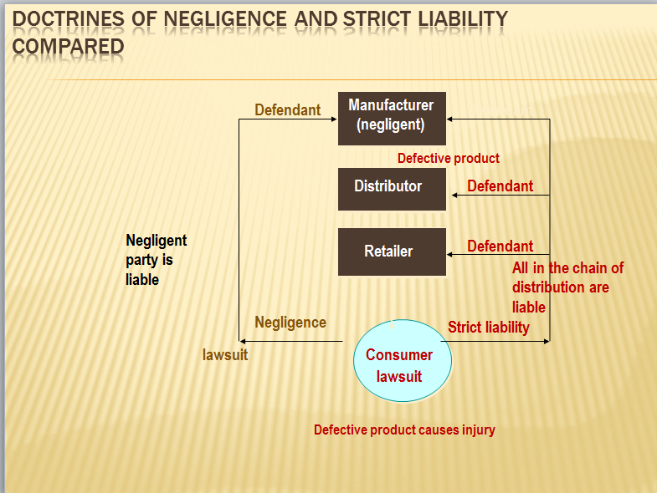

Defective Product

To recover for strict liability, the injured party must first ___________ that the product that caused the injury was somehow ______________.

Plaintiffs can allege multiple product defects in one lawsuit.

Defective Product(continued)

Manufacturing Defects — when the product departs from its intended design, even if all possible care was exercised.

Design Defects — when the foreseeable risks of harm posed by the product could have been reduced or avoided by the adoption of a reasonable alternative design, and failure to use the alternative design renders the product not reasonably safe.

Inadequate Instructions or Warnings Defects — when the foreseeable risks of harm posed by the product could have been reduced or avoided by reasonable instructions or warnings, and their omission renders the product not reasonably safe.

NAACP v. American Arms Inc.

Defect in Manufacture

Defect that occurs when the manufacturer fails to:

Properly assemble a product

Properly test a product, or

Adequately check the quality of a product

Defect in Design

Defect that occurs when a product is improperly designed.

Design defects include:

Toys designed with removable parts that could be swallowed by children.

Machines and appliances designed without proper safeguards.

Trucks designed without a backup warning device.

Failure to Warn

Defect that occurs when a manufacturer _________________________________________ of products that could cause injury if the danger is unknown.

Proper and conspicuous warning __________________ all in chain of distribution

Defenses to Product Liability

__________________ of the risk

Government contractor Defense-

Misuse of Product- __________________________ of product

Superseding event – Alteration of the product after it leaves the seller.

Government Contractor Defense

1. Contractor who was provided specifications by the government is not liable for any defect in the product that occurs as a result of those specifications

2. Product must conform to specifications

3. Contractor must have warned of known defects or dangers

Applies to such things as Aircraft, Aerospace, weapons technology etc.

Liability for Torts and Crimes

The Story:

Who’s Liable?

Servant and Master Relationships:

Master = Employer = ___________________________________

Respondeat Superior: ______________________________! The master is held responsible for the servants conduct

Servant =___________________

Joint and Several = __________________________________________________ and ________ for the servants conduct.

Respondeat Superior Justifications:

The master will _____________________________ next time in servants

The master will ______________________ in the supervisory role.

The liability of a servant is __________________________________________.

The master can _________________________________________.

The master can _____________ the costs.

Definitions:

Vicarious Liability: Legal responsibility for the _______________________ by another person.

Strict Liability: Liability for an _____________ because it occurred and caused damage, not because it is the fault of the person who must pay.

“Deep Pockets”: Expression used to describe those who have ________________________________.

Things to Remember:

No one factor controls the court decision.

Every court case is different, but can be based and judged on precedent setting cases.

Fact situations that seem very similar may result in different decisions.

The “_________________________________” issue will always play a role in the decision of the case.

Scope of Employment

Determining whether a servant is within the scope of his or her employment.

The Story…

The Restatement (Second) of Agency indicates the factors that should affect the determination of whether a servant is within the scope of his or her employment.

The factors include:
Employee:

1.
2.
3.
4.

Questions regarding the Employer’s Actions Include:

Failure to Act

Responsibility of the servant to whom? (What if there is more than one boss?)

Indemnification

Analysis of a Servant’s Torts:

Was the person acting as a servant for the hiring party?

Did the servant commit a tort?

Was the servant acting within the course and scope of the job?

Is the master entitled to indemnification from the servant? Is the servant entitled to indemnification from the master?

Crimes and Intentional Torts:

Battery: _____________________________________ of another person without legal justification or consent.

Conspiracy: A plan to engage in __________________ involving ______________ persons.

Solicitation: __________________a person to engage in criminal activity.

Accessory to Crime: Assistance in a crime. i.e., driving the “get-away” car.

Indemnification: The right to be _____________ by a servant, if the master has had to pay for his servant’s crime.

Injury on the job

Worker’s Compensation

The Story…

Injury on the Job:

Under common law, if an employee is hurt at work, the employer can utilize a number of defenses to avoid an obligation to the employee:

These are two such defenses…

_________________ by the employee

The employee’s __________________________________

Worker’s Compensation Eligibility:

Must __________________that the injury occurred on the job.

The injury was caused in the __________________________.

Some statutes vary:

Some cover only major industrial occupations.

Some exclude small shops w/few employees

Some exclude injuries caused intentionally by the employer or other workers.

Wild/Dangerous Animals and Strict Liability:

The owner of the animal has a ________________________ to anyone who might possibly come in contact with the animal.

The issue of “_______________________________” always plays a role because there is always an issue of the animal escaping. Therefore great care and caution is of the utmost importance when handling the animal as it interfaces with the public.

All parties will be held liable despite the issue of fault. Strict Liability is imposed.

Warning signs, although helpful to those who heed them, does not indemnify the owner/handler from liability. (Joint and Several)

Dog Laws…..

Websites to view:
http://www.eff.org/pub/legal.com
http://wwwsecure.law.cornell.edu/topics/workers_Compensation.html.com
http://www.workcompsite.com
http://www.getareferral.com
http://www.opm.gov/oca/index.htm

