3.1 DESCRIPTIVE ADJECTIVES

ESCRIBIR: Completar (Texto P. 91 Práctica 2)

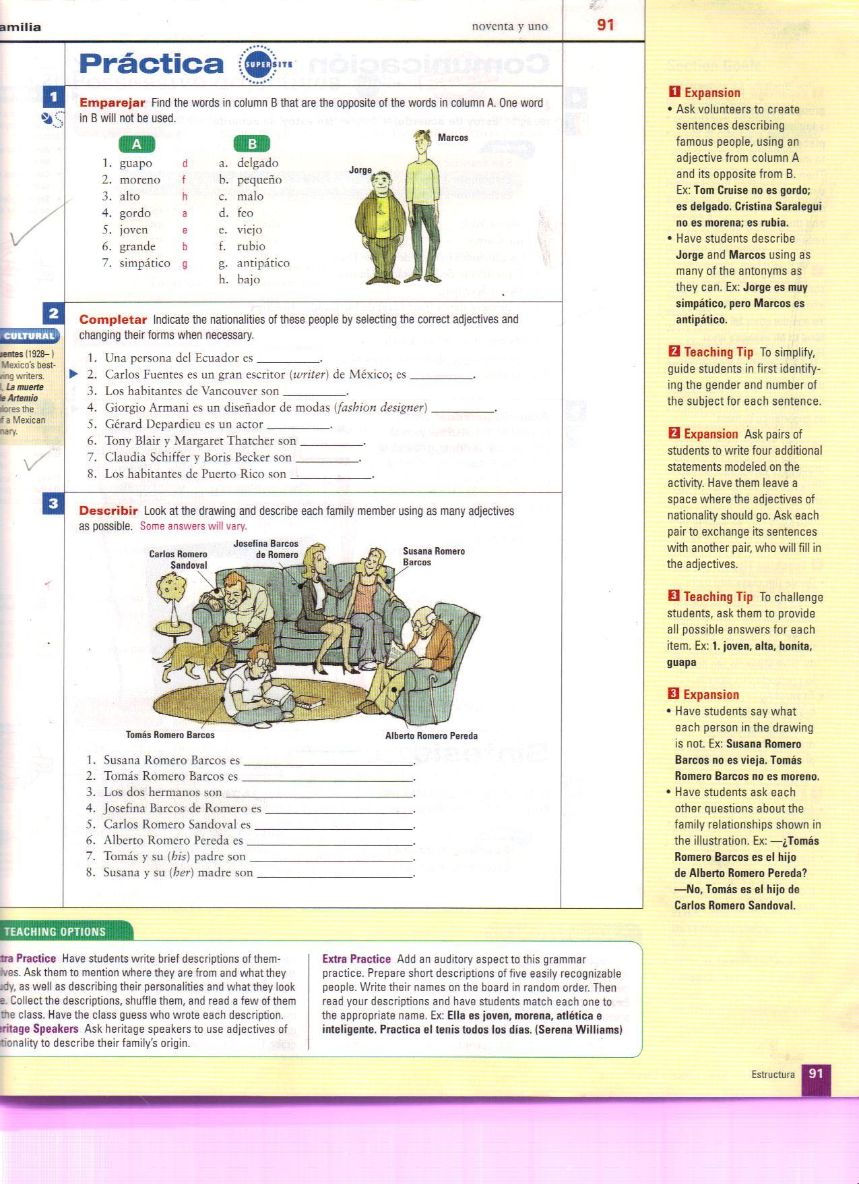
Write numbers 1-8 on a piece of paper and list the nationalities as instructed.

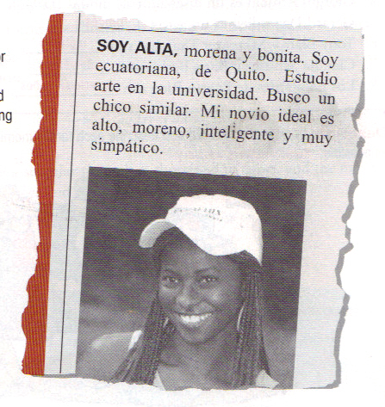
Describir Anuncio Personal
(Texto P. 91 Práctica 3) (Texto P. 92 Práctica 5)
Use the grid provided. -Use the newspaper template
-Write the names of the family titled “Anuncios Personales”.
members. -Follow the model below.
-check each description that
applies.
-Then, answer questions 1-8.

