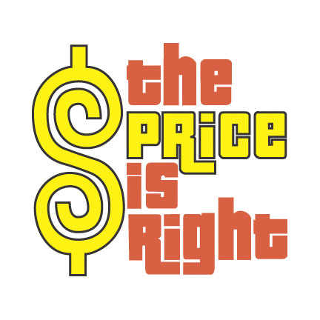

El Precio es Correcto!

Item Price
- Yellow accents $520,00
- Baby carriage and car seat $350,00
- Sun room $15.000,00
- Face lift $4.500,00

- Towels $125,50
- Washer and dryer $1.499,00
- Bedroom set $2.750,00
- Toyota car $25.000,00

- Bertolli Tomato Sauce $7,00
- Sofa $755,95
- Diswasher & oven $1.250,00
- Home $2.000.500,00

- Gevalia Coffee Maker $178,00
- Money bundle $200,00
- Patio furniture $999,99
- Trip to Louisiana $3.700,50

