CONTEXTOS

Nombre: _____________________________________ fecha/date: _____________

ESCUCHAR: Asociar
You will hear three conversations (track 2). Look at the drawing and select the letter that corresponds to each conversation in the order presented.
1. ____________ 2. ____________ 3. ____________

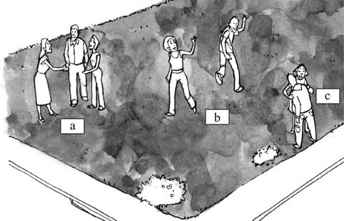
------------------------------------------------------------------------------------------------------------
CONTEXTOS

Nombre: _____________________________________ fecha/date: _____________

ESCUCHAR: Asociar
You will hear three conversations (track 2). Look at the drawing and select the letter that corresponds to each conversation in the order presented.
1. ____________ 2. ____________ 3. ____________

