CONTEXTOS
Nombre: _____________________________________ fecha/date: _____________

ESCRIBIR: Saludos
For each question or expression, write the appropriate answer from the box in each blank.
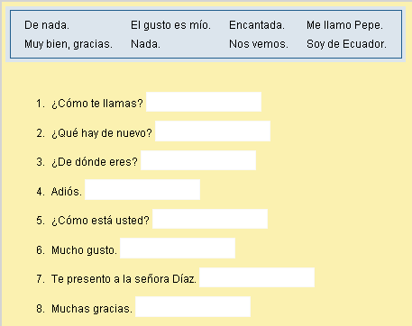

------------------------------------------------------------------------------------------------------------
CONTEXTOS
Nombre: _____________________________________ fecha/date: _____________

ESCRIBIR: Saludos
For each question or expression, write the appropriate answer from the box in each blank.

