CONTEXTOS
Nombre: _____________________________________ fecha/date: _____________

ESCRIBIR: Conversación
Complete this conversation by selecting one word for each blank.

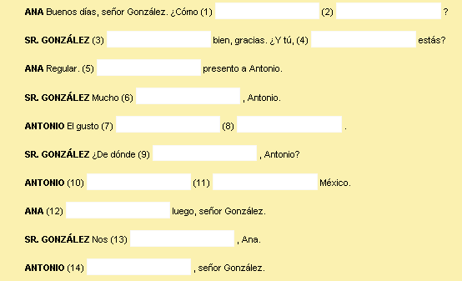
-------------------------------------------------------------------------------------------------------------- CONTEXTOS
Nombre: _____________________________________ fecha/date: _____________

ESCRIBIR: Conversación
Complete this conversation by selecting one word for each blank.

