Lección 4
Nombre:

1 Escuchar You will hear five personal questions. Answer each one in Spanish using complete sentences. (5 x 2 pts. each = 10 pts.)

2 En la ciudad Look at the illustration and imagine that some friends are going to spend the day in the city. Describe what they are going to do, using vocabulary from this lesson, based on what you see in the image. Write at least five sentences.
(6 pts. for vocabulary + 6 pts. for grammar + 3 pts. for style and creativity = 15 pts.)
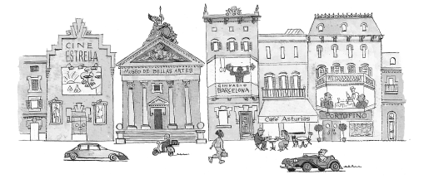

3 Lectura Read this advertisement for the Club Deportivo Mérida and answer the questions in complete sentences. (5 + 2 pts. each = 10 pts.)
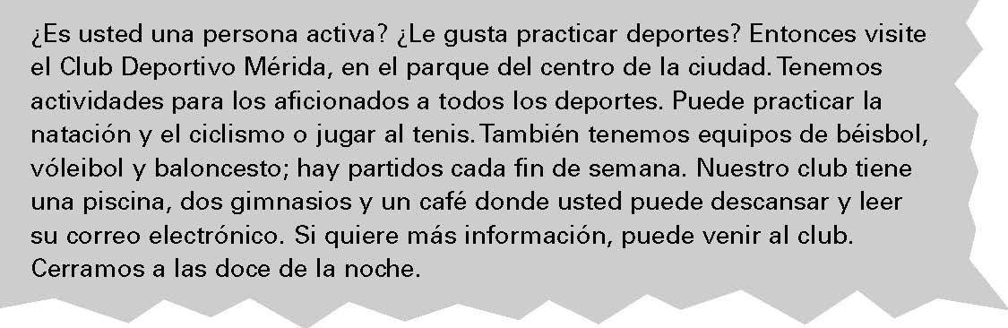

1. ¿Dónde está el Club Deportivo Mérida? ___________________________________________________
______________________________________________________________________________________
4. ¿Qué deportes puedes practicar en el Club Deportivo Mérida? __________________________________
______________________________________________________________________________________
5. ¿Qué actividades te gustan? _____________________________________________________________
______________________________________________________________________________________

4 El fin de semana Describe your favorite movie in a paragraph of at least five sentences using five verbs from sections 4.2 and 4.3.
pedir | decir | conseguir | repetir
seguir | cerrar | comenzar | empezar
entender | pensar | perder | preferir
querer | almorzar | contar | dormir
encontrar | mostrar | poder | recordar
volver | jugar | ir

______________________________________________________________________________________________________________________________________________________________________________________________________________________________________________________________________________________________________________________________________________________________________________________________________________________________________________________________________________________________________________________________________________________________________________________________________________________________________________________________________________________________________________________________________________________________________________________________________

