Configuring the EHR
Unit 7: Lab 2 and Exercise 2
Create Order (Menu) Screen

This session will focus upon customizing Order screen(s) designed to enhance the ordering capabilities for clinicians. For example, an order screen can be designed specifically for Diabetic patients. The order screen would include medications orders, laboratory orders, and diabetic supply orders for Diabetic patients. When the order screen is ready for viewing, it would be added to the ‘Write Orders’ list in CPRS.

Unit 7 / Lab 2:

Instructions for Creating an Order Screen

- Select the VistA_Apps folder on the desktop
- Open the folder and double click the VistATerminal icon.
- Enter the Clinical Application Coordinator Access Code and Verify code provided by your instructor.
- At Select Training Menu Option: type “ORCM” <Enter>
- At Select Order Menu prompt, type the name of a new Order Menu and press <Enter>.
  - Note: Use a naming convention that will clearly and consistently identify your work. Typing “??” at this point will give you a list of existing orders. If you type in a name that is already in that list then that order menu will appear.
- At Are you adding ‘”…” (the name you typed in will appear)…. as a new order dialog? No// - Type <Yes> and press <Enter>.
- At Do you wish to copy an existing menu? Type <Yes> and press <Enter>.
- At Select Menu to Copy, type the name of an existing menu and press <Enter>. To view a listing of current menus, type “??” and press <Enter>.
- At the Display Text prompt, accept default text or add text and press <Enter>.
- At the Description prompt, you may type in a description and press <Enter> Note: Type “Ctrl + e” to exit the text dialog box..
- At the Column Width prompt, you may accept default width or type in a different width and press <Enter>. This is the width, in characters, for each column in a menu. For example, to have 3 columns on an 80 character screen, enter a width of 26.
- At the Mnemonic width, accept default and press <Enter>. Mnemonics are essentially abbreviations that can be used in place of the longer descriptive name, the default is 4.
- At the Path Switch prompt, accept default and press <Enter>. The menu will display. You are now ready to revise the Menu Screen by removing and adding items. Enter “??” at the Path Switch prompt to get a description of what this item controls.

Instructions for Adding Item(s) to an Order Screen:
- At Select Action prompt, type Add and press <Enter>.
  - NOTE: At Add prompt, you can choose to add:
  - a menu item by typing <Menu Items>
  - text by typing <text>
  - a row by typing <row> and pressing <Enter>. This inserts a row at the spot you choose.
    - Try adding all three to the order menu.

- At Add: prompt, enter <Menu Items>.
- At Item: prompt, enter the item you are adding (typing “??” will give you a list and typing the first letter of the menu item and typing <Enter> will provide you with a list of menu items starting with that letter). Try using “ORZ GMENU DIABETIC REMINDER”.
- At Row prompt, enter the number of the row and press <Enter>. For example, choosing 3 or 4 would leave room for a header at the top of the screen.
- At Column prompt, enter the number of the column and press <Enter>. (Unless you have created multiple columns, choose 1.
- At Display Text prompt, enter text for this item and press <Enter>. (A description of what the item is).
- At Mnemonic prompt, enter an abbreviation for the item and press <Enter>. E.g. DR for Diabetic Reminder.
- Repeat steps 16 through 20 until you are done adding items, then press <Enter> at the Item prompt. The Quick Order menu displays with the items you added. You may then choose to add/remove text or insert/remove a row.

Instructions for Removing Item(s) from an Order Screen:

- At Select Action prompt, type <Remove> and press <Enter>.
- At Remove prompt you can choose to remove specific items or delete specific rows. Type <Items> and press <Enter>.
- At Select Item(s), enter item you are removing and press <Enter>. If you entered a mnemonic you can use your mnemonic to select the item.
- Are you sure you want to remove these items? Type <Yes> and press <Enter>.

Instructions - Add Order Screen to appear in the Write Orders list in CPRS

- At Select Action prompt, type “Select New Menu” and press <Enter>.
- At Select Order Menu, type “ORZ GMENU WO CAMP MAIN” and press <Enter>.
Note: Press <Page Down> to scroll through the full menu.
- At
  - 1 ORZ GMENU WO CAMP MAIN
  - 2 ORZ GMENU WO CAMP MAIN (PJH)

  - CHOOSE 1-2: type “1” <Enter>

- at Select Action prompt type “Add” <Enter>
- at Add prompt type “Menu Items” <Enter>
- at Item prompt enter the menu you created in Step 5, and press <Enter> (type “??” to view the list of options, which should include the menu you created).
- at Row prompt, enter the Row number where you want the menu to be (hint: enter “1” to make it easy to find).
- At Column prompt enter “1” <Enter> (if you are prompted to shift items in the menu down enter “Yes” <Enter>).
- at Display Text prompt enter the text that will appear as the menu name in CPRS <Enter>.
- at Mnemonic: prompt press <Enter>.
- at Item: prompt press <Enter>
- Exit VistA terminal by typing “^”, and pressing <Enter> until you are logged out.
- Login into the CPRS Chart using Clinical Coordinator access code.
- Select a patient and select “OK”.
- Click on the Orders tab located at the bottom. The menu that you created should appear under the Write Orders menu on the left side of the screen.

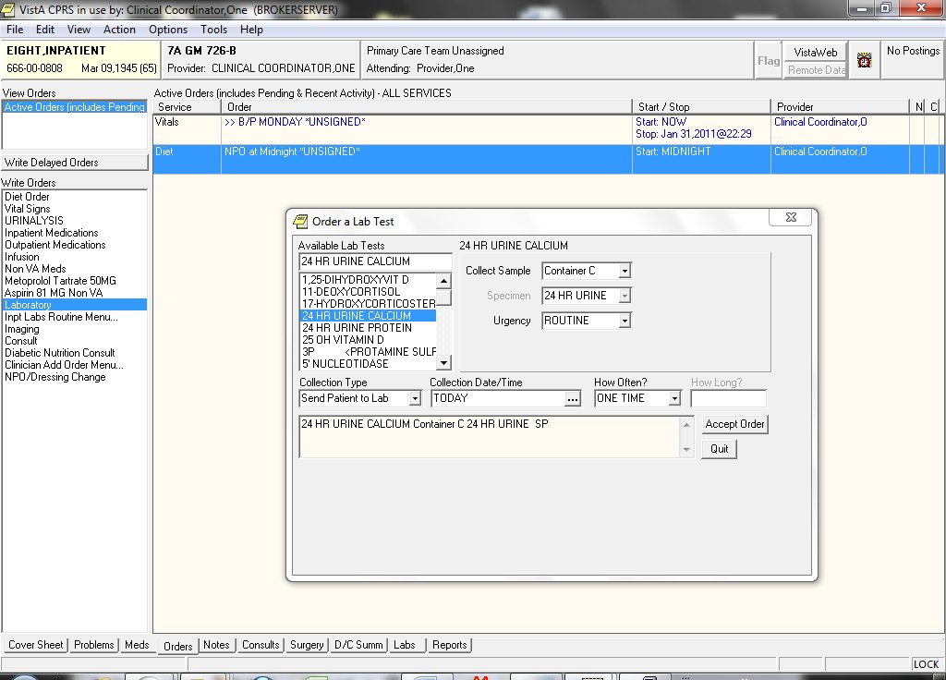
Exhibit 1: Example of Laboratory order screen in CPRS

Configuring the EHR
Unit 7 - Exercise 2: Create an Order Screen

Please complete the exercise by carrying out the following directions in the order listed. At the end of the exercise, print the order screen as evidence of successful completion.

- Log into the roll and scroll environment (VistATerminal) as a clinical application coordinator.

- Create an Order Screen for Diabetic patients. Use the VA’s naming convention when creating a new Order Screen that makes them easy to find and identify – the convention used by the VA is to prefix each order menu with ORZ.
Example ORZ MY ORDER NAME.-Student1

- Use Print Screen or another screen capture method to print the steps taken to setup the new Order Screen

- Add the new Order Screen to Write Orders List in CPRS.

- Use Print Screen or another screen capture method to print steps taken to add the new Order Screen to the Write Orders List in CPRS.

- Use Print Screen or another screen capture method to print the new Order Screen in CPRS.

- Revise the Write Order List in CPRS by removing an item.

- Use Print Screen or another screen capture method to print changes made to the Write Order Screen.

Hint: Use ‘Lab 2 - Instructions for Creating Order Screen’ as a guideline.

