Activities
Unit 5: Fundamentals of Usability in HIT Systems – What Does It Matter?

Activity 2 Answer Key

PART 1: Changing the font size to accommodate user preferences:
  - Choose EDIT from the toolbar
  - Choose PREFERENCES
  - Choose FONT
  - Adjust the font size to different sizes.
    - Adjust the coversheet (using click and drag in cells) to accommodate the new sized font. Experiment until you arrive at a layout that balances between font size and view-ability. In example, large fonts will run over the edges of the cell, preventing the user from viewing portions of data. This is an example of where improving one factor of usability may cause an unintended usability consequence elsewhere.
    - Click through all of the tabs (problems, meds, orders, etc.) to examine the downstream effect of the change.
    - Change patients – pick another inpatient from the available patient list. Do not sign any orders if you are presented with the opportunity to do so as you try to change patients.
    - Were the adjustments you made for Patient Eight retained for your new patient? Does the optimal view for Mr. Eight translate into the optimal view for other patient records in all tabs? In a few short sentences, detail how you would explain the potential trade-offs of font size versus the need for increased scrolling to a very novice computer user.
    - Return to Mr. Eight. Adjust the font size and view screen for the cover sheet and the order sheet to be optimal for you. Capture and save both of these screens for submission to instructor.

ANSWER:
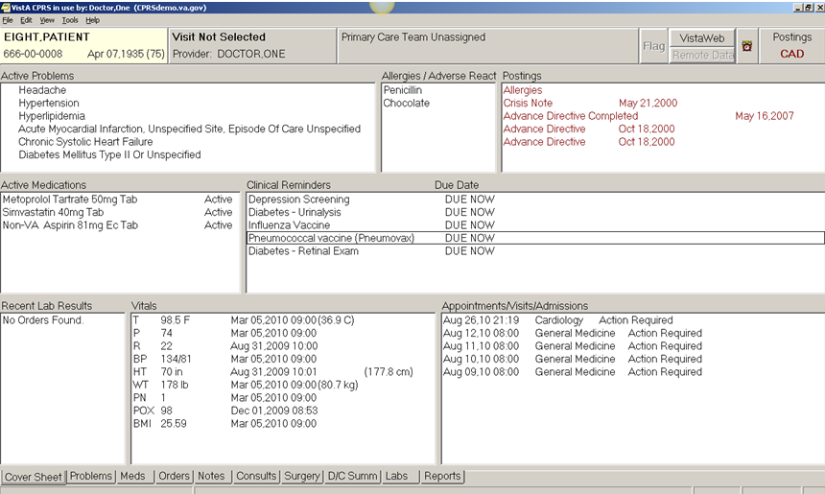
This is a 12 point font snapshot of the Cover Sheet
This is a 12 point font snapshot of the Order Sheet

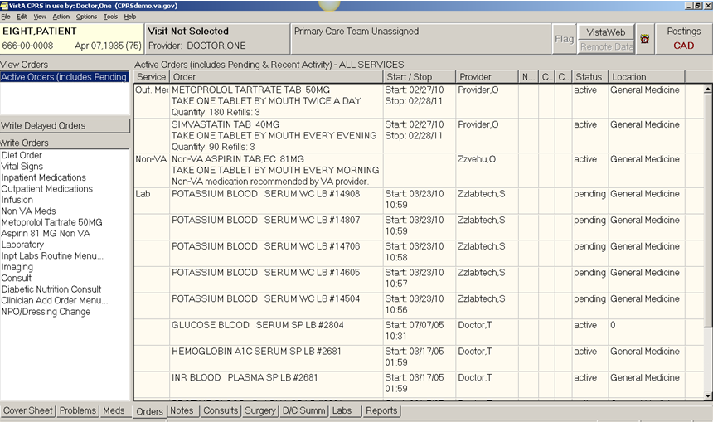

PART 2: Changing the default presentation order when opening the CPRS
  - Choose “TOOLS” and “OPTIONS” from the upper toolbar.
  - From the popup dialog box, choose “GENERAL” and “OTHER PARAMETERS”
  - Change the field for “Initial tab to display when CPRS starts”. Choose any field except cover sheet, but be thinking of a rationale for why this might be the first view that a given user would want to see. Choose ok, then ok again to get back to cover sheet view of Mr. Eight.
  - To apply the edit, you must exit CPRS and log back in. **NOTE: depending on the way that CPRS is set up to run on your computer or your school’s computer – logging out and logging back in may erase the option for tab display order that you just set. Check with your instructor or the lab manager, particularly about what is expected to be turned in for the assignment. It may require that you take a screen shot/print screen at step “C” above.
  - Verify that your start up view is now representative of the field that you specified prior to exiting. If not, repeat the prior steps. You must log out and log back in for the change to apply. Capture the screen that shows the new default presentation order for submission to the instructor. In 2-3 short sentences, create the “ask” that the user presented which influenced your rationale/choice of the new default presentation order (from 2c.)
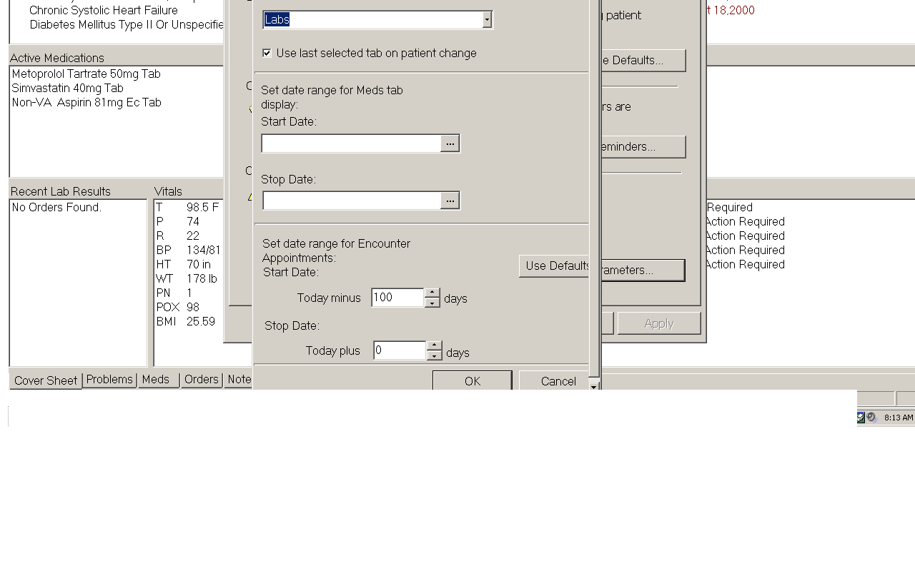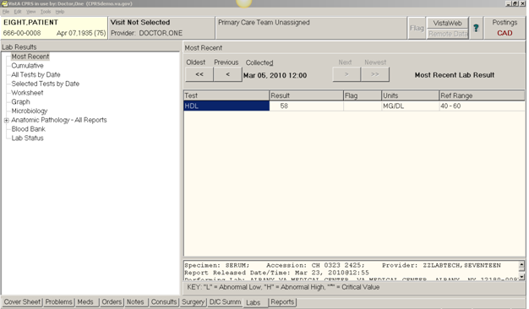
NOTE TO INSTRUCTOR:
Depending on response to Part 2 “d” – you may or may not see this as part of the homework turn in.
New default presentation order displayed on start-up.
In 2-3 short sentences, create the “ask” that the user presented which influenced your rationale/choice of the new default presentation order.
I was approached by the lab manager who wanted to know if I could create an opening view for her that just showed the most recent lab results. She was involved in a Quality Improvement project and was making early morning rounds to see if the night shift lab personnel were timely in having results up for each patient BEFORE morning rounds with the care provider team.

PART 3: Creating a user defined view involving the graphing function:
  - From within Mr. Eight’s chart, Choose “TOOLS” and “OPTIONS” from the upper toolbar.
  - From the popup dialog box, choose “GRAPHS” and “VIEW DEFINITIONS”.
  - Explore the box that pops up. Scroll down in the “Sources” box and choose “problems” or “orders” or…….. Determine the difference between “Select Items Using All Items” and “Select Items Using Patient Items”.
  - To create a graph –items must be selected for which values exist. For example, you cannot graph data points if there is no data! This points back to 3c, above.
  - Under “Sources” choose ONLY (VITALS) Blood Pressure, Weight, Body Mass Index, and (LAB TESTS) Hemoglobin A1C. You will need to transfer the items that you want to graph into the “Items for Graphing” box.
  - Choose “Save Personal” box, and save your personal view with your initials. If you have saved your personal view before and are editing, it is ok to overwrite your old existing file (since you are editing it) with your new personal view.
  - Choose “Close” and “OK”.
  - Refresh your patient view by clicking “file” and “refresh patient information” in the upper right hand toolbar.
- Click the REPORT tab at the bottom of the screen.
- Click “Graphing (local only)” to display your custom graph. In the graphing window, find the “View” tab. The “Items” tab and the “View” tab are side by side.
- Click the view tab in the graphing area, find your personal view (saved with your initials in 4c. above) and select it.
- Set the date range to 1 year. A graph will display. Check and uncheck “Individual Graphs”. Observe the difference.
- Set the graphs to display the values that are associated with each point on the graph. Right click in graphing window, choose “settings” – compare the results with the gradient box checked and unchecked, the clear background checked and unchecked, and the results when both boxes are unchecked. Choose the background you most prefer.
- Capture an image of the graph with individual graphs checked and unchecked and save your work for submission. In a brief paragraph, explain when and why it might be best to display data in separate graphs versus a single consolidated graph.

ANSWER:
Below you will see two images of the graph – the first with the individual graph box checked and the second with it unchecked (pink arrows). ***NOTE TO INSTRUCTOR: points should be awarded if all of the criteria are met. There should be no other data showing than the four values requested (red circles), the values should be present IN the graph (marked with blue circle below as example), and in “personal views” – there should be a saved personal view with the student’s initials in it (green circle). The background of the graphs can be either clear (as shown), a gradient color, or gray depending on the student preference. There is no set order that the values must display in.
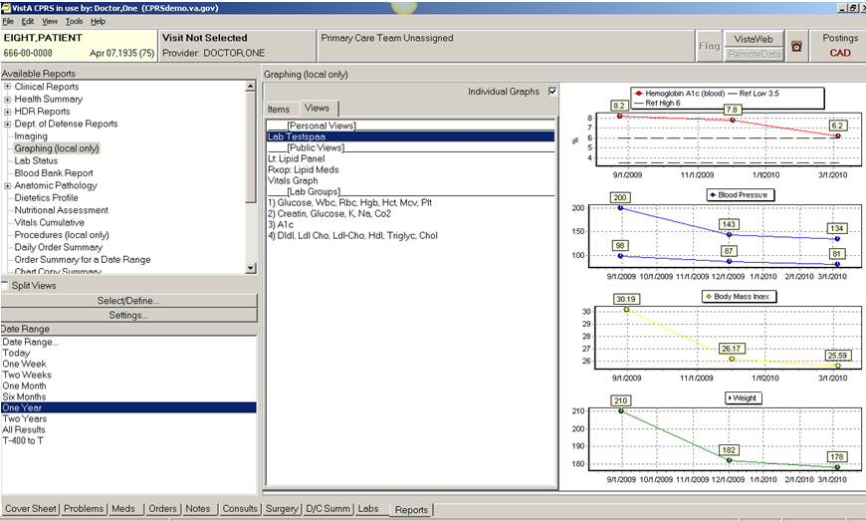

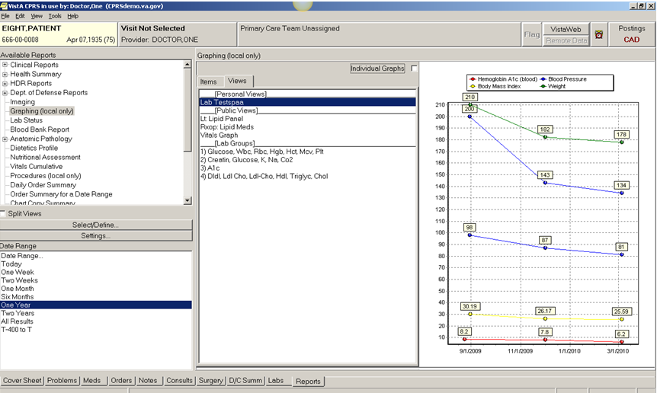
In a brief paragraph, explain when and why it might be best to display data in separate graphs versus a single consolidated graph.

I think it would be best to display the graph in a consolidated view if a user was specifically requesting to be able to compare one value with another. For example, maybe a nurse practitioner would want to look at the temperature readings as compared to when the patient was given her antibiotic to see if the medication is helping to reduce the fever. As we saw in earlier units, maybe a case manager wants to compare the patient’s weight with his blood pressure or his cholesterol level. In the quest for meaningful use – there may be requests by providers to examine the trend of the patient’s HGBA1C over time to check with good blood sugar control. If the provider did not want to look at that HGBA1C trended against anything else – then I might use individual graphs. I would use individual graphs any time a user would request a collection of data that do not require their comparison against anything else.

