Configuring the EHR
Lab 5: Combining Orders to Build Order Set

This session will focus on combining quick orders in an Order Set. Order sets enable a group of quick orders to be executed in a sequence without having to select each quick order individually. When the user selects the order set, CPRS will execute the quick orders in the exact order that the creator placed them in the order set.

Instructions for Building an Order Set
- Select the VistA Programming folder on the desktop
- Open the folder and double click the VistATerminal icon.
- Enter the Clinical Application Coordinator Access Code and Verify code provided by your instructor.
- At Select Training Menu Option: type “ORCM” <Enter>
- At Select Order Menu prompt, type the name of Order Menu and press <Enter>. Note: Use a naming convention, i.e. ORZ GMENU DIABETIC ORDERS-Student1.
- At Select Order Menu prompt, type name of Order Menu and press <Enter>.
Note: Use the Order Menu created in Lab 2.
- At the Select Action prompt, type ”Order Dialogs” and press <Enter>.
- At the Select prompt, type “Order Sets” and press <Enter>.
- At the Select Order Set Name prompt, enter name of Order set and press <Enter>.
Note: Naming convention for Order Set - ORZ
- Are you adding ‘ORZ…..’ as a new Order Dialog? (No) Type ”Yes” and press <Enter>.
- Do you wish to copy an existing order set? (Yes) Type ”No” and press <Enter>.
- At the Name prompt, accept default or make change and press <Enter>.
- At the Display Text prompt, enter Order Set name and press <Enter>.
- At the Description prompt, you may type a description and press <Enter>.
- At the Component Sequence #, enter a number and press <Enter>.
Note: This field specifies the order in which this item will be displayed in the set.
- At the Sequence prompt, accept default or make change and press <Enter>.
- At the Item prompt, type name of Item using correct naming convention and press <Enter>.
- Continue adding Sequence # and Items until Order Set is complete
Note: To review items in Order Set, type ‘?’ at Select Component Sequence prompt.

Exhibit 1: Example of a Diabetic Order Set in vxCPRS
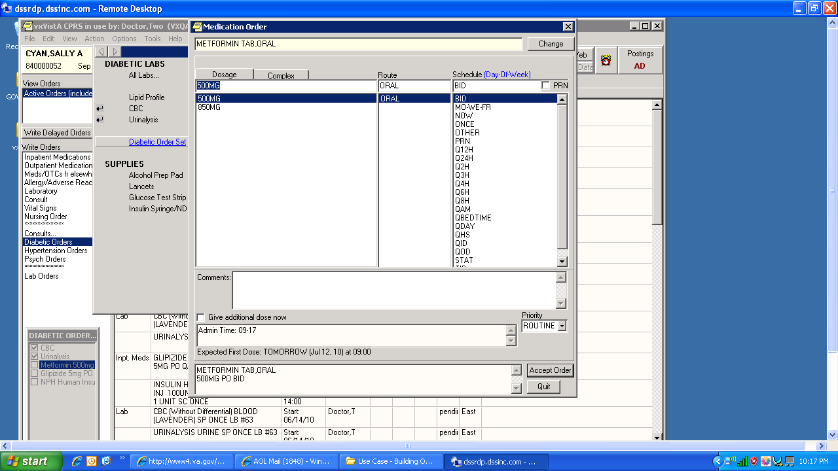

Diabetic Order Set

